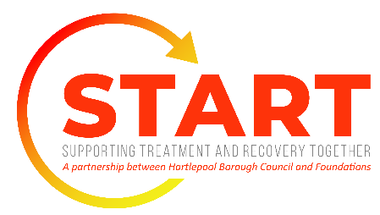
ADULT REFERRAL FORM

Telephone referrals will also be accepted: please have the below information when telephoning.
Please email your completed form to: Substancemisuse@hartlepool.gov.uk

Section 1 – Referrer Details

**If you are completing this form on behalf of a friend or family member you must have their consent to do so and they agree for START services to contact them. **

DATE |  | Are you referring yourself? | Yes ( ) No ( )
Are you referring a friend or family member? | Yes ( ) No ( ) | If referring on behalf of someone, have they consented to this referral? | Yes ( ) No ( )
If you are referring a friend or family member, please share your name & contact details:

Section 2 – Personal details of who requires support of START service:

Name |  |  | Date of birth:
Preferred name: |  |  | Gender assigned at birth: | Male | Female | Prefer not to answer
Address  Postcode |  |  | Telephone number | Mobile:  Landline:
Please state you’re your preferred mode of contact | Letter | Mobile (including voicemail & texts) | Landline |  | Other: please state
Do you give consent for us to contact you via? | Letter  Yes ( )  No ( ) | Mobile (including  voicemail & texts)  Yes ( )  No ( ) | Landline  Yes ( )  No ( ) |  | Other: please state  Yes ( )  No ( )
GP Name and Surgery

Are you/they in full time employment? | Yes ( ) No ( ) |  | Would you/they require a translator to support in yours/their appointments?  If so, what is yours/their first language? | Yes ( ) No ( )

Section 3 – Additional Information
How can we help?
Please describe your/your friend/family members’ drug and/or alcohol use: How much & how often?
Why is the referral being made today?
Tell us more about you or your friend/family members’ physical & mental health:
Are there any physical or mental health diagnosis?

Are you/they prescribed any medications?

Have you/your friend/family member ever received drug and alcohol treatment before? | Yes | No
If yes please provide details on when & with who:

Supporting Treatment & Recovery Together (START)

Whitby Street
Hartlepool
TS24 7AB

Tel No. 01429 285000

Secure email address: substancemisuse@hartlepool.gov.uk

