**­­­­­­­­­­­**

**For Sale Freehold**

**Dumfries Road Former Garage Site,**

**Hartlepool, TS25 5ED**

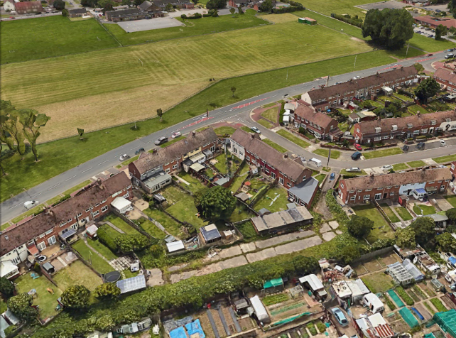

**Offers Invited by Informal Tender**

Closing Date: **12 noon on Friday 9th December 2022**

**All enquiries to:**

Strategic Asset Management, Civic Centre, Victoria Road,

Hartlepool, TS24 8AY

**Tel:** 01429 523282Email: Estates@Hartlepool.gov.uk

**Description**

Hartlepool Borough Council is offering Dumfries Road former garage site for sale by way of a sealed tender.

This former Garage Site, measuring approximately 0.36 Acres, became dis-used in the early 2000’s. There are currently 6 garage structures on site with access being granted through a locked gate from Dumfries Road.

A licence to occupy part of the site has been granted to the owner of 22 Rossmere Way, which covers an area of land to the rear of their property. It is understood that there may be boundary irregularities that the purchaser of the site would need to resolve.

The site may be suitable for residential development or alternatively could be used as a garage site, allotments or garden extensions (subject to Planning).

**Property Location**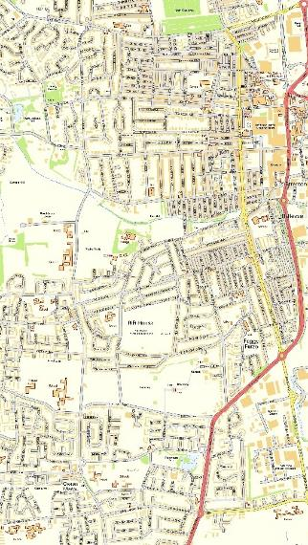

**Location**

Situated at the south end of Hartlepool in a residential area approximately 1.5 miles from the Town Centre. The site is accessed from Dumfries Road, which is off Rossmere Way. The A689 is 0.35 miles from the site.

**Services**

It is understood that all major services can be accessed from the adjacent adopted highway. It is the responsibility of prospective purchasers to confirm with the relevant utility service providers their availability and suitability for their proposed use.

**Site Boundaries**

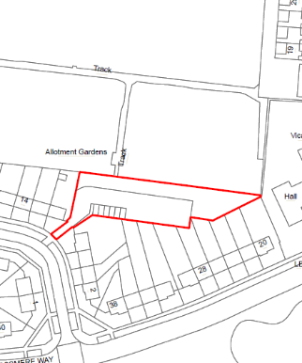

*Approximate Location of Site*

**Rating Assessment**

The property is not assessed for business rates.

**Viewing**

By arrangement with Hartlepool Borough Council’s Strategic Asset Management Team on 01429 523282 or [estates@hartlepool.gov.uk](mailto:estates@hartlepool.gov.uk).

**Closing Date for receipt of tenders**

All offers to be made on the attached tender form and returned in a sealed envelope to the Managing Director at the above address, clearly marked “**Informal Tender in respect of Dumfries Road former Garage Site” before 12 noon Friday 9th December 2022.**

**General Conditions**

All offers are to be based on these Particulars

Persons submitting offers shall be deemed to have visited and inspected the property and to be submitting their offer with full knowledge of its condition.

All necessary statutory consents are to be obtained by the purchaser at his own cost prior to the commencement of development

**Freehold purchase:-**

Details of the person(s) or company that is offering to purchase the freehold interest. A company should include details of the full company name, registration number, registered address and contact details for the individual submitting the offer.

The applicant must provide detailed information to confirm:-

* Proposed Use
* Funding arrangements for the acquisition and any proposals for the property.
* Description of their proposals and if relevant any indicative drawing(s)
* Details of the overall timescale required to complete the transaction.

**Money laundering legislation**

The Council is required to comply with the anti-money laundering legislation and will take all necessary steps to ensure compliance.

**Conditions of Sale**

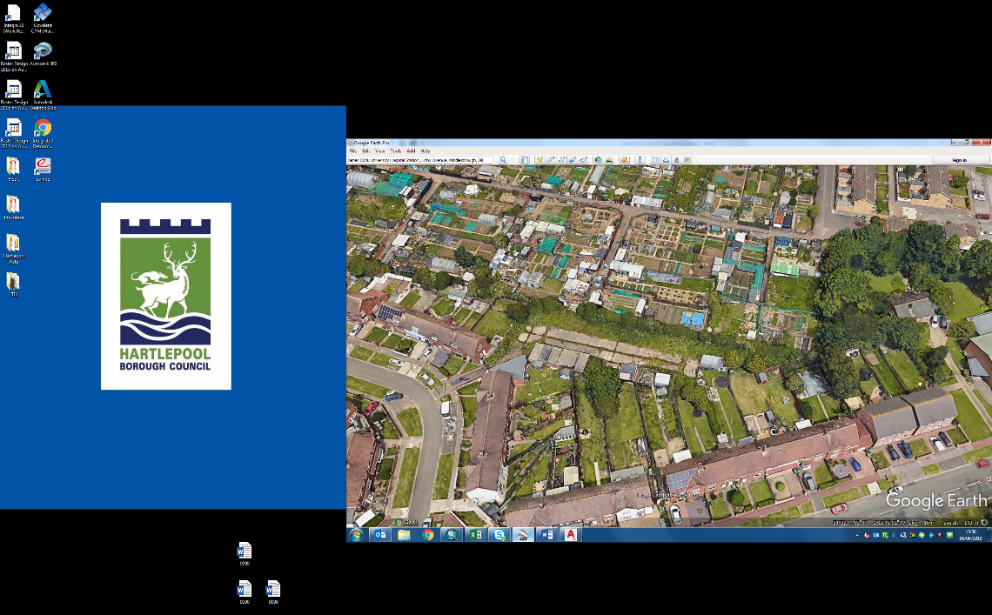

The purchaser will be responsible for the Councils surveyor’s fees based on 3% of the accepted offer price (subject to a minimum of £1,000) and the Council’s reasonable legal fees.

|  |
| --- |
|  |

A minimum 10% deposit payable on exchange of contracts required

**Notice is hereby given that**

1. These particulars are set out as a general outline only for the guidance of interested parties and do not constitute, or constitute part of an offer or contract.
2. All descriptions, dimensions, references to condition and necessary permissions for use and occupation and other details are given without responsibility and intending purchasers/lessees should not rely on them as statements or representations of fact but must satisfy themselves by inspection or otherwise as to the correctness of each of the statements contained in these particulars.
3. Hartlepool Borough Council does not make or give any representation or warranty whatsoever in relation to the property.
4. None of the building services or service installations (whether these be the specific responsibility of the freeholder(s), lessor(s) or lessee(s)) have been tested and are not warranted to be in safe working order.

**VAT**

Any offers will be deemed to be excusive of VAT