Hartlepool Public Health Baseline Data 2022

Introduction`
People in Hartlepool live shorter lives and have more ill health than people in the North East and England. There are many possible reasons for this starting from before birth and throughout our lives. We can act on causes or ill-health and early death (and the causes of the causes) so people can live longer healthy lives in Hartlepool.
Additional data in this document provides a baseline summary of health in Hartlepool. Where possible, an “average” Hartlepool street of one hundred people is used to help explain health data throughout the life course.

Best start in life
Giving children the best start in life is vital, since experiences during pregnancy and in childhood can significantly affect wellbeing and opportunities over the whole of a person’s life and even in the next generation.
To live healthy, happy, long lives it is important for a family to have the building blocks of health (good housing, food, community, education, work, money and transport) from the start. However, many children are born into families without these resources.
In an “average” Hartlepool street of one hundred children, 39 are in poverty. This has increased from 27 in every 100 children in 2014/15.
Number of children in poverty on an “average” Hartlepool street of one hundred children
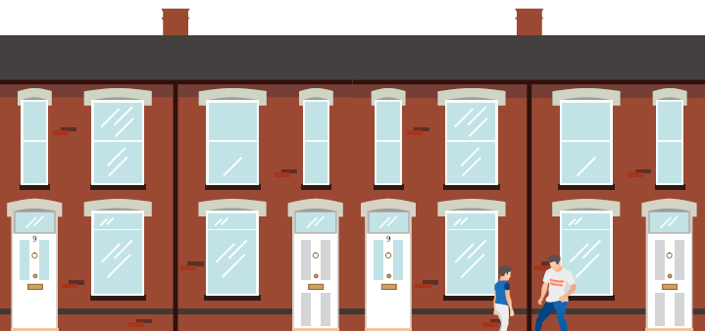
39 children in poverty in a street of 100
Smoking in pregnancy and in the home can have significant effects on children’s health. In Hartlepool, 14 in every one hundred mothers are smoking when their baby is born. This is higher than in the North East or England (10 in 100)
Breastfeeding has significant benefits to the health of babies and mothers. However, in Hartlepool, only 25 in every one hundred children are breastfed at 6-8 weeks (compared with 48 in 100 children in England).

Immunisations
Vaccines are important to protect against key serious diseases. Vaccines protect the person receiving the vaccine but also, if enough people are vaccinated, reduce the spread of disease and protect people who are too young to have the vaccine or for whom the vaccine is not suitable/effective. The national target for infant vaccines is 95% and Hartlepool is around this figure.
Out of one hundred children under 2 years, 95 have had each of the routine infant vaccines.

Number of children under 2 years in vaccinated on an “average” Hartlepool street of one hundred children

95 children vaccinated in a street of 100

5 children unvaccinated in a street of 100

The Spine chart below shows vaccine trends (arrow), coverage and comparison to England (dot for Hartlepool coloured according to whether 95% threshold is met compared to red line for England). Infant vaccines include combined diphtheria, tetanus and pertussis/whooping cough (Dtap), Inactivated Polio vaccine (IPV), Haemophilus influenzae type b (Hib), Meningococcal B (Men B), Rotavirus, Meningococcal C (Men C), Pneumococcal conjugate vaccine (PCV) and Measles, mumps and rubella (MMR).
Vaccines given after two years old tend to have lower coverage:
- 53 out of 100 children aged 2-3 years have had their flu vaccine
- 87 out of 100 children aged 5 years have had their preschool vaccines (dTaP/IPV and MMR)
- 58 out of 100 primary school age children have had their flu vaccine (17 children in an average class of thirty)
- 66 out of 100 children aged 14-15 years have had their Meningococcal ACWY vaccine
- 38 out of 100 boys, and 45 out of 100 girls aged 12-13 years old, have had their Human papilloma virus (HPV) vaccine

Spine chart showing childhood vaccinations
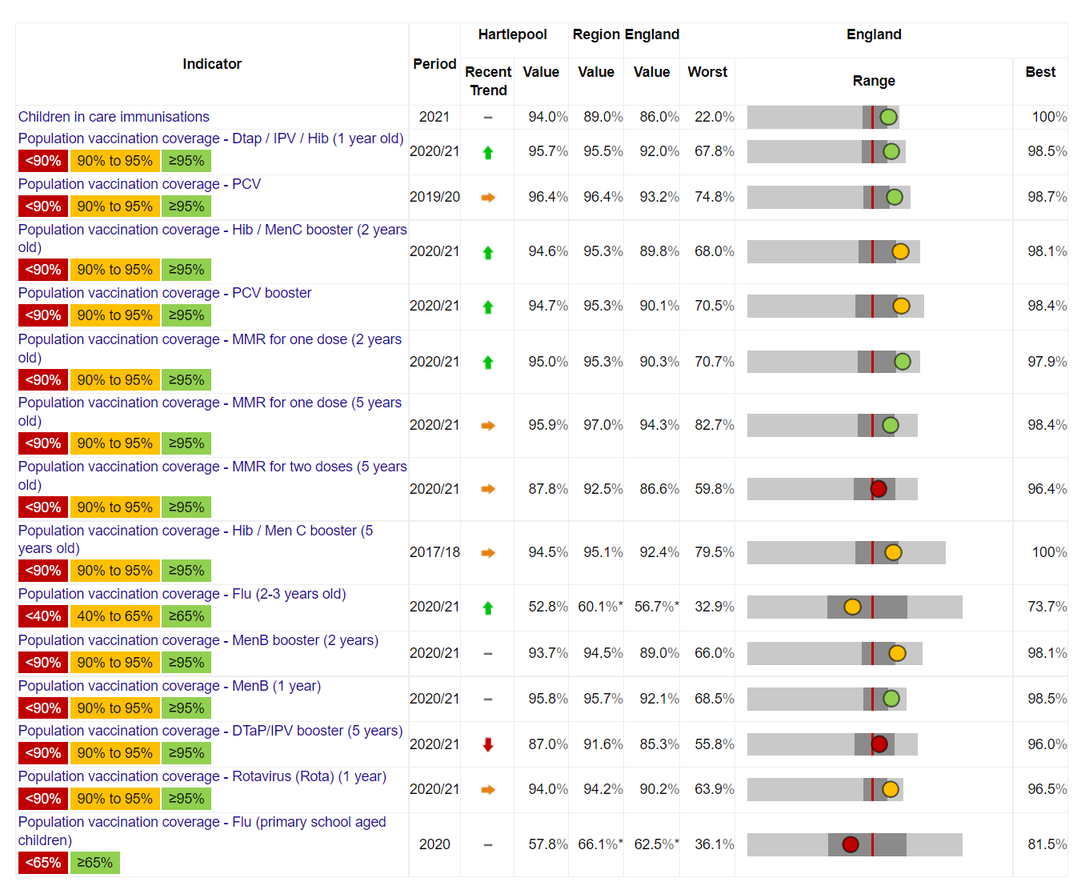
Source: COVER 2022

Spine chart showing teenage vaccination
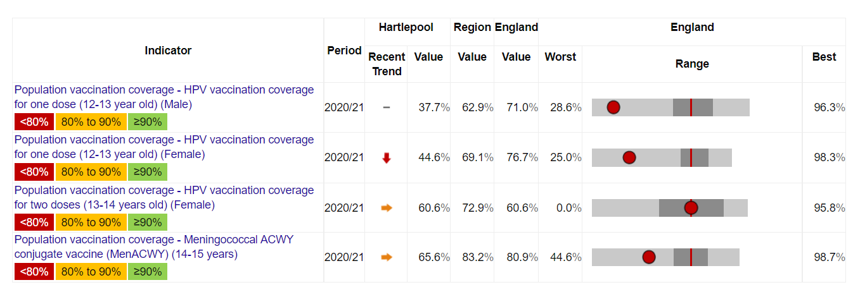
Source: COVER 2022

Childhood accidents
For the majority of hospital admissions for childhood accidents, Hartlepool’s rate is statistically similar to England average, however rates for emergency admission for exposure to animate mechanical forces for children aged 0-4 in Hartlepool is the highest in England. Injuries from animate mechanical forces includes accidental injuries caused by another person, as well as contact (bites, stings and impacts) from animals and plants.
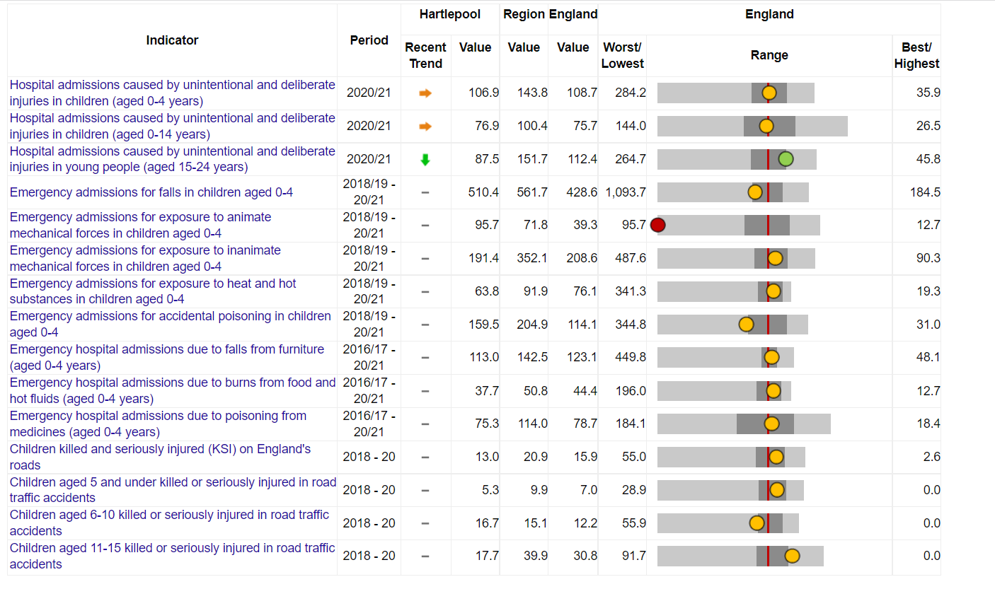
Source: NHS Digital/HES/OHID, 2022

Children who are overweight or obese
In an average class of thirty children starting school in Hartlepool, 9 are already overweight or obese (30 in 100). This is higher than an average class in the North East and England (7 in a class of thirty)
By year six of school, 12 children out of an average class of thirty are overweight or obese in Hartlepool (40 in 100).
The number of children who are obese has been increasing over the last six years in Hartlepool, the North East and England. In a class of 30 children starting school, around 4 are already obese (12 in 100)
By year 6, more than 7 children in a class of thirty in Hartlepool are obese. Another way to visualise this is that a quarter (1 in 4) year 6 children are obese in Hartlepool.

Teenage pregnancy
Fewer people aged under 18 are becoming pregnant (around 2 in 100 people aged 15-17 years became pregnant in 2020, compared to around 4 in 100 in 2018.
These figures are now similar to the north east regional average, though still higher than the England average.

Source: ONS 2022 Trend
Around half of teenage pregnancies end in abortion in England. In Hartlepool, between 2015 and 2020, the proportion of teenage pregnancies ending in abortions varied between 33 and 58 in a hundred teenage pregnancies.

Living well (working age)

Smoking
In an “average” Hartlepool street of one hundred adults, 16 people smoke.
Number of people smoking on an “average” Hartlepool street of one hundred adults

16 adults smoking on a street of 100
This is higher than an average street in the North East (14 in 100) and England (12 in 100) but is falling (from 20 in 100 in 2015).

There are fewer women smoking in Hartlepool than men.

Illicit tobacco in Hartlepool continues to be an issue, with 6 premises reported for illegal tobacco sales in 20/21, with 2.45kg of rolling tobacco and 18,400 illicit cigarettes being seized by Hartlepool Trading Standards in 20/21.

Physical activity
Physical activity reduces the risk of many diseases and helps maintain a healthy weight. Over time adults in Hartlepool have become less active. This is in contrast to the values for the England and north east averages which have remained stable.
In an “average” Hartlepool street of one hundred adults, 55 meet the guidance for being physically active (150 minutes of moderate activity, or 75 minutes vigorous activity per week).
Number of people physically active on an “average” Hartlepool street of one hundred adults
55 adults physically active on a street of 100

45 adults not meeting guidelines for physical activity on a street of 100

The graph below shows the steady decline in people meeting the guidelines for physical activity from 2015/16 to 2019/20.

Adults who are overweight or obese
Over time, more adults in Hartlepool have become overweight or obese.
In an “average” Hartlepool street of one hundred adults, 73 adults are overweight or obese. This means almost three quarters of adults in Hartlepool are overweight or obese.

Number of overweight or obese people on an “average” Hartlepool street of one hundred adults
73 overweight or obese adults on a street of 100

This is higher than an average street in the North East or England (68 in 100 in North East 63 in 100 in England)
The graph below shows the rise in adults who are overweight or obese from 2015/16 to 2019/20.

Source: Active Lives 2022

Sexual health
New diagnoses for sexual transmitted infections (STI) in Hartlepool are at a nine year low and are significantly lower than the England average. However, this may be due to significantly reduced testing in Hartlepool compared to England.
Spine chart showing STI indicators
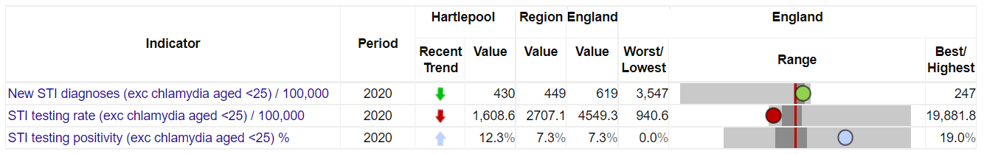
Source: OHID 2022

Cervical screening
Cervical screening is offered to all women and people with a cervix aged 25 to 64 to check the health of cells in the cervix. It is offered every three years for those aged 25 to 49, and every five years from the ages of 50 to 64.
In an “average” Hartlepool street of one hundred women aged 25-49, 74 have been screened.
Number of women screened for cervical cancer on an “average” Hartlepool street of one hundred eligible women
74 eligible women screened for cervical cancer on a street of 100
26 eligible women who have not screened for cervical cancer on a street of 100
on a street of 100

This is better than an average street in England where only 68 in 100 women have been screened.
In an “average” Hartlepool street of one hundred women aged 50-64, 72 have been screened.

Source: NHS Digital/OHID 2022

Breast screening
Breast screening is offered to women aged 50 to 70 to detect early signs of breast cancer.
The proportion of people aged 53-70 who have been screened for breast cancer in the last 3 years fell sharply in 2021 in England, the North East and Hartlepool.
In an “average” Hartlepool street of one hundred women aged 53-70 years, 74 would normally be screened. In 2021 this dropped to 67 in 100. However, this figure is better than an average street in England (64 in 100).

Number of women screened for breast cancer on an “average” Hartlepool street of one hundred eligible women
74 eligible women screened for breast cancer on a street of 100

26 eligible women who have not screened for breast cancer on a street of 100
on a street of 100

Hospital admissions and deaths due to alcohol
Hospital admissions and deaths due to alcohol are higher in Hartlepool than England, even when accounting for age of population through direct standardisation.
There were 904 admissions specifically due to alcohol for every 100,000 people in Hartlepool, compared with less than 600 admissions per 100,000 people in England.

Between 2017 and 2019, there were more deaths specifically due to alcohol in Hartlepool compared with England (around 18 deaths specifically due to alcohol for every 100,000 in people Hartlepool compared with 11 deaths per 100,000 in England).

Hospital admissions and deaths due to illegal drugs (substance misuse)
In Hartlepool, drug-related hospital admissions have fallen over time but drug related deaths have increased.

There were 16 deaths specifically due to drugs for every 100,000 people in Hartlepool compared with 11 deaths per 100,000 in England and the gap in death rates has worsened over time.

Source: ONS, 2022

Living well in later life

Length of life (Life Expectancy)
People in Hartlepool live shorter lives than people in the North East and England. In an average street in Hartlepool a women can expect to live to around 81 years old and a man can expect to live around 77 years old. In an average street in England, people can expect to live around 2 years longer (women can expect to live to around 83 and men can expect to live around 79 years old).
Life expectancy does vary across different areas of Hartlepool. For example in Manor House people can expect to live around 6 years less than people in Rural West. This is illustrated in the picture below showing life expectancy in different areas.

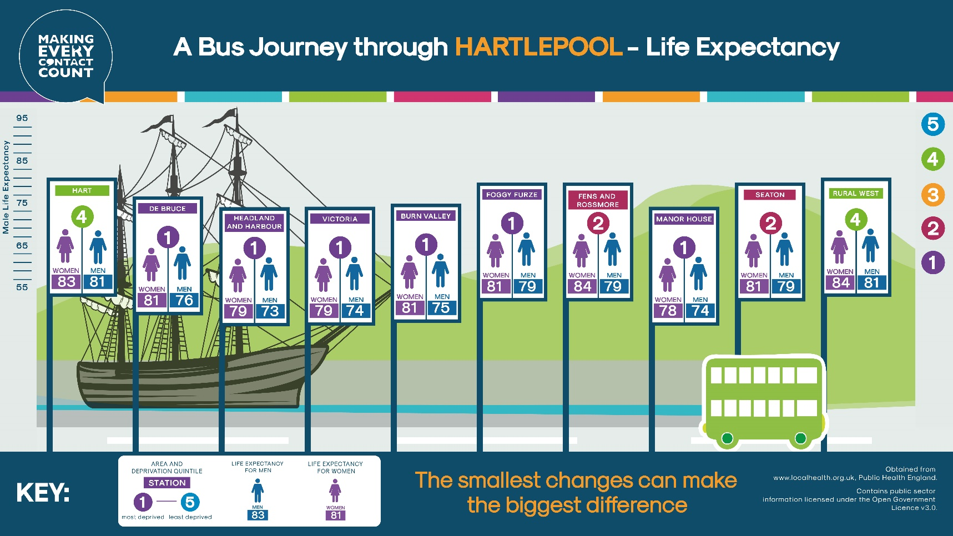
Hartlepool has experienced a downward trend in life expectancy in the latest figures for both males and females, however this is mirrored in the both the England and north east figures.

Source: ONS 2022

Source: ONS 2022

Healthy Life expectancy
Although length of life is important, quality of life of any extra years is arguably more essential. Healthy Life Expectancy (HLE) is number of years a person would expect to live in good health. It is based on death rates and the proportion of people reporting their health as “good” in surveys.
For healthy life expectancy, the Hartlepool figures are below both the national and regional averages.

Source: ONS 2022

Source: ONS 2022
Both male and female healthy life expectancy at birth dipped in a way that was not mirrored by either the north east or England rates. For Hartlepool males the dip was in 2012-14 and for females in 2013-15. However both Hartlepool rates have increased since these points. Both male and female rates in Hartlepool have increased in the latest figures, with the female rate closer to the north east average than at any other point in the reporting period.

Bowel cancer screening
In an “average” Hartlepool street of one hundred people aged 60-74 years old, 65 have been screened for bowel cancer. This is similar to the number of people screened in an average street in England.

Number of people screened for bowel cancer on an “average” Hartlepool street of one hundred eligible people
65 eligible people screened for bowel cancer on a street of 100

35 eligible people who have not screened for bowel cancer on a street of 100
on a street of 100

The graph below shows more people in Hartlepool are getting screened for bowel cancer than previously (57% in 2019 to 65% in 2021).

Immunisations
Adults are offered a single dose of Pneumococcal vaccine (PPV) at 65 years old and the Shingles vaccine between 70-79.
Adults 65 years and older (any younger people with particular health problems) are offered the Flu vaccine each year.
In an “average” Hartlepool street of one hundred eligible people, 81 have had their Flu vaccine, 62 have had their Pneumococcal vaccine, and 43 have had their shingles vaccine.

Number of women screened for breast cancer on an “average” Hartlepool street of one hundred eligible women
81 eligible people who have had their Flu vaccine on a street of 100

19 eligible people who have not had their Flu vaccine on a street of 100

Of the adult vaccinations in Hartlepool, only Flu for people aged 65 years and older has hit the required target threshold, in this case 75%. This vaccination is also the only one showing a positive upward trend.

Spine chart showing adult vaccinations
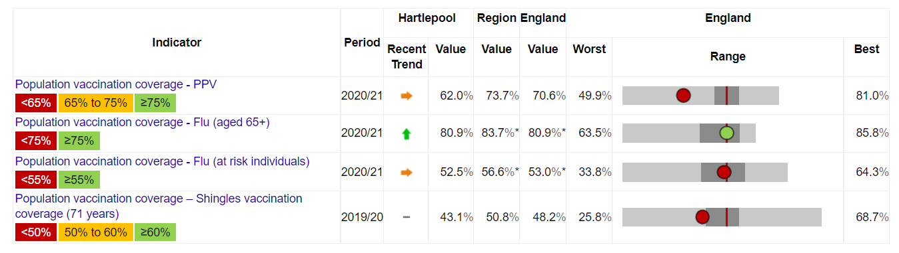
Source: COVER 2022

People living with chronic heart disease
In an “average” Hartlepool street of one hundred people, 4 are living with heart disease. In an average street in England 3 are living with heart disease.

Number of people living with heart disease on an “average” Hartlepool street of one hundred people
4 people living with heart disease on a street of 100

These figures are generally decreasing over time.

Early deaths from heart disease
Heart disease and stroke are common causes of death in old age. It is important to act on early deaths (deaths under 75 years) or preventable deaths due to heart disease or stroke. This can help people can live longer healthier lives.
The graph below shows early deaths due to heart disease in people in Hartlepool increased from 48.6 per 100,000 in 2014/16 to 57.4 per 100, 000 in 2017/19. During these years deaths due to heart disease have been falling in the North East and England so the gap between Hartlepool and the rest of the country is worsening.

Source: ONS/OHID 2022

Early deaths from either heart disease or stroke
Deaths due to heart disease or stroke are often examined together (under cardiovascular disease) since they share many of the same risk factors.
People aged under 75 years old in Hartlepool are more likely to die from either heart disease or stroke than England. These figures are getting worse in Hartlepool over time (despite improving in the North East and England).
Around 99 people died of heart disease or stroke for every 100,000 people aged under 75 in Hartlepool in 2017-19. This is higher than in 2012-14, when there were 90 deaths for every 100,000 people. In contrast, the death rates in the North East and England are lower (82 in 100,000 and 70 in 100,000) and falling over time. This means the gap between Hartlepool and the rest of the country is worsening. A similar pattern is visible in the rates for preventable deaths.

Hospital admissions for falls
People aged 65 and over in Hartlepool, are less likely to be admitted to hospital because they have fallen than people in the North East or England and this has got better over time (1419 hospital admissions for falls per 1000 people aged 65 and over in Hartlepool vs around 2023 admissions per 1000 people in England.
Another way to look at this is, in an “average” Hartlepool street of one hundred people aged 65 and over, around 1 person might be admitted to hospital each year. In an average street of one hundred people aged 65 and over in England, around 2 people might be admitted to hospital each year.
Number of people admitted to hospital due to a fall on an “average” Hartlepool street of one hundred people each year
1 person admitted to hospital due to a fall on a street of 100 each year

The graphs show Hartlepool has a declining trend in hospital admissions for falls in all of the elderly age brackets, 65+, 65-79 and 80+.

Source: HES/ONS/OHID 2022

Source: HES/ONS/OHID 2022

Source: Source: HES/ONS/OHID 2022
Within Hartlepool, the hospital admission rate is higher for females, but the gap between the genders is closing. Both male and female admissions show a declining trend.

Source: Source: HES/ONS/OHID 2022
Lower figures for hospital admissions for falls could reflect fewer falls or people being less likely to be admitted to hospital after a fall.
Hartlepool’s rate of hip fractures in those aged 65 and above, whilst on a declining trend, has had a series of peaks and troughs throughout the reporting period. Hartlepool’s latest rate is similar to the north east average, though both are above the England average.

Source: Source: HES/ONS/OHID 2022

Covid-19
Covid-19 has affected all ages but older people have been at greatest risk of death throughout the pandemic.
People in Hartlepool have been more likely to catch Covid-19 and die from it than people in England.
In an average Hartlepool street of 100 people, 36 people had tested positive for Covid-19 by March 2022 (when most free Covid-19 testing ended).

Number of people who had tested positive for Covid-19 on an “average” Hartlepool street of one hundred people by March 2022
36 people who had tested positive for Covid-19 on a street of 100 by March 2022

In an average English street of 100 people, 32 people had tested positive. Women were more likely to catch Covid than men.

By February 2022 there were 350 Covid-19 deaths per 100,000 people in Hartlepool compared to 290 deaths per 100,000 people in England.

Source: CHIME 2022
Within Hartlepool, people living in poorer (more deprived) areas were more likely to die of Covid-19 than those in richer areas.
The graph divides Hartlepool into five groups (quintiles) depending on how rich or poor an area is and compares the death rates.
The death rate in the most deprived population (Quintile 1), was more than twice that of the least deprived population (Quintile 5).

Source: CHIME 2022

Conclusion
This document outlines some additional data to provide a baseline summary of Hartlepool. It describes some of the challenges, and inequalities, in Hartlepool as well as some good news. There is always more data that can be analysed and new updates to data. The Fingertips tool from the Office for Health Improvement & Disparities offers up-to-date data on a range of Public Health measures.
As well as analysing data, it is important to act together to make a difference. The final section of the Director of Public Health Report discusses ways in which we can all work together to improve health and wellbeing in Hartlepool.

The national definition of poverty is less than 60% of median income. Poverty means lack of resources to have adequate diet/living conditions and participate in society

