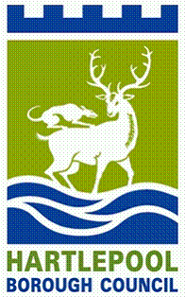

Tender for the provision of uniforms
for the Tall Ships Event (July 2023)
NEPO Portal ProContract Ref No: DN 634741
Hartlepool Borough Council are hosting the Tall Ships Races in July 2023, and they are looking for an organisation able to provide uniform for an event of this scale.
Objectives
- Provide high quality uniform
- Provide value for money
- Provide durable and sustainable items that can be used during and after the event
Organisations wishing to register an interest and download the tender documentation, should apply via the NEPO Portal only.
https://procontract.due-north.com - NEPO Portal Procontract Reference DN634741
All completed documentation must be returned via the NEPO Portal Only and by no later than Wednesday, 22nd February 2023
For guidance notes on how to register onto the NEPO Portal please follow link below: -
https://procontract.due-north.com/SupplierRegistration/Register

