**­­­­­­­­­­­­­To Let c. 25.87 Acres**

**Grade 2/ 3 Arable & Pasture Land**

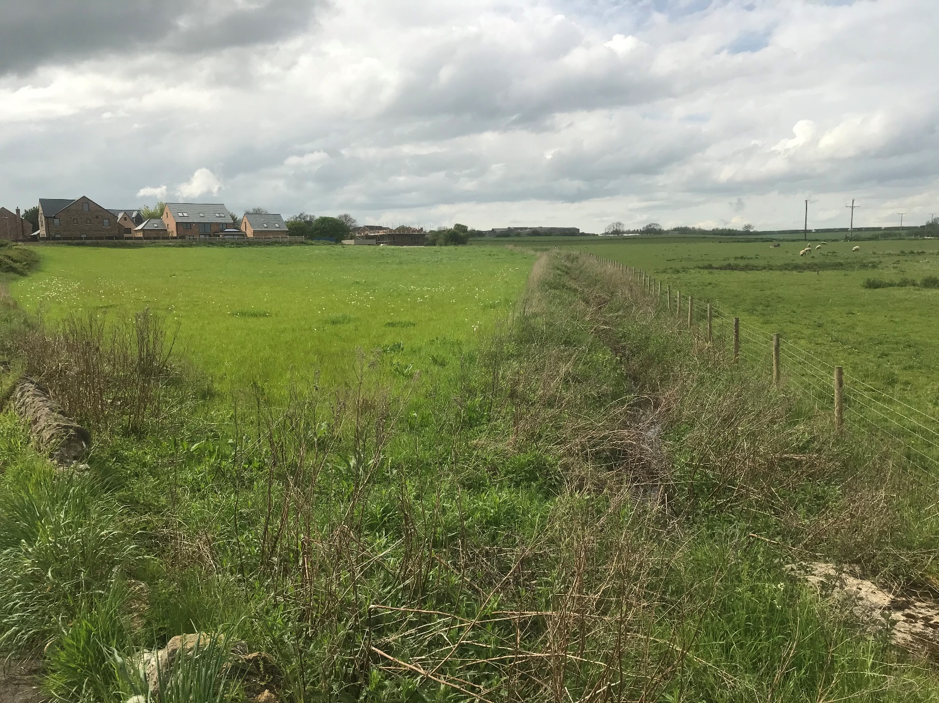

**Land at Hart Village (East) and**

**Land at Nineacres, Hart Village**

**Tenders invited by 12 noon, Friday 23rd June 2023**

**All enquiries to:**

Asset Management Department, Civic Centre, Victoria Road,

Hartlepool TS24 8AY

**Tel:** 01429 523228Email: [estates@hartlepool.gov.uk](mailto:estates@hartlepool.gov.uk)

**Land at Hart East and Nineacres**

A rare opportunity to rent some of the regions’ Grade 2/3 agricultural land ideally suited for arable cropping, grass production and livestock.

The land extends to a total of **25.87 acres** in 3 lots as follows:

**Lot 1 Adjoining Nineacres Hart Village 8.63 acres**

**Lot 2 West of the Fens, Hart Village 9.95 acres**

**Lot 3 East of the Fens, Hart Village 7.29 acres**

All lots are offered to let by way of 6 year Farm Business Tenancies with rent reviews every three years.

The locations are shown edged red on the attached Location Plan.

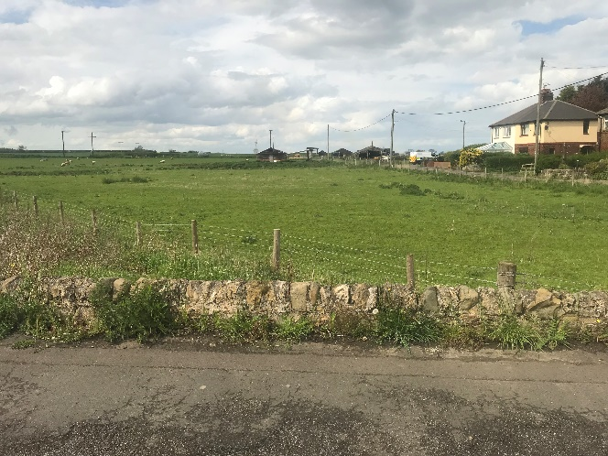 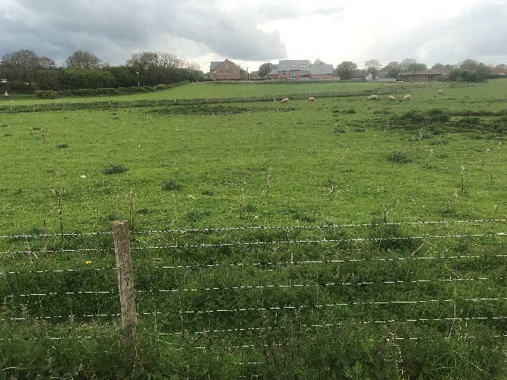

**Location Plan**

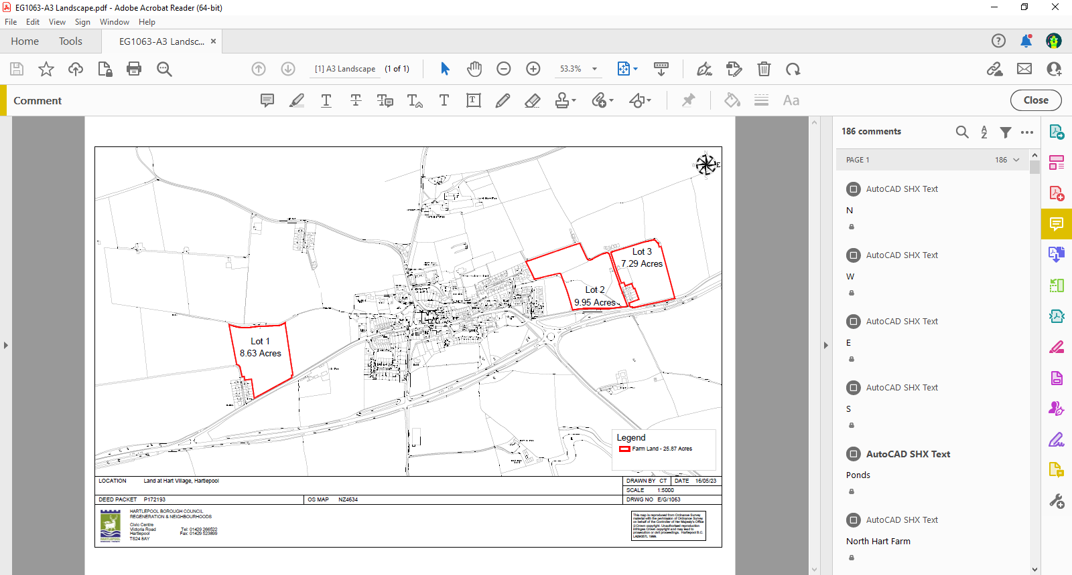

**Terms of Letting**

**Costs**

Successful bidder to pay the Councils Surveyors fees of £1,000 plus reasonable Legal Fees.

**Landlord Break Right**

The lease will be subject to a landlord’s right to break part or all of the lease on one year’s notice at any time for development purposes.

**Repairs and Insurance**

Tenant to be responsible for repair and cost of insurance. However the existing building on the land is in poor condition and should be demolished; replacement not required.

**Schemes and Designations**

It is believed thatthere are no statutory designations in place on the land. The outgoing tenant has entitlements which may be available for sale – further details on request.

**Easements & Wayleaves**

The land is offered to let subject to and with the benefit of all rights of way, water, drainage, water courses, light and other easements, quasi or reputed easements, and rights of adjoining owners (if any) affecting the same and all matters registerable by any competent authority pursuant to statute. Lot 1 is subject to a wayleave for electricity pylons.

**Sporting Rights & Mineral Rights**

There are no sporting and mineral rights included in the Tenancy.

**Viewing**

At any time during daylight hours from the public highway

**Property Misdescriptions Act 1991**

Every reasonable effort has been made by Hartlepool Borough Council to ensure accuracy. Interested parties are strongly advised to take appropriate steps to verify by independent inspection or enquiry all information for themselves and to take appropriate professional advice.

**Finance Act 1999**

Unless otherwise stated all prices stated are exclusive of VAT.

**Misrepresentation Act 1967**

Hartlepool Borough Council gives notice that:

1. These particulars do not constitute any part of an offer or contract.
2. None of the statements contained in these particulars as to the property(s) are to be relied upon as statements of or representations of fact.
3. Any intending licensees must satisfy themselves by inspection or otherwise as to the correctness of each of the statements contained in these particulars.
4. Hartlepool Borough Council does not make or give any representation or warranty whatsoever in relation to the property(s).
5. None of the building services or service installations (whether these be the specific responsibility of the freeholder(s), lessor(s) or lessee(s)) have been tested and are not warranted to be in safe working order.

**Tenders to be submitted via email to** [**estates@hartlepool.gov.uk**](mailto:estates@hartlepool.gov.uk)

All offers are to be based on the Particulars of Letting. It should be noted that the Borough Council does not undertake to accept the highest or any offer and that any offer is made subject to formal approval of the appropriate Committee.

Persons submitting offers shall be deemed to have visited and inspected the site and to be submitting their offer with full knowledge of its condition.

All offers must be submitted by **12 noon, Friday 23rd June 2023**

**Tenderers are requested to submit tenders on the basis outlined above**

**All enquiries to:**

Asset Management Department, Civic Centre, Victoria Road

Hartlepool, TS24 8AY

**Tel: (01429) 523228**

Email: [estates@hartlepool.gov.uk](mailto:estates@hartlepool.gov.uk)