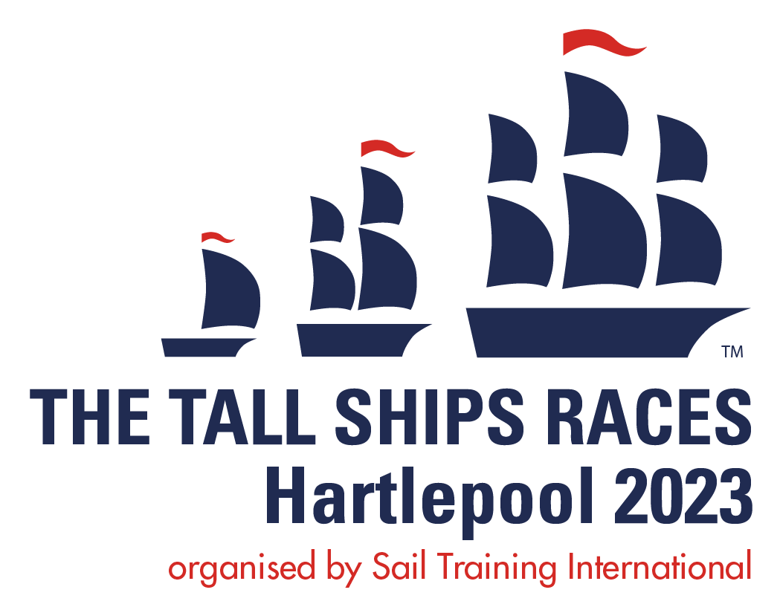

The Tall Ships Races Hartlepool 2023 – Permit Parking Scheme

A permit parking scheme will be in operation for residents and businesses on the Headland and in areas along Old Cemetery Road during The Tall Ships Races Hartlepool 2023 from 6th-9th July.

Following a number of enquiries from residents, please see below answers to some frequently asked questions (FAQs). These will be updated periodically.

Frequently Asked Questions
Why are we introducing a temporary parking restriction?
The nature of the historic Headland means that it does not cope well with large volumes of traffic. The Tall Ships Races Hartlepool 2023 is different to when the town last hosted the tall ships in 2010 in that it is more focused on showcasing the Headland. The Crew Parade will take place predominantly on the Headland and the Parade of Sail will be held offshore and, therefore, to ensure that we maximise the enjoyment for both residents and visitors this permit system will protect the Headland from becoming a free-for-all car park.
How many permits will I be allowed?
All residents’ vehicles will be entitled to a permit. However, each vehicle will also need to be registered to the property to be eligible.
I am a business operator and have a number of staff that would normally park at a premises on the Headland. What should they do?
Permits will be issued to businesses in the area, though the request must be made by the owner of the business.
What if I rent my flat out or I am expecting to host visitors during the times of the event?
Visitors will not be able to obtain permits to park in the area.
What if my vehicle is a company car or leased and the DVLA V5C form does not show my address?
Company cars will require a letter (on company letter-headed paper) confirming the vehicle arrangements. Owners of a lease car will need to provide a copy of the lease contract/motor vehicle insurance documentation in order to demonstrate the vehicle is associated with the property address.
I am insured on my partner’s car but they do not live on the Headland? Can I apply for a permit?
Yes, as long as you can provide insurance documentation linking the vehicle to the address.
I have lost my logbook, what else will allow me to apply for a permit? –
An insurance document, as long as it links the vehicle to the address.
Our business has its own private car park and customers come from outside the area, how will this work?
A short-term permit can be issued for the day that the customer will be visiting but you will be required to manage the parking and access within your own private car park.
I am a carer for someone who lives in the area, how do I gain access?
The resident can request a short-term permit to allow the carer access to the area on a required day. Registered carers and NHS medical staff have already been issued with temporary access permits via their employers.
Will pre-arranged shopping deliveries, postal services and Amazon couriers be allowed access?
Yes, marked liveried vehicles will be allowed short-term access for deliveries except at times when additional formal road closures are also in place. We would, however, ask that residents try to limit deliveries during the days of the event.
I have visitors coming to celebrate an event during this period, can they gain access?
Yes, a short-term permit can be issued but any long-stay parking will not be permitted on the public highway. Any long-stay parking would have to be accommodated on private driveways.
Can I gain access to pick up children for child care purposes?
Yes, a short-term permit can be issued.
We have volunteers attending an event at a local church, can they access the Headland?
Yes, the church can apply for short-term permits for the vehicles concerned.
I have a doctor’s/dentist/other appointment during the event, what should I do?
The practice should be able to request a short-stay permit for your vehicle to cover the duration of your appointment.
Will there be unrestricted access to parking during the entire event?
No a number of additional temporary road closures are required during the event (such as the crew parade) during this time vehicular access will be restricted / prohibited.
We are holding an event will our guests be able to access the headland?

We would work with the event organiser requiring details of the event, location, number of people attending etc to minimise any disturbance.

When will I receive my permit?

Permits will be sent out the end of June.

