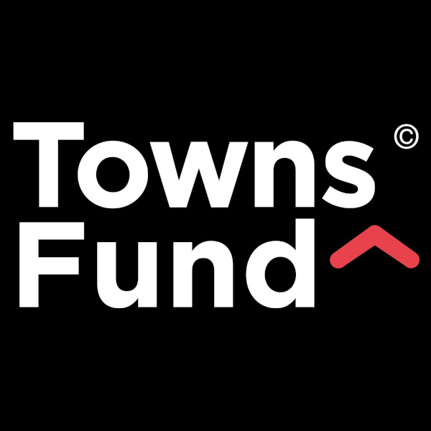

AUGUST 2023
Version 3.0
Published in line with latest guidance for Town Deal Boards (November 2022)
www.gov.uk/guidance/towns-fund-supplementary-guidance-for-town-deal-boards

Revisions Log

Version | Date | Revision
V.1.0 | 31 March 2023 | New, draft Terms of Reference issued for comment to Town Deal Board for comment following Board Member workshop on 2nd March 2023. ToR accompanies Proposals Report
V2.0 | 24 May 2023 | Revisions following decisions at 21 April 2023 Board meeting. ToR circulated to new Board membership for approval
V3.0 | 23 August 2023 | Updated membership

CONTENTS Page
1.0 Purpose and Functions of the Town Deal Board 3
2.0 Roles and responsibilities of Board Members 4
3.0 Membership, Chair and Vice Chair 5
4.0 Chair and Deputy Chair, Term and Responsibilities 5
5.0 Removal of a Member from the Board 6
6.0 Meetings and procedures 6
7.0 Task and Finish Groups 8
8.0 Decision Making and Voting 8
9.0 Declaration of Interest, Gifts and Hospitality 9
10.0 Public Access to Board Meetings 9
11.0 Risk Management 9
12.0 Accountable Body Arrangements 9
13.0 Legal and Procurement 10
14.0 Freedom of Information, information governance and GDPR 11
15.0 Complaints Procedure and Whistle Blowing 11
16.0 Stakeholder Engagement, Communications and protocols 11
17.0 Equality and Diversity 12
18.0 Geographical scope 13

APPENDICES
Appendix 1: Town Deal Board Membership 14
Appendix 2: Board Meeting dates 2023/24 15
Appendix 3: Geographical scope of Hartlepool’s Town Deal 16

- Purpose and Functions of the Town Deal Board

The non-constituted Hartlepool Town Deal Board is established under guidance issued by the Department of Levelling Up, Communities and Housing (DLUHC) to “support the Town Deal Accountable Body (Hartlepool Borough Council) in delivering the vision of the adopted Town Investment Plan (TIP)”
The Board shall be a strategic body bringing together the private, public and community sectors to provide:
- a defined vision and strategy for the delivery of the Hartlepool Town Deal Programme
- leadership and governance in supporting the delivery of the Town Deal programme and projects
- expertise and skills in as part of the delivery of the Town Investment Plan and Town Centre Masterplan
- organisational knowledge and expertise across the programme and projects
- contribute to the collective development of plans and pipelines to secure external funding and investment,
- an evidenced based understanding of the regeneration needs of the Borough, focusing on its assets, opportunities and challenges
- support for the long term delivery of economic and productivity and growth through a) urban regeneration, b) skills and enterprise infrastructure, c) Improved connectivity.
The role of the board is to:
- Oversee the delivery of the adopted Town Investment Plan
- Provide strong governance of the approved Town Deal Programme
- Monitor and evaluate the delivery of the five, approved Town Deal capital projects
- Contribute skills, resources and intelligence to ensure added value across the programme
- Provide ambassadorial duties to maximise the success of the programme on a regional and national level
- Engage the community and wide ranging stakeholders across all projects and the programme
- Ensuring communities’ voices are heard in shaping design and decision making at each phase of project development
- Provide strong, transparent public leadership of the programme which builds trust with people across the town
- Ensuring diversity in engagement with local communities and businesses
- Oversee each step of delivering a Town Deal, and oversee compliance with the Heads of Terms Agreement with government
- Operate within this approved Terms of Reference, which may be reviewed in accordance with any new issued guidance and Board approval. The Board may amend these terms of reference at any time and will be reviewed on an annual basis.

The Board shall undertake its duties and responsibilities in line with the requirements of the Towns Fund Prospectus (2019) and subsequent guidance (2022)
www.gov.uk/guidance/towns-fund-supplementary-guidance-for-town-deal-boards

The business of the Board will be managed in accordance with Hartlepool Borough Councils policies, procedures and codes, where relevant.
- Roles and responsibilities of Board Members

Town Deal Board Members will play an active part in the delivery of the Town Investment Plan, Hartlepool Town Centre Masterplan, Town Deal programme and constituent projects. Members will:
- Demonstrate commitment to the programme, projects and work of the Town Deal Board and Accountable Body
- Bring their own perspectives and experience, contribute to discussion and high quality debate and add value to programme delivery
- Contribute to effective decision making and act as consultee when required
- Provide skills to ensure that the projects are delivered successfully
- Represent their organisation, interest group or sector, and communicate to those groups and sectors on Town Deal, its programme and projects
- Engage positively with other stakeholders and positively communicate on Hartlepool’s Town Deal
- Be recognised for their valuable contribution bringing ideas, knowledge and expertise to the process
- Take a Borough wide perspective and develop consensus in the best interests of Hartlepool
- Act in accordance with the Council’s governance structures for capital delivery and financial management
- Abide by the Nolan Principles of public life and sign and return the Code of Conduct on an annual basis
- Maintain respect for others at all times regardless of gender, race, age, ethnicity, disability, religion, sexual orientation or any other status
The Nolan Principles are as follows:
1. Selflessness: Board Members should act solely in terms of the public interest.
2. Integrity Board: Members must avoid placing themselves under any obligation to people or organisations that might try inappropriately to influence them in their work. They should not act or take decisions in order to gain financial or other material benefits for themselves, their family, or their friends. They must declare and resolve any interests and relationships.
3. Objectivity: Board Members must act and take decisions impartially, fairly and on merit, using the best evidence and without any form of discrimination or bias.
4. Accountability: Board Members are accountable to the best interests of Hartlepool and the principle objectives of the Board.
5. Openness: The Board must act and take decisions in an open and transparent manner.
6. Honesty: Board Members should act with honesty, objectivity and integrity.
7. Leadership: Board Members should exhibit these principles in their own behaviour. They should actively promote and robustly support the principles and be willing to challenge poor behaviour wherever it occurs.

- Membership, Chair and Vice Chair

The Hartlepool Town Deal Board shall comprise of no less than 8, and no more than 12 individuals, representing a wide range of organisations and sectors.

Hartlepool Borough Council is the accountable body and secretariat for the Board and will be represented by the Leader and Managing Director on its membership.

The Board welcomes representatives of the following organisations:

- The Private sector
- The Voluntary Community and Social Enterprise (VCSE) sector
- Anchor institutions including:
- Further Education and Higher Education institutions
- Health Sector
- Cultural and creative institutions
- Tees Valley Combined Authority
- Arms-length bodies and other non-departmental government agencies
- Legal and financial professions
- Environmental bodies

The Member of Parliament for Hartlepool shall be an ex officio member of the Town Deal Board.
The Town Deal Board may call on professional advice, consultants and support for programme and project level specific advice support and delivery. This will include external consultants to support the delivery of the Town Deal Investment Plan, Town Centre Masterplan and individual projects. Individual named Project Managers for each of the five projects will attend the Board to provide progress, monitoring and evaluation reports.
The participants identified may change over time at the discretion of the Chair and Managing Director of the Council. Participants can be removed from the Town Deal Board if they do not adhere to the Terms of Reference.
Participation is by invitation only from Hartlepool Borough Council in consultation with the Chair and Vice Chair. The Membership of the Hartlepool Town Deal Board can be found in Appendix 1.

- Chair and Deputy Chair, Term and Responsibilities

The role of the Town Deal Board Chair is to:
- Uphold the Seven Principles of Public Life (the Nolan Principles)
- Lead the Board in achieving its aims and objectives, maintaining an overview of programme and project activity
- Champion and support partnership working and promote Hartlepool at a regional and national level
- Ensure that decisions are made by the Board in accordance with good governance principles.
- Work in partnership with the Town Deal Programme Lead of HBC to ensure that the programme and projects are delivered
- Provide an independent perspective
- Govern the Head of Terms Agreement with Hartlepool Borough Council and DLUHC
The parameters in which the Chair and Vice Chair roles shall operate are as follows:

- The Board shall operate until 31 March 2026, the end date of the programme Heads of Terms
- Two Members of the Town Deal Board will be will be nominated as Chair and Deputy Chair
- The Board shall appoint a Chair and Deputy Chair who will serve for a period of 18 months before re-election.
- In the absence of the Chair, the Deputy Chair will assume the responsibilities of the Chair
- HBC’s Strategic Development Team (as programme lead and support) will consult with, and report to, the Chair on progress, delivery, spend, monitoring and evaluation
- The Chair may convene an informal meeting of all or some of the Board Members to inform progress of a particular matter arising under the development of individual projects or the programme as a whole.
- The Chair may meet third parties and attend events on any matter pertaining to the Town Deal programme and individual projects to progress activity and outcomes.
- An evaluation of the programme will be undertaken in quarter 4 of financial year 2025/26 and an exit strategy developed for the programme before 31 March 2026

- Removal of a Member from the Board

In the event that a Board Member’s conduct falls short of that expected, has consecutive non-attendance (without a substitute) at Board and / or a breach of the Code of Conduct has taken place, the Board may agree resolution to remove that Board Member from the Town Deal Board.

This may only occur when;

- The Board Member has been given at least 14 days’ notice in writing of the meeting of the Board at which the resolution will be proposed and the reasons why it will be proposed; and
- The Board Member has been given a reasonable opportunity to make representations to the meeting in person and/or in writing. The other Board Members must consider any representations made by the Board Member and inform them of their decision following such consideration.

There shall be no right of appeal from a decision of the Board’s decision and vote to terminate the membership of a Board Member

A Board Member shall cease to be a member of the Hartlepool Town Deal Board in the following meeting if the Board Member gives written notice to the Chair of their notice of Resignation.

- Meetings and procedures

Town Deal Board meetings are a critical part of the successful delivery of the programme and individual projects, play a vital role in developing plans for the long term regeneration of Hartlepool and are a vehicle for discussing and debating important issues.
Meetings will be held within the following parameters:
- Members will endeavour to attend all meetings of the Town Deal Board, however if they are unable to attend any meeting then they should submit their apologies in advance of the meeting.
- Each Member may identify a named substitute in advance of the meeting who may attend on their behalf when necessary, and the substitute must record their attendance at the start of the meeting
- All Board members should appoint named substitutes to the Board. The named substitute will be the only person to attend in the absence of the Board member
- Meetings of the Town Deal Board will be called by the Chair of the Town Deal Board and all dates of meetings to be approved by the Chair
- Meeting dates for 2023/24 are shown at Appendix 2.
- Members (or their names substitute) must attend 75% of Board meetings on a rolling 12 month basis or the Member place will be removed and made available to other individuals / organisations
- The Chair, Vice Chair and Town Deal Programme Lead will hold a pre agenda meeting at least 14 days prior to each meeting
- In order to be quorate, any six members of the Town Deal Board must be present but this must include the Chair (or Deputy Chair).
Meeting papers will be managed within the following parameters:

- The agenda and papers for meetings shall be approved by the Chair
- Proposed Items for the agenda should be communicated to the Strategic Development Team at least 14 days prior to the meeting
- Reports and any appendices should be received electronically by the Strategic Development Team at least 7 days prior to the meeting
- Reports are presented on the agenda in four categories:

- Presentation
- Items for Approval
- Item for Discussion
- Items for Information

- The Strategic Development Team should be informed of any additional persons attending the meeting to present a report or take part in a presentation.
- Papers for the Town Deal Board meetings will be made be distributed electronically to all Board Members by the Strategic Development Team at least 7 days prior to the meeting.
- Copies of papers for meetings will be made publically available on the Hartlepool Borough Council website within 7 days of the meeting unless they contain exempt information under Schedule 12A Local Government Act 1972 (as amended by the Local Government (Access to Information)
- Approved minutes shall be published on the Town Deal pages of the Council’s website within 10 working days of the Board meeting
- Approved minutes shall be published on the Council’s website following the subsequent Board meeting

Minutes shall be kept of the Town Deal Board meetings and accuracy of the minutes shall be the responsibility of the meeting Chair. Minutes shall remain draft until formally approved by the subsequent meeting Chair. Any queries arising from minutes shall be raised at the subsequent meeting and the Council has responsibility for ensuring that accurate minutes are kept for all meetings.

Urgent meetings
Urgent Meetings will be held within the following parameters:
- An urgent meeting can be called by the Chair with a minimum of 5 working days notice to Board Members
- Members will endeavour to attend the urgent meeting
- Each Member may identify a named substitute in advance of the urgent meeting
- The Urgent Meeting of the Town Deal Board can be called by the Chair
- Attendance of the urgent meeting will not contribute to the attendance requirements of 75% of Board meetings
- The Chair, Vice Chair and Town Deal Programme Lead will hold a pre agenda meeting prior to the urgent meeting
- In order to be quorate, any six members of the Town Deal Board must be present but this must include the Chair (or Deputy Chair).

Urgent meeting papers
Urgent meeting papers will be managed within the following parameters:
- The agenda and papers for meetings shall be approved by the Chair
- Proposed Items for the agenda should be communicated to the Strategic Development Team at least 2 days prior to the meeting
- Reports and any appendices should be received electronically by the Strategic Development Team at least 1 day prior to the meeting
- Papers for urgent meetings will be made be distributed electronically to all Board Members by the Strategic Development Team prior to the meeting.
- Copies of papers for meetings will be made publically available on the Hartlepool Borough Council website within 7 days of the meeting

- Task and Finish Groups

At the approval of the Chair, the Hartlepool Town Deal Board may establish a Task and Finish Group to undertake a specified action or piece of work, which requires focussed activity or where a more specialist membership is required. The formation of a Task and Finish Group should be bound by the following parameters:

- The group and rationale must be proposed to the Board and be approved by the Chair
- Be time limited with specific end date identified for the completion of the work and / or achievement of the specified outcome with milestones articulated
- Proposed membership of the group must be identified with agreement of those individuals / organisations, including a Chair whose responsibility will be to report to the Board
- External stakeholders may be proposed as members of the group where the particular expertise, skills and knowledge is required
- A clear remit, outcome(s) and scope of work must be identified prior to formation of the group
- The group will report directly to the Town Deal Board

Membership of the sub group will be agreed by the Board.

- Decision Making and Voting

Discussion, challenge, debate, consensus and decision making are vital parts of the Board’s governance function. The Programme Lead, Project Managers and other individuals will report to the Board on a regular basis on wide ranging matters and often a decision is required of Board to expedite delivery. Decisions may be required of Board in a number of areas and may include (but not limited to):

- Membership and nominations
- Amendments to Terms of Reference and ways of working
- Programme level activity such as spend, communications and engagement
- Financial re-profiling, granting funds, project adjustments and programme amendments
- Adoption of strategies and plans
- Risk management

The parameters by which decisions will be made are as follows:

- Each Member of the Board (or their attending substitute) shall have one vote which may be cast on matters considered at the meeting by a show of hands
- Votes can only be cast by members (or their substitute) attending a meeting of the Board.
- Any decision of the Board must be a majority decision at a meeting. In the event of a tied vote the Chair will have a casting vote

- Declaration of Interest, Gifts and Hospitality

Each member of the Town Deal Board is required to declare any personal, prejudicial or disclosable pecuniary interest (direct or indirect) in any agenda items. Where an interest is prejudicial or is otherwise a disclosable pecuniary interest the member shall take no part in the discussion or decision making about that item. All such declarations must be included in the minutes of the meeting.

Board Members shall duly sign and return the Hartlepool Town Deal Boards Declaration of Interests on an annual basis. A Register of Interests will be maintained by the Council. The Council will provide guidance on the pecuniary and non-pecuniary interests individuals must declare, outline the process that Board members must follow for declaring interests and explain the process for requesting an exemption.

The Council has a Declaration of Offers of Hospitality and Gifts policy and the Board Members are required to abide by the terms of that policy.

- Public Access to Board Meetings

The Town Deal Board will be closed to the public and press unless invited. Observers will not be allowed to comment or address the Town Deal Board unless asked to do so by the Chair. The Town Deal Board Secretariat should be informed of any persons attending the meeting to observe in advance.

Members of the public may wish to contact the Town Deal Board and any such contact will be managed by the Strategic Development Team who will engage with the Chair and/or wider Board to seek approval for attendance.

11.0 Risk Management
The Town Deal Board will take a planned and systematic approach to identifying, evaluating and responding to risks. It will consider the full range of activities and responsibilities and regularly ensure that strong risk management disciplines are in place across a range of areas including strategic, financial, legal and delivery risks. An annual risk review of the programme will be undertaken by the Risk Review Group (membership at Appendix 1) and report to the Town Deal Board.

The responsibilities of the Board, working in partnership with the Strategic Development Team and project owners, for risk management are as follows:

- A programme level Risk Register will be in place, reviewed annually
- Each individual capital project will have a risk register in place, reviewed annually
- Risk management will be a standing item at each Town Deal Board meeting
- The Board will have a named Risk Management champion who will work alongside the Programme Lead to report regularly to Board
- The risk register will link to the Council’s Strategic Risk Register, as the accountable organisation for the £25m programme

12.0 Accountable Body Arrangements

Hartlepool Borough Council (acting as Lead Council and Accountable Body) is responsible for the following:
- Upholding the Seven Principles of Public Life (the Nolan Principles)
- The Heads of Terms Agreement with government
- Accountable body for all monies received from DLUHC through Town Deal, and any other additional funding allocated from the Department for the programme
- Receiving and accounting for all funding allocations under the Towns Fund
- Ensuring compliance with the Subsidy Control regime for the programme and individual projects. This includes ensuring third parties such as those grant funded for the delivery of individual schemes maintain compliance with the regime through contractual agreements
- Monitoring and evaluating the delivery of individual Towns Fund projects and the programme and submission of all reports to DLUHC
- Maintaining a reporting dashboard documenting project and programme progress, spend, milestones, outcomes and outputs
- Funding Assurance, Private Sector funding assurance, Project Adjustment Request’s, and Chief Finance Officer Assurance with DLUHC
- Co-ordinating the delivery team, delivery arrangements and agreements and ensuring that the capital projects are mandated and report to the Councils Programme Management Forum and Capital Programme Board
- Providing Secretariat and support arrangements for the Town Deal Board and task and finish groups
- Developing and administering all grant agreements with third parties for the delivery of the individual projects
- Ensuring that decisions are made by the board in accordance with good governance principles
- Ensuring transparency requirements are met through publication of information on the HBC website, and maintaining an active YourSay website for the programme and projects
- Developing a Communications and Engagement Strategy and action plans in partnership with Stakeholders
- Be represented on the Board by the Leader and Managing Director of the Council and will be the formal link between the two bodies in the delivery of the programme.
- Reporting to both the Council’s Finance and Policy Committee and Economic Growth and Regeneration Committee in line with the Council’s Constitution.

13.0 Legal and Procurement

The Town Deal Board is not a legal entity nor the accountable body for any grant or funding received from DLUHC. This Terms of Reference does not change, replace, substitute or amend in any way the statutory duties or other responsibilities of partners. It does not change, replace, substitute or amend in any way partner’s own management or accountability frameworks.

The National Procurement Strategy for Local Government defines procurement as "The process of acquiring goods & services to meet the customer's requirement while achieving the optimum combination of whole life costs & benefit". Town Deal expenditure, including that executed by third parties through contractual and grant agreements, will be managed in line with the Council’s procurement strategy, policies and procedures and includes the:
- Supply or disposal of goods or materials.
- Hire, rental or leasing of goods or equipment.
- Execution of works.
- Delivery of services, including those offered by consultants.

14.0 Freedom of Information, information governance and GDPR

The Freedom of Information Act (2000) creates a general right of access to all types of recorded information held by most UK public authorities, including Hartlepool Borough Council. It also sets out exemptions and places a number of obligations on us to provide the right to access information. The council as the accountable body for Town Deal is responsible for the management of information under a number of pieces of legislation including FOI.

The Council's Information Governance framework sets out the way HBC handles information, in particular, the personal and sensitive data relating to our service users, providers, partners and employees. The framework determines how data is collected and stored, and specifies how that data is used and when and how it can be shared confidentially. Information Governance ensures both HBC and individuals deal with personal information legally, securely, efficiently and effectively.

The framework also encompasses the General Data Protection Regulation (GDPR) legal framework which came into force in 2018. This legislation provides a framework for keeping everyone's personal data safe by requiring organisations to have robust processes in place for handling and storing personal information.

The Town Deal Board will be administered in accordance with, and will operate within, these information governance frameworks.

15.0 Complaints Procedure and Whistle Blowing

Hartlepool Borough Council is keen to ensure that all board members, partners and residents are happy with the procedures and arrangement in place for the board.

If however an individual is dissatisfied they should first of all verbally raise their concern with
a member of the Town Deal Board Secretariat team who will endeavour to resolve the problem quickly and amicably.
Where it is alleged that the Board is acting in breach of the law or failing to safeguard public funds the whistleblowing procedure of the Council will be applied.
In the event of the issue not being resolved the individual should then make a formal complaint, in writing, to the Chair detailing the nature of the complaint. The Chair will then ask the Managing Director of Hartlepool Borough Council to investigate in line with the Council’s Corporate Complaints Procedure which can be found on the website below: https://www.hartlepool.gov.uk/info/20004/council_and_democracy/429/complaints_comments_and_compliments.

16.0 Stakeholder Engagement, Communications and protocols

The Town Deal Board will engage proactively and positively with stakeholders through an adopted Communications and Engagement Strategy. The strategy will set out the principles of:
- Engaging with our communities so that they can have an active role in shaping the delivery of the Town Deal programme.
- Support our communities to take part and deliver on local priorities by providing them with opportunities to develop their skills, confidence, and local networks
- Strengthen the bonds between our communities, improve tolerance and understanding and reduce tensions
The Town Deal Board will be committed to working with all local stakeholders in a consistent, collaborative, inclusive and open manner to deliver the Town Deal programme Hartlepool. This will be achieved by:
- Keeping a wide a range of stakeholders informed of the programme utilising a variety of methods and tools including the YourSay engagement platform, a communications and engagement plan, presentations and discussion forums
- Listening to our stakeholders
- Ensuring that we work in partnership with other people, businesses and organisations where this adds value to the engagement process.
- Working with local people, businesses and organisations to understand the range and type of information that they are interested in

To achieve effective engagement the Town Deal Board will inform, consult and involve stakeholders as follows:

Inform:
The board will provide information about events, opportunities to get involved and decisions made relating to the programme and projects. This will be achieved through the website, YourSay, newsletters and email updates, social media, press releases and displays.

Consult:
The board will invite community and stakeholder opinion on the issues facing Hartlepool and how these can be addressed through the Town Investment Plan and Towns Fund Programme.

Involve:
The Board will work with stakeholders to ensure that issues are understood and debated. This will be achieved through the Consultative Forum and Focus groups and workshops.

Press and media enquiries shall be referred to the Chair and the Council before any official statement is made by individual members of the Town Deal Board.

17.0 Equality and Diversity

The​ Public Sector Equality Duty (PSED) is part of the Equality Act 2010. The PSED requires public bodies in carrying out their functions to have due regard to the need to achieve the objectives set out in Section 149 of the Equality Act 2010. These objectives are:
- Eliminate discrimination, harassment, victimisation and any other conduct that is prohibited by or under the Equality Act 2010;
- Advance equality of opportunity between persons who share a relevant protected characteristic and persons who do not share it;
- Foster good relations between persons who share a relevant protected characteristic and persons who do not share it.​
Hartlepool Borough Council as the accountable body is committed to promoting a community and organisational culture that fully respects and values everyone’s differences and needs. Equality, diversity and inclusion is integral to the Council’s core business, employees and service users, and adopted its latest Equality, Diversity and Inclusion Policy in March 2023. The Town Deal Board will operate under this policy.

18.0 Geographical scope

The Towns Fund Programme will cover the area outlined in the map at Appendix 3 and any revisions to the geographical scope must be proposed by the Board, through agreement and agreed with the Government.

Strategic Development Team

Development & Growth
Hartlepool Borough Council
Tel: 01429 806858
Mob: 07812 486607

Email: paul.taylor2@hartlepool.gov.uk

APPENDIX 1: Membership of the Hartlepool Town Deal Board as at June 2023
No. | Position | Name | Organisation | Sector
1 | Chair | Darren Hankey | Hartlepool College of Further Education | Education and skills
2 | Vice Chair | Maxine Craig | Independent | Independent
3 | Board Member | Councillor Mike Young – Leader | Hartlepool Borough Council | Local Government
4 | Board Member | Denise McGuckin – Managing Director | Hartlepool Borough Council | Local Government
5 | Board Member | Elizabeth Hutchinson | Tees Valley Combined Authority | Local Government
6 | Board Member | Reshma Begum | Federation of Small Businesses | Business
7 | Board Member | Roslyn Adamson | National Museum of the Royal Navy | Cultural
8 | Board Member | Martin Raby | Northern School of Art | Education and skills
9 | Board Member | Gary Wright | North Tees and Hartlepool NHS Foundation Trust | Health
10 | Board Member | Linda Hunter | North Tees and Hartlepool NHS Foundation Trust | Health
11 | Board Member | Toni Rhodes | Hartlepool 6th Form College | Education and skills
12 | Board Member | Vacant | Vacant | Vacant

Observers
N/A | Observer | Jonathan Gilroy | DLUHC | Public

Ex Officio members
N/A | Board Member | Jill Mortimer MP | Member of Parliament | Public

Membership of the Annual Risk Review Group
No. | Name | Organisation
1 | Ros Adamson | National Museum of the Royal Navy
2 | Toni Rhodes | Hartlepool 6th Form College
3 | Paul Taylor | Hartlepool Borough Council

APPENDIX 2: Town Deal Board meeting dates 2023/24
Date | Time | Venue
2023
Friday 21st April | 9am – 11am | ONLINE – TEAMS
Tuesday 6th June | 9.00am – 11am | ONLINE – TEAMS
Tuesday 5th September | 11.00am – 1.00pm | ONLINE – TEAMS
Thursday 7th December | 9.00am – 11am | TBC
2024
Tuesday 5th March | 1.00pm – 3.00pm | TBC
Thursday 6th June | 9.00am – 11am | TBC
Tuesday 3rd September | 1.00pm – 3.00pm | TBC
Thursday 5th December | 9.00am – 11.00am | TBC

APPENDIX 3: Geographical scope of Hartlepool’s Town Deal
The scope of the Town Deal programme is as follows:

The red line boundary of each of the five project sites as set out in the approved Business Cases for the following projects:

- Reimagining Middleton Grange
- Waterfront Connectivity
- Wesley Chapel
- Health and Social Care Academy
- Civil Engineering Academy (Brenda Road)
- Civil Engineering Academy (Exeter Street)

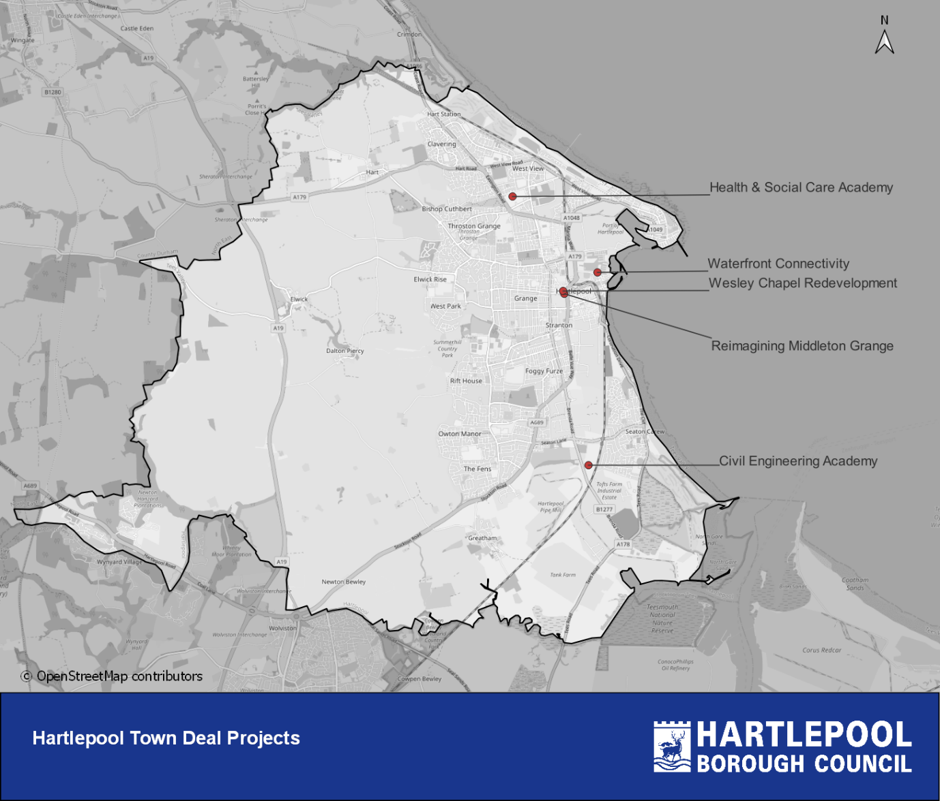

APPENDIX 3 Draft Communications and Engagement Strategy

(Separate document)

