Street Trading Pitch



Street Trading Pitch
Elephant Rock, Headland Promenade, Hartlepool
12 month duration


TO LET BY INFORMAL TENDER
Closing Date: midnight, Sunday 28th April 2024

ALL ENQUIRIES TO:
Daniel Garthwaite, Active & Creative Hartlepool, Level 4, Civic Centre, Victoria Road, Hartlepool, TS24 8AY

Tel: (01429) 523599 or 07824523664
Email Daniel.garthwaite@hartlepool.gov.uk

Street Trading Pitch

Tenders are invited for this exciting opportunity to occupy a prime trading pitch at Elephant Rock on the Headland Promenade for a 12 month period (start date subject to tender process and Street Trading Consent).

Elephant Rock is an award winning, purpose designed, outdoor events and performance space that was completed and opened in 2022. Elephant Rock is popular for informal leisure activities (i.e. walking; running; cycling) and also acts as a venue for Hartlepool Folk Festival, Wintertide Festival and Headland Carnival. From spring 2024 onwards, the Council’s intention is to develop a varied, seasonal programme of activities and events at the site.

Tenders are invited to occupy a pitch at the site as approximately shown on the adjacent plan. We are therefore looking for a reputable operator to operate mobile catering vehicles/ units from this pitch.

Please note that this tender is for the right to occupy land and the successful applicant will have to apply for a Street Trading Licence and will be responsible for all associated costs. Additional permissions, such as Food Registration, may be required and the successful applicant will be required to take part in the Local Government food hygiene rating scheme (The cost of these is to be borne by the winning tenderer). Tenderers should make their own enquiries regarding what they will need, to enable them to trade legally, safely and facilitate their proposals.

Due to the site’s proximity to Heugh Gun Battery Museum café, the successful tenderer will not be permitted to sell cake, pastries, ice creams or dog foods (such as treats and ice creams).

The successful tenderer will be able to operate throughout the year (subject to agreement of exact days and times with Hartlepool Borough Council). The right to operate within an agreed location for during events such as Hartlepool Folk Festival, Wintertide Festival and Headland Carnival will be subject to consultation with Hartlepool Borough Council and the respective event organisers.

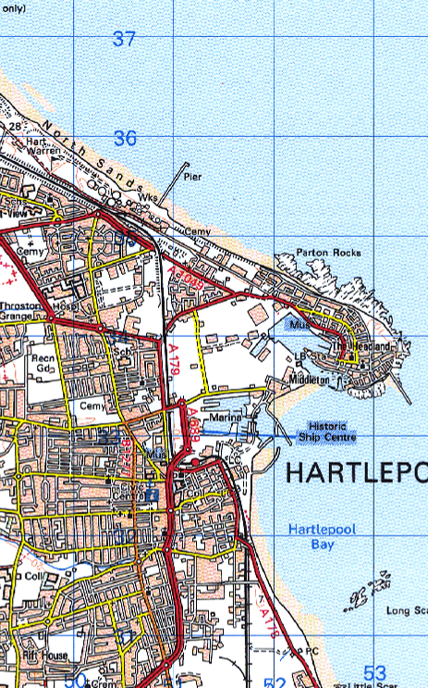
Street Trading Location

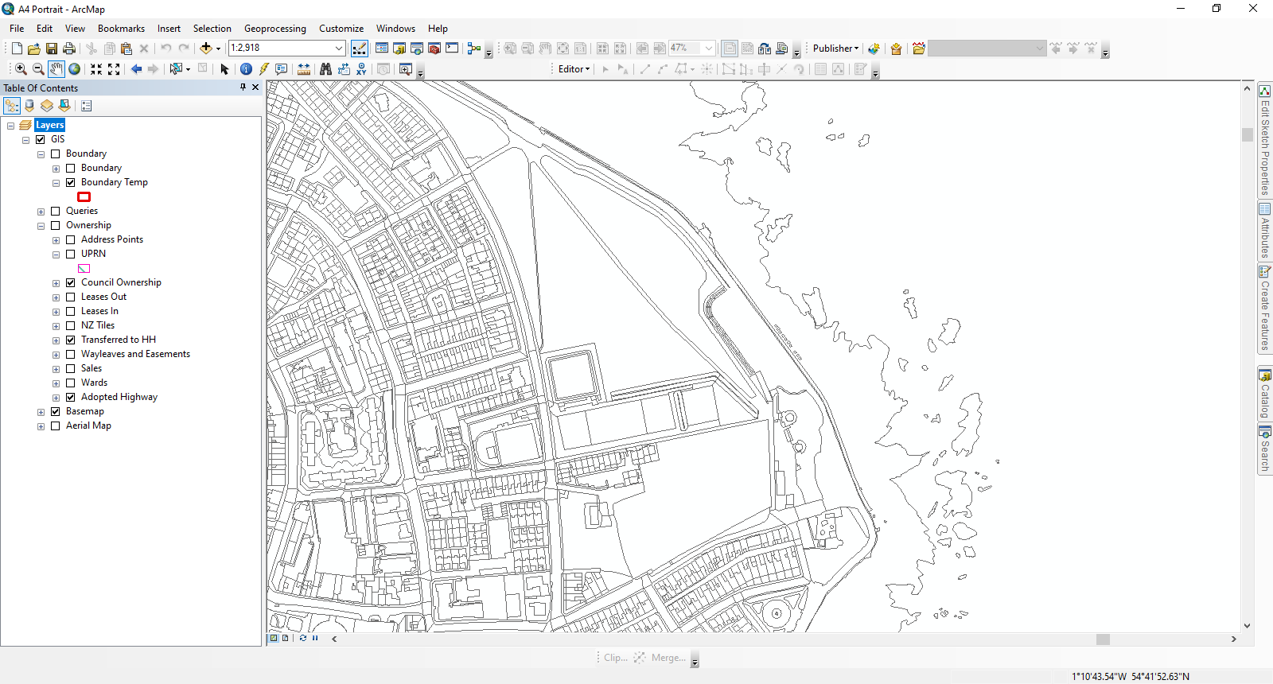

To Let by Informal Tender
Approximate Location of Pitches

Terms
Anyone interested in occupying the pitch must submit a tender, which must include:

- Bidders proposed conditions for taking the trading pitch

- Tenders must include rental offer and outline details of proposals including what will be sold from the pitch

- Proposed hours of occupation

- Draft menu

- Details of appropriate insurances

- Evidence of previous positive, collaborative working, including at least one reference, provided by a former or current landowner

The tender is to be submitted via email to Daniel.Garthwaite@hartlepool.gov.uk

Exact areas to be occupied are to be agreed subject to onsite restrictions.

Any licence to occupy land is to be granted subject to obtaining a Street Trading Consent at a cost of £1,445 per annum.

Generators must be diesel, tamper proof and shielded in order to reduce noise in the interest of nearby residents.

Tenderer to ensure all staff hold a minimum level 2 food hygiene award

All offers must be submitted by midnight, Sunday 28th April 2024.

All offers are to be based on the terms set out within these Particulars.

It should be noted that the Borough Council does not undertake to accept the highest or any offer and that any offer is made subject to formal approvals.

Persons submitting offers shall be deemed to have visited and inspected the site and to be submitting their offer with full knowledge of its condition and any access restrictions.

All necessary statutory consents are to be obtained by the purchaser at their own cost prior to the commencement of development.

The purchaser will be required to keep the property in a tidy state at all times following purchase and during development.
Misrepresentation Act 1967
Hartlepool Borough Council gives notice that:

1. These particulars do not constitute any part of an offer or contract.

2. None of the statements contained in these particulars as to the property(s) are to be relied upon as statements of or representations of fact.

3. Any intending licensees must satisfy themselves by inspection or otherwise as to the correctness of each of the statements contained in these particulars.

4. Hartlepool Borough Council does not make or give any representation or warranty whatsoever in relation to the property(s).

5. None of the building services or service installations (whether these be the specific responsibility of the freeholder(s), lessor(s) or lessee(s)) have been tested and are not warranted to be in safe working order.

Property Misdescriptions Act 1991
Every reasonable effort has been made by Hartlepool Borough Council to ensure accuracy. Interested parties are strongly advised to take appropriate steps to verify by independent inspection or enquiry all information for themselves and to take appropriate professional advice.

Finance Act 1999
Unless otherwise stated all prices stated are exclusive of VAT.

Tenderers are requested to submit tenders on the basis outlined above

