To Let
(by Informal Tender)

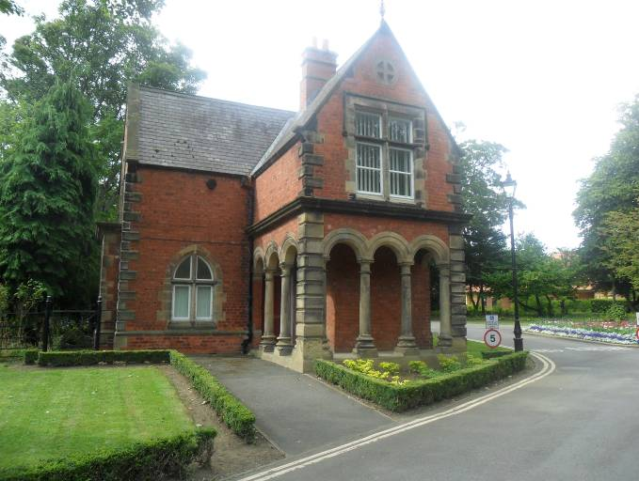

Ward Jackson Park Lodge

Elwick Road, Hartlepool TS26 0EA
Closing Date 12 Noon, Friday 2nd May 2025

All enquiries to:

Tel: (01429) 523208 Email: gerard.darby@hartlepool.gov.uk

Description

A grade ll listed former park keeper’s lodge situated at the southern entrance to the picturesque Ward Jackson Park with parking for 5 vehicles.

Location

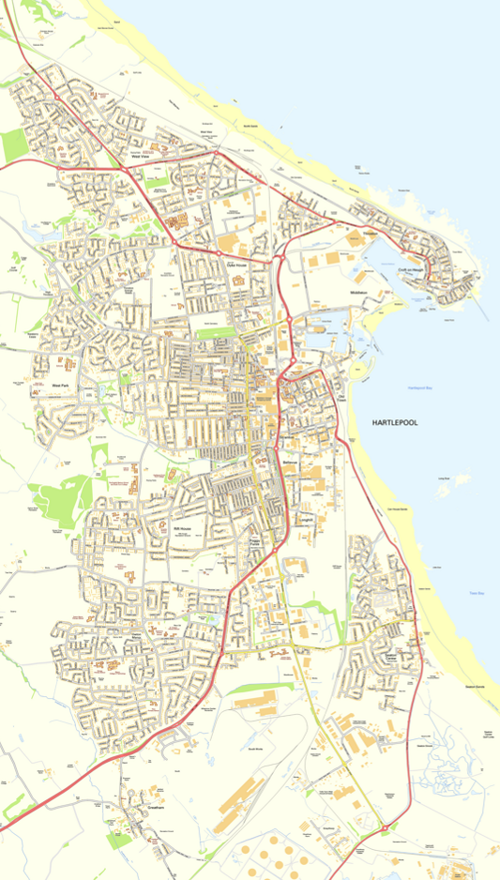
Ward Jackson Park Lodge

Demised Area

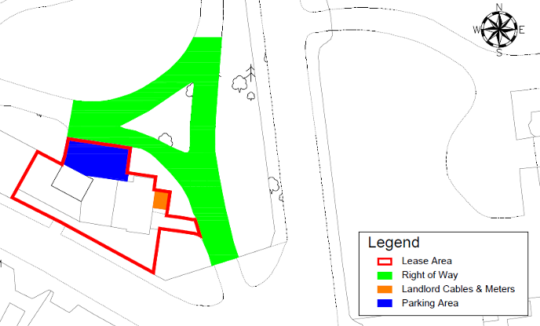

Accommodation

The accommodation comprises:

Ground Floor

Office – 6.67m² separate external access.

Office – 11.18m²

Office – 12.85m²

Kitchen – 11.16m² Stainless steel sink unit and range of laminate base and wall units with worktop, wall mounted gas central heating boiler, tiled splash back, and radiator

Two WC’s - 1.21m x 0.94m with toilet, wash hand basin, and radiator

First Floor

Office – 16.06m²

Office- 11.25m²

Office – 10.42m²

External Store 27.48m²

Planning

The property has planning permission for office use although other uses may be acceptable subject to planning permission.

Services

As far as we are aware the property has the benefit of mains supply of gas, water, and electricity in addition to mains drainage. Interested parties should make their own enquiries in this regard.
.
Energy Performance Certificate

The property has an EPC rating of E and this can be viewed at Energy performance certificate (EPC) – Park Lodge Ward Jackson Park Hartlepool

Rating Assessment

The current rateable value for the property is £3,800 with the current small business multiplier £0.499.
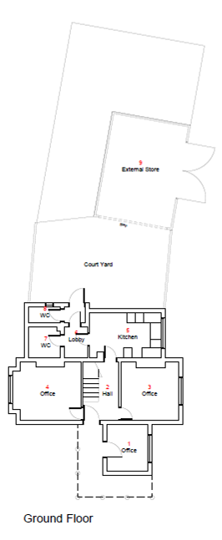

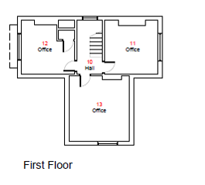

Proposed Lease Terms

Term

Interested parties are invited to include in their bid their preferred term which should be between 3-10 years.

User Condition

The property will be leased with a specific condition that it is to be used in accordance with the use proposed by the tenant and in accordance with any terms imposed if planning permission for a change of use is required and obtained.

Repairs

The tenant is to be responsible for the repair and maintenance of the property.

Insurance

The Landlord will continue to insure the building but the tenant will be recharged the premium cost. The tenant will be responsible for contents insurance.

Assignment

Not permitted

Outgoings

All tenants’ responsibility

Rent

Offers over £5,000 p.a. invited.

Rent Review

Every three years, upwardly only.

Rent Deposit

The tenant will be required to pay a rent deposit of one month’s rent prior to commencement of the lease.

Costs

The tenant will be responsible for the following costs: Landlords Surveyor Fees: 10% of agreed annual rent (minimum £500) Landlords Legal Fees (minimum £500).

Supporting Information

The prospective tenant must provide two trade and a personal reference. New businesses will be considered on an individual basis.

VAT

VAT will not be payable on rent.
Security of Tenure:
The lease shall not have security of tenure and Sections 22 to 28 of the Landlord and Tenant Act 1954 shall be excluded from the agreement. The tenant shall sign the required declaration prior to the signing of the lease.
Viewing and enquires
Please contact Gerard Darby on (01429) 523208 or email gerard.darby@hartlepool.gov.uk

Closing Date for receipt of tenders

12 noon Friday 2nd May 2025

General Conditions

All offers are to be based on these Particulars and Interested parties shall be deemed to have visited and inspected the property and to be submitting their offer with full knowledge of its condition.

Any necessary statutory consents are to be obtained by the tenant at their own cost.

Misrepresentation Act 1967

1. These particulars do not constitute any part of an offer or contract.

2. None of the statements contained in these particulars as to the property are to be relied upon as statements of, or representations of fact.

3. Interested parties must satisfy themselves by inspection or otherwise as to the correctness of each of the statements contained in these particulars.

4. The Council does not make or give any representation or warranty whatsoever in relation to the property and no person in the employment of the Council has any authority to make or give any representation or warranty whatever in relation to this property

5. None of the building services or service installations have been tested and are not warranted to be in safe working order.

6. The council is not bound to accept the highest offer made, or any offer, and will accept no responsibility for any costs

Consumer Protection from Unfair Trading Regulations

Every reasonable effort has been made by the Council to ensure accuracy. Interested parties are
however strongly advised to take appropriate steps to verify by independent inspection or enquiry all information for themselves and to take appropriate professional advice.

West Facing View

South Facing View

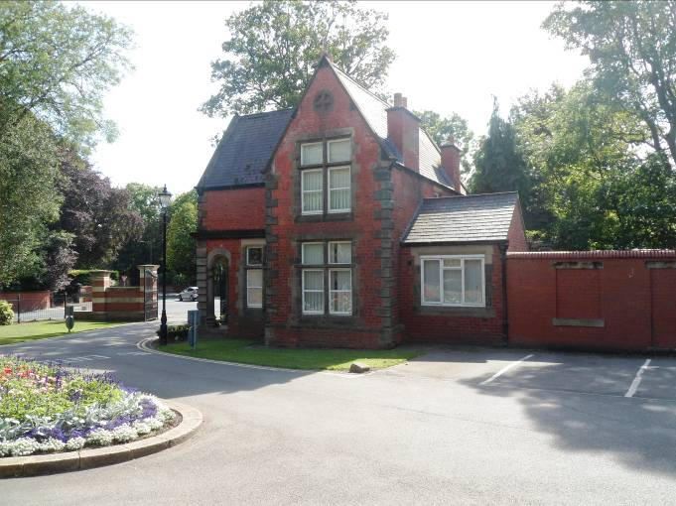

FF Office

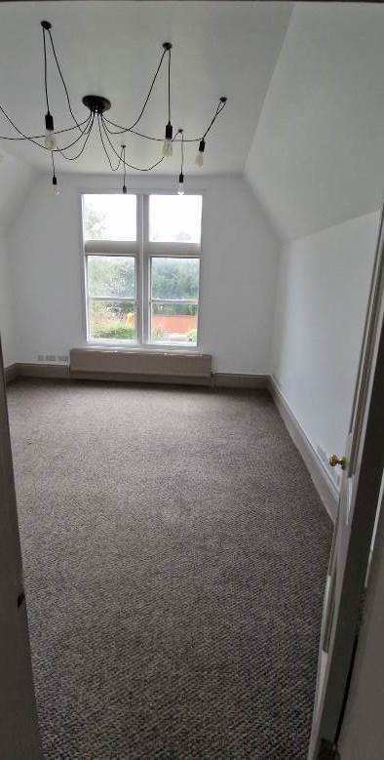

FF Office

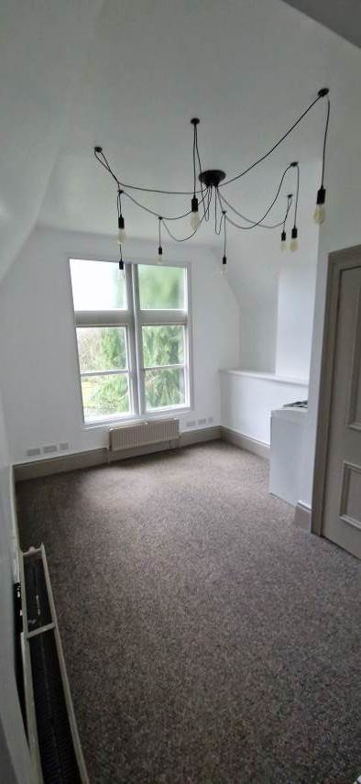

GF Office

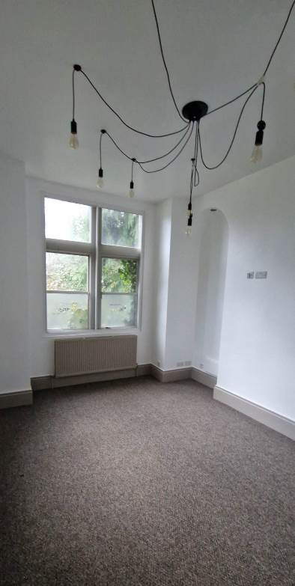

Kitchen

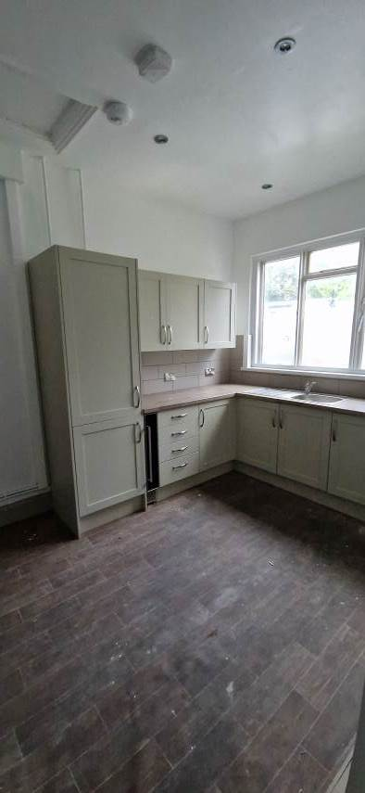
WC

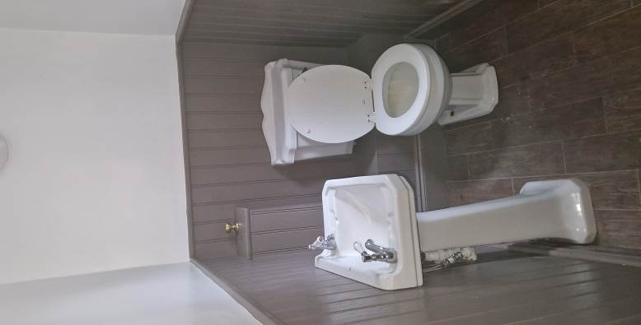

WC

