**­­­­­­­­­­­­­**

**To Let**

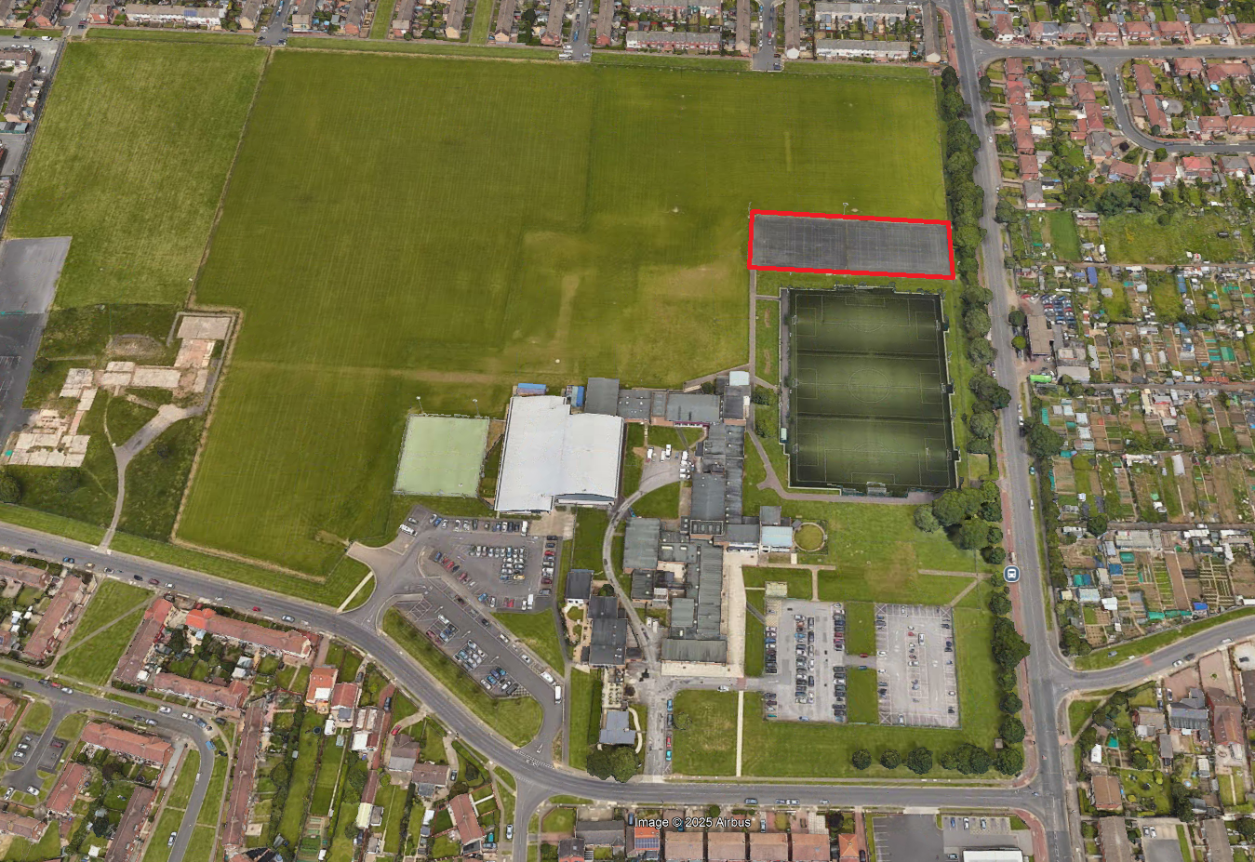

**Approximately 3,200 sq./m of Land at Brierton Sports Centre, Brierton Lane, Hartlepool, TS26 0EA**

**Closing Date:** 12 Noon, Friday 12th September 2025

**Enquiries to:**

**Tel:** (01429) 523282

**Email**: [Craig.Temple@hartlepool.gov.uk](mailto:Craig.Temple@hartlepool.gov.uk)

**Description**

Brierton Sports Centre is an established sports and education facility located in a residential area with on- site parking. The site has car parking, hard standing footpaths to and from the courts and disabled access/ ancillary facilities.

The opportunity has arisen for a suitable operator to lease an area of land at the facility for sport uses (subject to agreement/ planning consent).

The successful operator may be granted use of changing and toilet facilities within the Brierton Sports Centre’s standard opening hours, which are currently Monday - Friday 7am - 9pm and weekends 8am -4pm.

**Site Area/ Accommodation**

The site measures approximately 3,200 sq./m currently laid out as 6 no. tarmac tennis courts.

**Location**

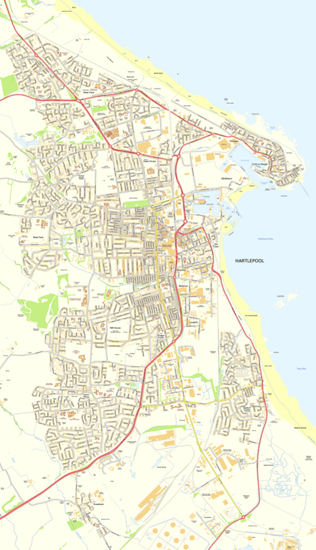

**Approximate Location of Brierton Sports Centre**

**Site Plan**

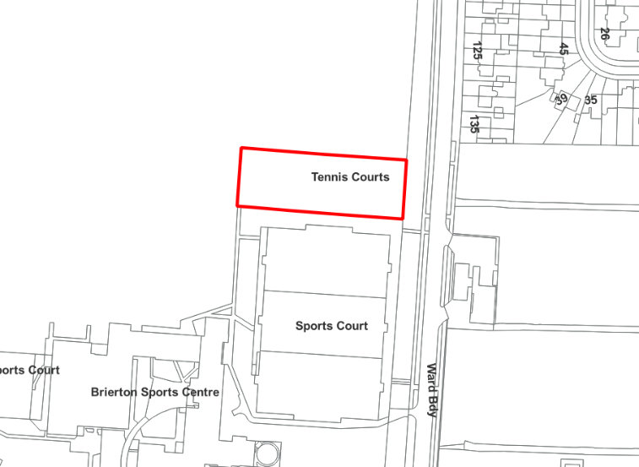

**Brierton Lane**

**Photos**

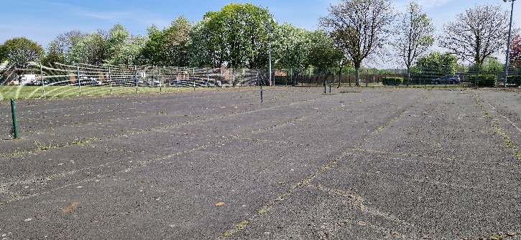

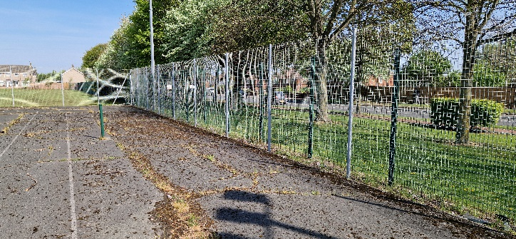

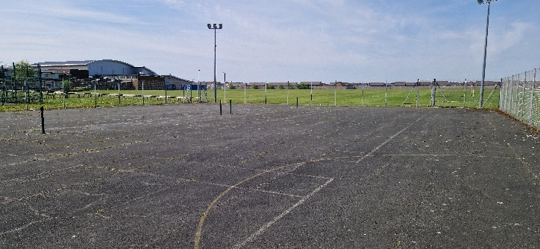

**Conditions of Lease**

All offers are to be based on these Particulars and Interested parties shall be deemed to have visited and inspected the property and to be submitting their offer with full knowledge of its condition.

Any necessary statutory consents are to be obtained by the tenant at their own cost.

**Rent**

Offers over £2,400 per annum are invited

**Rent Review**

Every three years, upwardly only

**Repairs**

The tenant is to be responsible for the repair and maintenance of the property including floodlighting

**Services**

The land has existing floodlighting installed. The electricity supply for this lighting is fed from the Brierton Sports Centre. Assuming it kept this way, usage will be monitored and recharged to the tenant at appropriate intervals. Charges will also need to be made if toilets and changing rooms are to be utilised.

**Term**

Interested parties are invited to include in their bid their preferred term which should be between 3-10 years.

**User Condition**

The property will be leased with a specific condition that it is to be used in accordance with the use proposed by the tenant and in accordance with any terms imposed if planning permission for a change of use is required is obtained.

**Insurance**

The Tenant will be responsible for obtaining their own liability insurance

**Assignment & Subletting**

Not permitted

**Outgoings/ Business Rates**

Tenants’ responsibility

**Costs**

The tenant will be responsible for the following costs: Landlords Surveyors Fees: £500, Landlords Legal Fees subject to a minimum of £500.

**Supporting Information**

The prospective tenant must provide 2 trade and 1 personal reference. New businesses will be considered on an individual basis

**Security of Tenure:** The lease shall not have security of tenure and Sections 24 to 28 of the Landlord and Tenant Act 1954 shall be excluded from the agreement. The tenant shall sign the required declaration prior to the signing of the lease.

**VAT**

The property has not been elected for VAT therefore no VAT will be payable on rent.

**Tenders**

Bids are to be submitted in writing before the Closing Date. Bids should be sent in an envelope marked “Brierton Sports Centre Tender” and posted to *Strategic Asset Management, Civic Centre, Victoria Road, Hartlepool, TS24 8AY*

**Viewing and enquires**

Please contact Craig Temple on 01429 523282 or [craig.temple@hartlepool.gov.uk](mailto:craig.temple@hartlepool.gov.uk)

**Consumer Protection from Unfair Trading Regulations**

Every reasonable effort has been made by the Council to ensure accuracy. Interested parties are however strongly advised to take appropriate steps to verify by independent inspection or enquiry all information for themselves and to take appropriate professional advice

**Misrepresentation Act 1967**

1. These particulars do not constitute any part of an offer or contract.

2. None of the statements contained in these particulars as to the property(s) are to be relied upon as statements of or representations of fact.

3. Any intending lessees must satisfy themselves by inspection or otherwise as to the correctness of each of the statements contained in these particulars.

4. The Council does not make or give any representation or warranty whatsoever in relation to the property(s) and no person in the employment of the Council has any authority to make or give any representation or warranty whatever in relation to this property

5. None of the building services or service installations have been tested and are not warranted to be in safe working order.

6. The council is not bound to accept the highest offer made, or any offer, and will accept no responsibility for any costs