

Domestic Abuse
Needs Assessment
2024/2025

- Summary
- Introduction
- Data and Intelligence
- Which population groups are most at risk?
- Consultation and engagement
- Strategic issues
- Evidence base
- What is being done and why?
- What needs are unmet?
- What needs to be done?
- What additional needs assessment is required?
- Key contacts and references
- Appendices

- Summary
The most recent needs assessment in Hartlepool was published in 2021, followed by Hartlepool’s Domestic Abuse Strategy: Building a System Based on Lived Experience 2022-2025. The purpose of this document is to refresh and review the level of need for domestic abuse services, including –
- safe accommodation
- the extent of unmet need and gaps in provision
- the effectiveness of current service provision

It will also make recommendations of meeting need and using resources effectively and efficiently.

It will build on progress already made since 2021, combining national data and research with the local context of Hartlepool to continue conversations with stakeholders, commissioners and partner agencies about the future of domestic abuse services in Hartlepool and inform the development of the Domestic Abuse Strategy for 2026 and inform the commissioning of domestic abuse services.

The below strategic issues are a summary of the needs that have been identified throughout this needs assessment.

Issue number | Strategic issue? | What needs to be done?
1 | There is an insufficient availability of support services for victims and survivors of domestic abuse, particularly for those who are hidden from services or have complex needs. This limits early intervention and identification of domestic abuse, recovery, and long-term safety. | - Early intervention and prevention. Awareness raising and promotion of services, especially with hidden victims (such as those with disabilities, from ethnic minority groups or different cultural backgrounds and male victims) and those with complex needs  - Utilise existing service user forums to ensure that victim and survivor voice informs the commissioning and delivery of services  - Ensure services are accessible, trauma-informed and use professional curiosity when individuals decline their service or do not engage  - Provide training to multi-agency practitioners in recognising and responding to domestic abuse and ensure that practitioners are aware of the many forms of domestic abuse and the definition of ‘personally connected’ covering intimate partners and family members  - Ensure pathways and information sharing is robust, including MARAC, MATAC and HRAP  - Consider alternative safe accommodation options including specialist, by and for and move-on.  - Review the proportion of out of area referrals both in and out of Hartlepool.  - Consider a multi-agency dashboard to create consistency in the recording and reporting of data relating to domestic abuse  - Understand the effectiveness of the Domestic Violence Disclosure Scheme (Clare’s Law).  - Continue to implement the Safe and Together model across multi-agency partners to standardise the response victims receive
2 | Children affected by domestic abuse are not consistently recognised as victims in their own right, and current services are not always responsive to their needs—whether in the home, in their own relationships, or in cases of child/adolescent to parent violence and abuse (CAPVA). | - Focus on early intervention and prevention to ensure all children understand healthy relationships  - Ensure all services are recognising children as victims in their own right  - Ensure therapeutic support services are available for children  - Review the prevalence of CAPVA, the demand on services and ensure that the offer in place can meet the need of children and their parents.  - Understand the effectiveness of Operation Encompass  - Continue to implement the Safe and Together model across multi-agency partners to standardise the response children as victims receive
3 | There is a lack of consistent accountability for perpetrators of domestic abuse, and existing intervention services may not be sufficiently effective in changing behaviour or reducing repeat offending. | - Support the OPCC Perpetration Strategy  - Review the criminal justice response to perpetrators within Hartlepool  - Monitor the effectiveness and engagement of perpetrator provision  - Reduce repeat offending and the number of repeat high risk MARAC cases  - Continue to implement the Safe and Together model across multi-agency partners to standardise the response perpetrators receive

- Introduction
Domestic Abuse is a global, national and local issue. The Crime Survey for England and Wales estimated that 2.3 million people aged 16 years and over experienced domestic abuse in the year ending March 2024. This is estimated at 1.6 million women and 712,000 men.

Domestic abuse is a hidden crime due to underreporting but also that one domestic abuse incident can have multiple impacts on victims, their families, communities and services. Domestic abuse impacts everyone and can be devastating for all.

The economic and social costs of domestic violence and abuse are immense. The Home Office estimated in 2017 the cost to be £66 billion in England and Wales.

It is widely known that domestic abuse is recognised as a gendered crime and predominantly perpetrated by men towards women, in intimate partner relationships as a form of violence against women and girls. However, it is now widely recognised that anyone of any gender, sex, sexual orientation, age, race, or religion can be a victim of domestic abuse, and the Domestic Abuse Act (2021) introduced a recognised definition to encompass those who are personally connected. See Appendix 1 for the definition.

It is critical to provide life-saving safe accommodation and support for those victims and their children that need it following domestic abuse and as they rebuild their lives after the trauma of domestic abuse.

Part 4 of the Domestic Abuse Act requires local authorities to undertake a
needs assessment and strategy every 3 years. See Appendix 2 for further detail on the statutory guidance of the Domestic Abuse Act, including Part 4 and other relevant legislation.

The following needs assessment has used published statistics including both national and local datasets from a range of organisations and held locally in-house at Hartlepool.

The way data is collected and the level of detail held varies considerably between organisations as does the time periods that data is available for. The timeframe for each dataset is given each time within the report.

The data in this needs assessment covers the period 1st April 2023 – 31st March 2024. Where possible, data from the previous needs assessment has been used as a comparison to review trends and progress.

The term victim and survivor will be used interchangeably throughout this document; however, it is important to recognise that not everyone who has been impacted by domestic abuse will identify as either. Those who cause harm will be referred to as perpetrators of domestic abuse.
Other JSNA topics this topic closely linked to:
Housing | Sexual Health
Violent Crime | Substance Misuse
Mental Health | Youth Offending
Safeguarding Children and Vulnerable Adults

- Data and Intelligence
National Prevalence and Trends

The prevalence of domestic abuse nationally is difficult to estimate as it is very often a hidden crime, which means that under-reporting of offences is an issue when looking at data.

Nationally data is available from ONS and from the Crime Survey for England and Wales (CSEW).

The latest annual results for the Crime Survey for England and Wales were published in July 2024.

The Crime Survey for England and Wales (CSEW) self-completion module provides a more reliable measure of long-term trends for domestic abuse than police recorded crime data. Estimates from the CSEW showed that 4.8% of people aged 16 years and over experienced domestic abuse in year ending (YE) March 2024, no statistically significant change compared with YE March 2023.

There has been a gradual decrease in domestic abuse over the last 10 years. The CSEW for YE March 2024 estimated that 5.4% of people aged 16 to 59 years experienced domestic abuse in the last year compared with 6.5% in YE March 2014.

Within national police data there are differences in the way that different police forces categorise and record domestic abuse offences. The CSEW does include data from victims who have not reported to the police but even so the estimated prevalence should be considered an under-estimation.

The Home Office developed a calculation in 2017 to estimate the economic and social costs of domestic abuse. This had the following findings –
- The economic and social costs of domestic violence are immense: £66 billion in England and Wales in 2017.
- The average cost per victim in England and Wales is £34,015.
- The cost of domestic abuse in Hartlepool in 2019/20 was around £50 million.
- The calculation includes direct costs, indirect costs and hidden costs.

These costs are likely to be an underestimate due to under reporting of abuse and are likely to be significantly higher due to inflation since 2019. The calculation has not been updated by the Home Office since 2019.

Hartlepool Characteristics

It is difficult to understand an individual’s journey of domestic abuse and their access to services due to the way data is recorded. There is currently no standardisation of what data is collected, how this is recorded and shared on a local level between services. This means that some services are unable to provide quality, meaningful data to truly understand need.

According to 2021 Census data, in Hartlepool, the population size is 92,338, with a gender split of 51.6% female and 48.4% male and made up of 40,930 households. 5.4% of households in Hartlepool have dependent children aged 0-4, while 23.4% of households have dependent children of all ages. The predominant band in Hartlepool is 50-64 years with 20,007 people (21.7%).

The Census data also shows that the largest ethnic group in Hartlepool is White at 96.5%, compared to 86.1% for England and Wales. The second largest ethnic group is Asian, Asian British or Asian Welsh at 1.7%, compared to 9.3% for England and Wales.

Census data also shows that most households are owner occupiers (31.2% own outright, and 27.6% own with a mortgage or loan or shared ownership). Compared to the previous needs assessment, social rented has increased to 23.4% from 14% and private rented has increased from 14% to 17.7%.

In terms of education, the 2021 Census shows that 24.8% of residents have achieved level 4 qualifications and above which is an increase from 2011 which was 18%. 23.1% have no qualifications which has decreased from the previous needs assessment which was 31%.

For health, Hartlepool has 5,625 (6.1%) residents that report being in bad health and 1,732 (1.9%) of residents that reporting being in very bad health which has remained consistent.

In relation to employment, 50.5% of residents are employed, with the majority (15.5%) working in professional occupations, 11.9% working in associate professional and technical occupations and 11.6% working in caring, leisure and other service occupations which has shown an increase from the previous Census in 2011.

In summary, Hartlepool has an ageing population, with the majority reporting good health however there is still a high proportion reporting bad or very bad health. There has been an increase in the number of people seeking social rented tenure, with a higher proportion of people owning their own home, lending to cheaper house prices in the Northeast of England. There has been an increase of educational attainment and employment however Hartlepool still has high levels of deprivation and poverty due to the recent cost of living crisis and residents working low skilled jobs with lower rates of pay.

How Hartlepool Compares to the National Trends

A comparison was carried out between local Hartlepool domestic abuse police data and the national ONS police and CSEW data to see how Hartlepool compares to the national picture.

The table below shows this comparison –

Metric | National data 2019/2020 | Hartlepool data 2019/2020 | National data 2023/2024 | Hartlepool data 2023/2024
Proportion of adults aged 16-74 who experienced domestic abuse in the past 12 months | 5.5% (2.3m) | 2.1% (1,392) | 4.8% (2.3 million) | 2.6% (1,793)
Proportion of females aged 16-74 who experienced domestic abuse in the past 12 months as a percentage of female population aged 16-74 | 4.7% (1.6m) | 3.1% (1,050) | 6.6% (1.6 million) | 3.6% (1,262)
Proportion of males aged 16-74 who experienced domestic abuse in the past 12 months as a percentage of male population aged 16-74 | 2.3% (757,000) | 1.0% (342) | 3% (712,000) | 1.6% (531)
Violence against the person (VAP) offences

Proportion of VAP offences flagged as domestic abuse-related | 35% | 32% | 33.3% | 35%
Proportion of VAP offences with a female victim which were flagged as domestic abuse-related | 53% | 48% | 46.7% | 71%
Proportion of VAP offences with a male victim which were flagged as domestic abuse-related | 23% | 21% | 22.9% | 28%
Sexual offences

Proportion of sexual offences flagged as domestic abuse-related | 16% | 16% | 18.9% | 20%
Coercive control offences |  | 1st April 2020 to 19th March 2021
Number of coercive control offences | 2019/20 – 28,856  2018/19 – 16,679 | 2020/2021* - 77  2019/20 – 0  2018/19 – 0 | 45,310 | 89
Domestic abuse crimes

Total number of domestic abuse incidents and crimes | 1,288,018 | 3,370 | 1,350,428 | 3,146
Proportion of domestic abuse incidents not subsequently recorded as a crime | 41% | 38% | 37% | 33%
Proportion of domestic abuse incidents recorded as a crime | 59% | 62% | 63% | 67%
Proportion of domestic abuse incidents recorded as a crime – percentage change from 2019/20 to 2023/2024 |  |  | +4% | +8%

The table above shows that locally, there has been a slight increase in the proportion of adults aged 16-74 who are experiencing domestic abuse and is around half of the proportion nationally. This can be attributed to the fact that the national data is taken from the CSEW which includes crimes which are not reported to the police, whereas the local data is purely based on police reports.

The proportion of domestic abuse offences recorded as sexual offence has increased by 4% in Hartlepool which mirrors the increase nationally of 3%. The proportion of domestic abuse incidents recorded as a crime has increased both nationally and locally.

Rates of domestic abuse per head of population remains difficult to calculate due to factors such as under-reporting and frequent changes in how this data is recorded and classified over time.

Public Health England have produced a crude rate based on the number of recorded domestic abuse incidents and crimes per 1,000 population.

This gives Hartlepool a rate of 43.2 domestic abuse incidents and crimes per 1,000 population in 2023/24. This is an increase of 3.2 since 2019/2020. However, it is worth noting this is based on the Cleveland Police force area. Nationally, the rate has decreased by 0.9.

Safer Hartlepool Partnership

Domestic violence and abuse is a strategic priority of the Safer Hartlepool Partnership and the strategic assessment for the period October 2022 to September 2023 highlighted an increase by 3% of police recorded incidents of domestic violence and a 12% increase of domestic related violent crimes compared to the previous year October 2021 to September 2022. Domestic violence crimes are 21% of all recorded victim-based crime in Hartlepool, 76% of which are violence offences.

Women and girls in Hartlepool continue to be at the greatest risk of domestic violence and abuse with 70% of all victims being female. 62% of female victims of domestic violence and abuse are aged between 21 and 42 years. Repeat victimisation is evident, with 34% of female victims and 22% of males suffering two or more incidents during the reporting period.
In relation to the perpetrators charged with domestic abuse offences during the assessment period, 84% were males with more than two thirds aged between 27 and 45 years. Repeat offending is evident with 41 males charged with 2 or more offences during the reporting period.
Cleveland Police Data (ONS)

Hartlepool, along with Stockton, Middlesbrough and Redcar and Cleveland are part of the Cleveland Police force area. Data provided by the ONS for the Cleveland Force for the year ending March 2024:

Domestic Abuse-Related Crimes
- 20,218 domestic abuse related incidents and crimes were recorded – equivalent to 35 incidents per 1,000 population. This is a 10.64% increase from 2024.
- Cleveland Police have the second highest rate of domestic abuse incidents per 1,000 population of all 43 police forces.

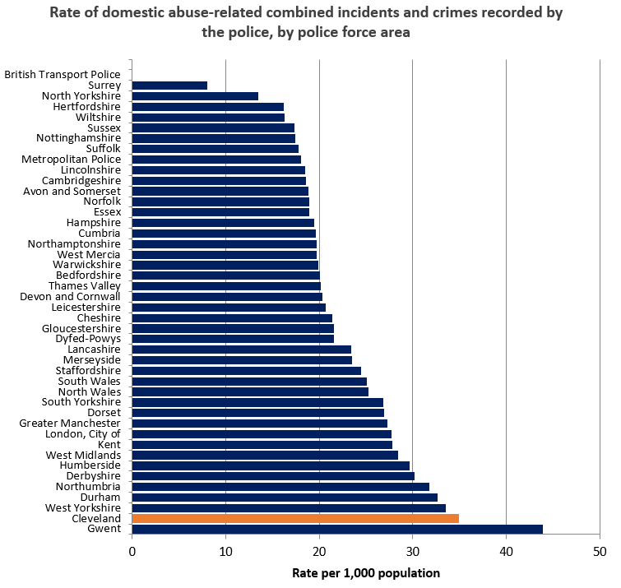

- 13,943 domestic abuse related crimes were recorded – equivalent to 24 crimes per 1,000 population.
- Cleveland Police have the highest rate of domestic abuse related crimes per 1,000 population of all 43 police forces.

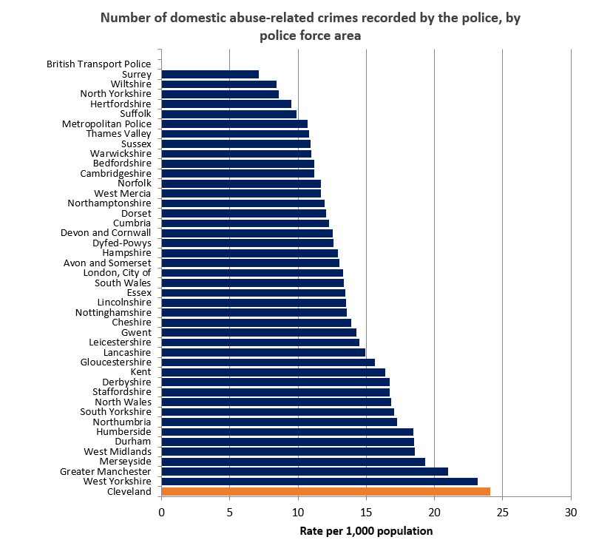

18% of all recorded crimes were classified as domestic abuse-related compared to 16% for England and Wales which is a 1% increase for both, since 2020.

4,058 domestic abuse-related stalking and harassment offences were recorded, which is a 44.67% increase from 2020. 39% of all stalking and harassment offences were domestic abuse-related in 2024, up from 33% in 2020. (Note: in May 2023, changes were made to the Home Office Counting Rules for conduct crimes (stalking, harassment and coercive and controlling behaviour). The requirement to record two crimes, reported at the same time by a victim involving the same perpetrator, when one of them was a conduct crime was removed. However, the police continue to investigate all offences. This has led to a reduction in offences often associated with conduct crimes, such as malicious communications, and an increase in offences such as stalking and harassment. The impact of these changes on statistics is difficult to measure as compliance in crime recording in this area has been inconsistent across policing. Therefore, caution should be taken when comparing domestic abuse-related police recorded data with previous years.)

Arrests, Charge Rate and Prosecutions
- In 2024, there were 35 arrests per 100 domestic abuse-related crimes in Cleveland; lower than the England and Wales rate of 42 arrests per 100 domestic abuse-related crimes.
- The charge rate for domestic abuse-related offences was 73% in Cleveland (equating to 910 domestic abuse-related charges). This is lower than the charge rate for England and Wales which was 79%. Note: CPS amended the method for reporting the charging rate in 2019 to exclude non-legal decisions. Data on the charging rate included in previous publications may not be comparable to data in this publication.
- 981 domestic abuse-related prosecutions took place – equivalent to 15% of all prosecutions in Cleveland, and up from 13% in 2020. The England and Wales rate fell from 14% in 2020 to 12% in 2024.
- 747 domestic abuse-related convictions were recorded in Cleveland – this means that 76% of domestic abuse-prosecutions resulted in conviction (a fall of 3% since 2020); this is the same as the rate of prosecution in England and Wales.

Use of Domestic Violence Protection Notices (DVPNs) and Domestic Violence Protection Orders (DVPOs)
- No data is available for the number of DVPNs applied for in Cleveland but 223 DVPNs were granted (a 266% increase from 61 granted in 2020).
- 223 DVPOs were applied for in Cleveland and 198 DVPOs were granted (equivalent to 89% - up from 67% in 2020); compared to 90% in England and Wales.

Clare’s Law
- Right to Know Clare’s Law applications made in Cleveland increased from 467 in 2020 to 1,286 in 2024 (175% increase). The number of Right to Know applications given disclosure increased from 296 to 382. However, the proportion of applications given disclosure fell from 63% in 2020 to 30% in 2024. The proportion of applications granted disclosure in England and Wales also fell from 52% in 2020 to 45% in 2024.
- Right to Ask applications made in Cleveland increased from 307 in 2020 to 828 in 2024 (170% increase). The number of Right to Ask applications given disclosure increased from 150 to 279. However, similarly to Right to Know, the proportion of Right to Ask applications granted disclosure fell from 54% in 2020 to 37% in 2024. The proportion of applications under Right to Ask for England and Wales increased from 37% in 2020 to 40% in 2024.
- Note: disclosures cannot be directly compared against applications made as there are many reasons why an application may not meet the threshold for disclosure so a low percentage of disclosures may not necessarily suggest a problem. Also, the Domestic Violence Disclosure Scheme (Clare’s Law) was put onto a statutory footing in the 2021 Domestic Abuse Act, which could have contributed towards the increase in applications received.

Additional local data provided by Cleveland Police for Hartlepool shows that there has been an increase in the number of Clare’s Law application, both right to ask and right to know. However, there has been a decrease in the percentage resulting in a disclosure.

Applications | 2022/2023 | 2023/2024
Right to Ask applications | 133 | 170
Right to know applications | 225 | 272
Total | 358 | 442

Disclosures | 2022/2023 | 2023/2024
Right to Ask disclosures | 61 | 61
Right to know disclosures | 100 | 77
% resulting in a disclosure | 45% | 31%

Operation Encompass

Operation Encompass is a police and education early information safeguarding partnership enabling schools to offer immediate support to children experiencing domestic abuse.

Cleveland Police provide Operation Encompass disclosures to schools but are unable to break this down into district area and were unable to provide any data relating to this. This continues to be a gap as highlighted in 2021.

MARAC

MARAC is the Multi-Agency Risk Assessment Conference meeting where the highest risk cases are heard. Risk is determined via a DASH risk assessment checklist or by using professional judgement that a victim is at serious risk of harm or death and all agencies have a responsibility to refer cases to MARAC where they believe the case is high risk.

Local data has been sourced from Cleveland MARAC for the periods April 2021 to March 2024. The table below shows the number of MARAC referrals submitted and the total number of referrals declined for Hartlepool as well as the total number of cases heard and the number of cases that were repeat. A case is listed as a repeat when there is another incident within a 12-month period.

As of March 2025, the screening process for declining referrals has ceased and all cases referred into MARAC will be heard.

 | Apr 21 – Mar 22 | Apr 22 – Mar 23 | Apr 23 – Mar 24
Referrals | 205 | 188 | 205
Declined | 71 | 65 | 41*
Total cases heard | 134 | 123 | 164
Repeats | 40 (30%) | 47 (38%) | 60 (37%)

*Police introduced gatekeeper process, so no referrals declined.

MATAC

Multi-Agency Tasking and Coordination (MATAC) is a multi-agency approach to:
- Reduce re-offending of domestic abuse perpetrators
- Safeguarding adults and children at risk of domestic abuse

The RFG(V) is a matrix tool used to identify the most serial and prolific DA offenders based on police data. A formula is used to interrogate police data to gain a “score” out of 100

The matrix looks at:
R – recency of offending
F – frequency of offending
G – gravity of offences
V – number of victims

MATAC looks at a 2 year rolling data set to establish the RFG score. It measures how many times the perpetrator has offended, when the most recent offence was, the number of victims impacted and the gravity of the listed offences.

As the data is monitored, the score can go up or down, the longer the period of no offending the more rapidly the score will reduce, at other times we may see the score increase as there may be increases of offending through the period of time. The rolling data set provides a more dynamic scoring system than the previous static 2-year period.
When an individual is identified as repeat and prolific perpetrator, they will be listed to be heard at the next available MATAC meeting.

When risk is reduced, they will be discharged with police monitoring for 12 months to ensure they are brought back to MATAC if the risk increases.

Local data for Hartlepool is as follows -

 | Apr 21 – Mar 22 | Apr 22 – Mar 23 | Apr 23 – Mar 24
Nominals | 9 (1 repeat) | <5 | 10
Discharged | 5 | <5 | 11

Since inception in June 2018, 33 nominals have been heard in MATAC. The average score of a perpetrator on entry into MATAC is 64 with the average score on exit being 43, showing a reduction in offending when using the MATAC approach.

MARAC

The CHUB provide a single point of contact to the MARAC process to information share and record any actions or outcomes. The following table shows the number of cases heard in Hartlepool and the number of children who have been impacted by domestic abuse.
Date | Number of Cases | Number of Children
2023 – 2024 | 204 | 443
2022 – 2023 | 132 | 268
2021 – 2022 | 145 | 345
2020 – 2021 | 150 | 321

This shows an increase in the number of cases identified as high-risk year on year as well as an increase of the number of children. On average, there are at least 2 children linked to each MARAC case.

High Risk Adult Panel (HRAP)

The purpose of the High Risk Adults Panel is to work in collaboration with a core group of multi-agency professionals and extended members to reduce/remove or manage the risk of our most vulnerable individuals who are identified as being complex and at high risk of harm. This includes both victims and perpetrators of domestic abuse. Hartlepool are currently piloting a new process where HRAP cases will be cross-referenced with MARAC and MATAC. In 2023/2024, 20% of cases identified domestic abuse as a risk factor.

Sanctuary Scheme and Target Hardening

A victim of domestic abuse can access a target hardening service on offer by the Crime Prevention Service in Cleveland Police, in partnership with the Community Safety Team. A crime prevention officer will receive a referral, either by police, Harbour or the local authorities’ social services and will book an assessment to consider any additional safety measures on the property. Harbour will also offer support to complete the Sanctuary Scheme, and any additional target hardening measures will be installed. Data was provided by the Crime Prevention Service for the period April 2023 – March 2024. This is the first year that data is available however can be used as a baseline for future needs assessments.

The below table shows the number of referrals between April 2023 – March 2024. This shows an increasing trend over the reporting period.

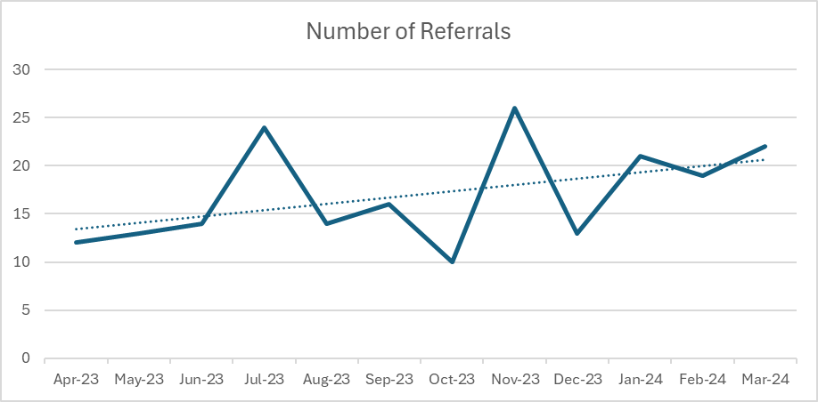

The below table shows the police are the highest referring agency in 2023/2024.

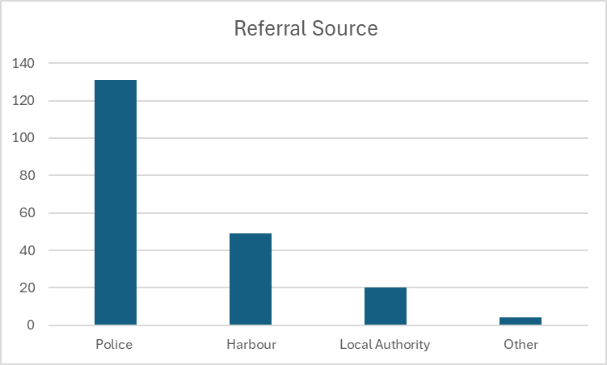
The majority (96%) of individuals referred to the service were female.

Of those referred into the service (204), there was a 55% (113) positive outcome of which 54% (61) received full target hardening and the remaining 46% (52) received advice and alarms.

Domestic Homicide Reviews
A Domestic Homicide Review (DHR) is a multi-agency review commissioned by Community Safety Partnerships to establish what lessons are to be learnt from deaths that have, or appears to have, resulted from domestic abuse. Following consultation, Domestic Homicide Reviews will be renamed Domestic Abuse Related Death Reviews which will reflect all deaths, including suicide.
The Local Government Association and the Office of the Domestic Abuse Commissioner (DAC) completed a review survey in 2024. They received 103 responses, covering 182 authorities (57%) which had the following key findings –
- Respondents reported a total of 370 ongoing DHRs currently in their area, as well as 144 open DHRs and 109 pending DHRs.
- Between 2018/19 and 2022/23 the number of DHRs undertaken by respondents increased by 76 per cent from 94 to 165.
- Respondent authorities spent a total of £1.0 million on DHRs in 2022/23, 45 per cent more than the 2021/22 figure. Around three-quarters of expenditure was on DHR chairs.
- On top of expenditure, staff time spent on undertaking and implementing DHRs was equivalent to 82 full-time staff in respondents.
In addition to this, the DAC reviewed all deaths identified by police as domestic abuse related between April 2022 to March 2023. A total of 242 domestic abuse related deaths were recorded including:
- 93 suspected victim suicide following domestic abuse (SVSDA)
- 80 intimate partner homicides (IPH)
- 31 adult family homicides (AFH)
- 23 unexpected deaths
- 11 child deaths
- 4 ‘other’ deaths (individuals living together who are not family members or intimate partners)
The most recent published DHR in Hartlepool is in 2019. Three reviews are currently ongoing.
Themes and lessons learned will be considered in future needs assessments once reviews are concluded, quality assured by the Home Office and published. An action plan accompanies each review from the highlighted learning and recommendations which are monitored via the Domestic Abuse Partnership Board and the Safer Hartlepool Partnership.

Harbour Client Data

Harbour is the only commissioned support service within Hartlepool and were re-commissioned in October 2022 to provide an integrated service for both victims and survivors, children and perpetrators of domestic abuse. This includes providing safe accommodation, outreach and targeted support programmes.

Harbour data shows that both overall referrals and individuals referred for support have decreased by 4-5% from 2022/23 to 2023/24 as shown in the table below. Repeat referrals also declined in both number and proportion in 2023/24, down from 13.1% to 10.5%.

Origin of referral | 2022/23 | 2023/24
Referrals | 3296 | 3165
Individuals referred | 2372 | 2266
Repeat | 310 | 239

The table below shows that in 2023/24, less than 50% of referrals to Harbour services came from the police, down from 52.3% in the previous year. Self-referrals, referrals from social services (both child safeguarding and early help) and MARAC all increased their proportion of referrals in 2023/24 and accounted for 35.2% of referrals in 2023/24. In contrast, 4% of referrals were made by health services (GPs, community midwives, hospital, health visitors and mental health services). More than half of the health service referrals came from mental health services, and no referrals came from community midwives or health visitors.

Origin of referral | % 2022/23 | % 2023/24
Police | 52.3 | 47.9
Self-referral | 16.0 | 16.4
Social Services - Child Safeguarding | 7.4 | 8.7
MARAC | 4.1 | 6.8
Health Visitors | 0.2 | 0.0
Other | 3.5 | 2.8
Mental Health Service | 2.3 | 2.7
Social Services - Adult Safeguarding | 1.9 | 1.0
Social Services - Early Help | 2.2 | 3.3
Court | 2.2 | 1.6
Housing Provider | 1.8 | 2.0
Hospital | 1.3 | 1.0
Other DV Service | 1.2 | 1.9
School/ college | 0.8 | 0.6
Other LA | 0.5 | 0.3
Probation | 0.5 | 0.5
Community Midwives | 0.3 | 0.0
SARC | 0.3 | 0.0
Drug/ Alcohol Service | 0.2 | 0.5
Family / Friend | 0.3 | 0.3
Homeless Team (other area) | 0.5 | 0.6
GP Practice | 0.1 | 0.3
Homeless Team (local) | 0.0 | 0.4
Victim Support | 0.0 | 0.1
IOM | 0.0 | 0.0
Unknown | 0.0 | 0.0

Demographic Breakdown of Harbour Referral Data

Ethnicity
 | 2022/23 |  | 2023/24
Ethnicity | Count | % | Count | % | % Hartlepool Population (2021 Census)
White | 1233 | 97.1 | 1070 | 95.2 | 96.5
Black, Caribbean or Black British | <5 | suppressed | 13 | 1.2 | 0.5
Asian or Asian British | 24 | 1.9 | 21 | 1.9 | 1.7
Mixed or Multiple Ethnicities | 5 | 0.4 | 12 | 1.1 | 0.7
Other Ethnic Group - Other | 6 | 0.5 | 8 | 0.7 | 0.6
Undisclosed | 129 | N/A | 135 | N/A | N/A
Unrecorded | 973 | N/A | 1007 | N/A | N/A

The table above shows the proportion of referrals from each of the main ethnic groups adjusted to remove undisclosed and unrecorded from the calculation. The Harbour categories have been grouped to fit against the ethnic group list used in the 2021 Census question on ethnicity to enable comparison.

The data shows that the proportion of referrals to Harbour support services that were white has reduced by 13% compared to 2022/23. This is due to a proportional increase in all other categories except Asian or Asian British. This probably reflects the changing population of Hartlepool, which is becoming more diverse in recent years.

Sex
 | 2022/23 |  | 2023/24
Sex | Count | % | Count | %
Male | 436 | 18.6 | 451 | 20.0
Female | 1910 | 81.3 | 1799 | 79.8
Transgender | <5 | <1 | <5 | <1
Unrecorded | 24 | N/A | 13 | N/A

The table above shows that the proportion of referrals for male victims of domestic abuse increased by 3% compared to 2022/23.

Of these, the data provided to the Ministry of Housing, Communities and Local Government (MHCLG) shows that in 2023/2024, 88 women accessed safe accommodation in Hartlepool which is the same as 2022/2023. No men accessed safe accommodation during this time. One trans person accessed safe accommodation in 2023/2024. The number of children decreased to 36 in 2023/2024 from 63 in 2022/2023. This could be attributed to changes in the recording of data.

Sexual Orientation
 | 2022/23 |  | 2023/24
Sexual Orientation | Count | % | Count | % | % Hartlepool Population (2021 Census)
Heterosexual | 710 | 89.2 | 649 | 90.1 | 91.1
Lesbian / gay | 7 | 0.9 | 10 | 1.4 | 1.5
Bi-sexual | 11 | 1.4 | 13 | 1.8 | 1.1
Other | 68 | 8.5 | 48 | 6.7 | 0.2
Undisclosed | 102 | N/A | 123 | N/A | N/A
No data | 1456 | N/A | 1423 | N/A | N/A

The table above shows a 9% reduction in the number of clients that disclosed their sexual orientation as heterosexual. However, because there was a smaller cohort in 2023/24 this has resulted in heterosexual making up a slightly larger proportion of the total referrals.

Whilst there were small increases in the proportion of referrals for lesbian/gay and bisexual clients, there was a 29% reduction in those selecting the “other” option. However, due to the low numbers involved, these changes should not be considered significant.

Age
 | 2022/23 |  | 2023/24
Age | Count | % | Count | % | % Hartlepool Population (2023 MYE)
Under 16 | 238 | 10.4 | 255 | 11.6 | 18.9
16-18 | 61 | 2.7 | 56 | 2.5 | 3.7
19-25 | 363 | 15.9 | 329 | 14.9 | 7.6
26-35 | 723 | 31.6 | 665 | 30.2 | 12.5
36-44 | 497 | 21.7 | 481 | 21.8 | 10.8
45-54 | 232 | 10.1 | 232 | 10.5 | 11.8
55-64 | 113 | 4.9 | 115 | 5.2 | 14.6
65+ | 59 | 2.6 | 69 | 3.1 | 19.9
Unrecorded | 86 | N/A | 64 | N/A | N/A

The table above shows referral data broken down by age bracket. As the age brackets cover different ranges, caution should be used when comparing different brackets that are not the same size. To find the comparable local population data, single year figures from the 2023 mid-year estimates have been compiled into matching brackets.

The table shows a 7% increase in referrals for under 16s compared to 2022/23. However, there was a reduction in the proportion of referrals for clients aged 19-25 (-9%), 26-35 (-8%) and 36-44 (-3%). However, these three age bands continue to be the largest categories of referrals and are considerably over-represented compared to the local Hartlepool population.

Disability
 | 2022/23 |  | 2023/24
Disability | Count | % | Count | % | % Hartlepool Population (2021 Census)
Yes | 138 | 20.0 | 131 | 16.0 | 22.9*
No | 551 | 80.0 | 688 | 84.0 | 77.1
Unrecorded | 1683 | N/A | 1447 | N/A | N/A

* This figure is a combination of the “limited a little” and “limited a lot” answer options to the question “If you have a long-term illness or condition, does this limit your day-to-day activities?”

The table shows that the proportion of those who said their daily activities were limited by a health condition or disability reduced slightly compared to 2022/23 and remains lower than the general population of Hartlepool. More detailed disability data would be useful to understand the types of disabilities experienced by people being referred. This would enable better understanding of what barriers exist for people with disabilities in accessing support services.

Tenure
 | 2022/23 |  | 2023/24
Tenure | Count | % | Count | %
Local RSL | 211 | 32.7 | 200 | 32.3
Other RSL | 26 | 4.0 | 14 | 2.3
Private rented | 177 | 27.4 | 198 | 31.9
Owner occupier | 49 | 7.6 | 35 | 5.6
Family / friends | 104 | 16.1 | 99 | 16.0
Other | 79 | 12.2 | 74 | 11.9
Unrecorded | 1726 | N/A | 1646 | N/A

The categories recorded for tenure in the 2021 Census are not a direct match for the categories used in the client data so comparison against the local population is not possible for this characteristic.

The table above shows that living in registered social housing or private rented accommodation continues to be the most common tenure of people referred to Harbour support services. The number of clients living in private rented accommodation increased by 12% compared to 2022/23, whilst the number of owner occupiers reduced by 29%. This probably reflects changes in the local housing market over the period.

Safe Accommodation
Referrals
Harbour data shows that the number of overall referrals for safe accommodation has decreased by 12% from 2022/23 to 2023/24 as shown in the table below. However, for the number of individuals referred, this is only a 0.9% decrease. This shows that whilst the number of referrals is decreasing, roughly the same number of people are being referred to the service. There are very few repeat referrals across both years.

Origin of referral | 2022/23 | 2023/24
Referrals | 372 | 326
Individuals referred | 323 | 320
Repeat | 8 | 3

The data also shows that the average stay in refuge accommodation increased by one third from 76 days to 100 days over the same period. If clients are staying in refuge longer this reduces the overall availability of accommodation at a time when demand is increasing.

% of referrals unable to accommodate | 2022/23 | 2023/24
No Space | 86.7 | 81.9
Room not big enough | 0.6 | 0.8
Complex Needs | 4.2 | 9.8
No recourse | 0.0 | 0.0
Other | 8.5 | 7.5
Total | 100 | 100

Complex Needs
The data also shows that the proportion of referrals to refuge which were turned down due to the victims having complex needs that could not be accommodated more than doubled from 4.2% in 2022/23 to 9.8% in 2023/24, almost 1 in 10 of referrals in 2023/24. However, some clients with complex needs were accepted into refuge. A lack of space fell from 86.7% in 2022/23 to 81.9 in 2023/24, which is still 4 in 5 occasions when a referral was unable to be accommodated.

The following table shows that in 2023/24 the proportion of clients accommodated with some degree of mental health or substance issues increased across the board on their 2022/23 levels. The proportion of clients with drug misuse issues increased more than fourfold, from 9% to 40%, and alcohol misuse issues increased sevenfold, from 3% to 21%. Almost half of new clients accommodated in 2023/24 had mental health issues and 2 in 5 had co-occurring mental health and substance misuse issues.

New Clients Accommodated | 2022/23 | 2023/24
% clients who have drug misuse issues | 9% | 40%
% clients who have alcohol misuse issues | 3% | 21%
% clients who have mental health (MH) issues | 33% | 47%
% clients who have substance misuse and MH issues | 23% | 40%
Abuse from Partner / Ex Partner
The overwhelming majority of clients accepted into refuge were experiencing abuse from an intimate partner or ex-partner rather than from a family member. However, in both 2022/23 and 2023/24 the proportion of clients experiencing abuse from a previous partner was higher than from a current partner, though in 2023/24 the proportion experiencing abuse from a current partner was around 1 in 3, compared with 1 in 4 in 2022/23.

New Clients Accommodated | 2022/23 | 2023/24
% clients who are subject to abuse by an intimate partner | 27% | 39%
% clients who are subject to abuse by an ex-intimate partner | 67% | 56%
% clients who are subject to abuse by a family member (minor) | 0% | 0%
% clients who are subject to abuse by a family member (adult) | 4% | 6%

Clients’ Children
Harbour’s refuge client data also shows that the number of clients accepted into refuge with children has almost halved in 2023/24, from 60% to 33%, largely because of this there has also been a sharp decline in the proportion of children with early help, child protection, or looked after care, though child in need increased fivefold, from 2% to 10%. Pregnant clients increased by 50% in 2023/24 compared with 2022/23, from 8% to 12%.

New Clients Accommodated | 2022/23 | 2023/24
% clients with children in Refuge | 60% | 33%
% clients who are pregnant | 8% | 12%
% clients with children engaged with Early Help | 2% | 0%
% clients with children subject to Child Protection | 47% | 14%
% clients with children subject to Child in Need | 2% | 10%
% clients with children in Looked After Care | 16% | 19%

In comparison, Harbour’s client data for those who accessed dispersed property shows that the percentage of clients with children increased. In 2022/2023, none of the children residing in a dispersed property had intervention from children’s social care however in 2023/2024 21% of the children were open on a Child Protection basis.

 | 2022/23 | 2023/24
Safe Accommodation Measures - Dispersed Property | Total | Total
% clients with children | 33% | 44%
Number of children linked to the client | <5 | 15
% clients who are pregnant | 0% | 25%
% children engaged with Early Help | 0% | 0%
% children subject to Child Protection | 0% | 21%
% children subject to Child in Need | 0% | 0%
% children in Looked After Care | 0% | 0%

Clients with a Disability
In terms of those clients accommodated in refuge who have a disability, in 2023/24 there were almost three times as many clients with a physical disability than the previous year (15% and 4% respectively).At the same time, the proportion of clients with a earning disability increased by 50%, from 4% to 6%.

In 2023/24 more than twice as many new clients had a physical disability than a learning disability, while in 2022/23 they were at the same level. In both 2022/23 and 2023/24 there were no clients who were providing care of a friend or relative.

New Clients Accommodated | 2022/23 | 2023/24
% clients who have a physical disability | 4% | 15%
% clients who have a learning disability | 4% | 6%
% clients who have a sensory impairment | 0% | 1%
% clients who care for a friend or relative | 0% | 0%

The data provided to the MHCLG shows that the number of individuals from an ethnic minority has doubled to 16 in 2023/2024. The number of individuals from the LGBTQ+ community has remained the same at 2 in 2023/2024.

The data provided to the MHCLG shows that in 2023/2024 the number of individuals supported from out of area was 64 which is 51.2% of all individuals who have accessed safe accommodation. This is an increase from 21.2% in the previous year.

Domestic Abuse Prevention Service (DAPS)
Referrals
Harbour data shows that in 2023/24 14% of referrals to the Domestic Abuse Prevention Service (DAPS), which works with perpetrators, were repeat referrals, compared to only 9% in 2022/23, an increase of more than 50%.

Origin of referral | 2022/23 | 2023/24
Social Services - Child Safeguarding | 33.3 | 52.3
Self-referral | 28.0 | 25.7
Police | 17.2 | 8.3
Social Services - Early Help | 6.5 | 6.4
Other | 5.4 | 1.8
Probation | 4.3 | 4.6
Drug / alcohol service | 1.1 | 0.0
Mental Health Service | 1.1 | 0.0
SARC | 1.1 | 0.0
Social Services - Adult Safeguarding | 1.1 | 0.0
MARAC | 0.0 | 0.0
Court | 0.0 | 0.0
School/ College | 0.0 | 0.0
Hospital | 1.1 | 0.0
Other DV service | 0.0 | 0.9

The table above also shows that referrals to DAPS in 2023/24 continue to be predominantly made by social services (child safeguarding) (52.3%) and self-referrals (25.7%). If all forms of social services are included, then referrals from self or social services account for 84.4% of referral is 2023/24, compared with only 68.9% in 2022/23. Referrals from the criminal justice system (i.e. police, probation and court) only make up 12.9% of referrals in 2023/24, this is down from 21.5% in 2022/23. In both years the courts did not make any referrals at all. Police referrals fell from 17.2% in 2022/23 to 8.3% in 2023/24, a fall of more than 50%. As most abuse meted out by perpetrators forms a criminal offence of one kind or another it is surprising that so few perpetrator referrals are being made by the criminal justice system.

In both 2022/23 and 2023/24 roughly half of referrals were assessed, but the proportion of those who were assessed and deemed not appropriate for the service fell from 17% in 2022/23 to 9% in 2023/24. In both years the majority of those deemed not appropriate were due to denying the abuse.

Clients with Children
Of those who were accepted onto the DAPS program in 2023/24 roughly four in five have children, compared with 2 in 3 in 2022/23. In both years roughly a third had child protection needs, but in 2023/24 a third had child in need, compared with only 1 in 10 in 2022/23.

Clients Assessed | 2022/23 | 2023/24
% clients with children | 66% | 82%
% clients with children engaged with Early Help | 0% | 5%
% clients with children subject to Child Protection | 34% | 29%
% clients with children subject to Child in Need | 11% | 31%
% clients with children in Looked After Care | 10% | 9%

Children and Young People’s Service
Harbour offers a therapeutic service for children and young people impacted by domestic abuse. The number of referrals has increased by 9% from 2022/2023 to 2023/2024. However, there has been a slight decrease in the number of individuals referred meaning that the average number of referrals per individual has increased.

The below table shows that of those children referred, there has been a decrease in the number of children assessed with 53% of referrals completing an assessment in 2023/2024, compared to 64% in the previous year. Although the safe accommodation data shows a decrease in the levels of involvement from children’s social care, there is an increase overall in children receiving support from Early Help or subject to Child in Need and Child Protection at assessment stage.

 | 2022/23 | 2023/24
Children and Young People Measures | Total | Total
Number of Referrals into the service | 275 | 301
Number of CYP referred | 265 | 255
Repeat | 18 | 22
New Clients Assessed
Number of new clients assessed | 177 | 160
% clients engaged with Early Help | 2% | 8%
% clients subject to Child Protection | 12% | 21%
% clients subject to Child in Need | 15% | 23%
% clients in Looked After Care | 3% | 1%
% clients who have a physical disability | 2% | 1%
% clients who have a learning disability | 7% | 3%
% clients who have a sensory impairment | 3% | 0%
% clients who care for a friend or relative | 1% | 0%
Number of cases closed in a planned way | 96 | 69
Number of cases closed in an unplanned way | 32 | 32

Children and Young People’s Services Outcomes
For those case closed in 2023/2024, 68% were planned, compared to 75% in 2022/2023. The most common reason is the client disengaging from the service (81%).

In terms of outcomes for those exit surveys completed with planned closures, there has been an increase in the percentage of the number of children and young people feeling safer and happier following their support from Harbour.
 | 2022/23 | 2023/24
Safe Lives Insights Report CYP | Total | Total
Number of CYP feeling safer at exit (planned closures) | 77% | 79%
Number of CYP feeling happier at exit (planned closures) | 77% | 80%

The Halo Project

The Halo Project provides safeguarding and on-going confidential advice, help and support to black and minoritised women, girls and children who are at risk of and/or are survivors of domestic and sexual violence and abuse, including forced marriage, honour-based abuse and female genital mutilation. They are based in Middlesbrough but offer support to individuals who reside in all four local authority areas within Cleveland. Halo were unable to provide local data however have stated the organisation have seen a 13% increase in cases for Hartlepool year on year. Local data for 2017-2018, 2018-2019 and 2020-2021 can be viewed in the 2021 needs assessment.

Children’s Social Care

Hartlepool Children’s Hub (CHUB) is a multi-agency team based within Hartlepool Borough Council which provides information, advice and guidance on services and support for children, young people and families. The CHUB also acts as a triage service for professionals and members of the public to report child safeguarding concerns. Hartlepool Council also commissions an emergency out of hours response to emergency situations involving child protection, childcare, mental health and other adult care service matters.

Referrals to the CHUB are generally made using a SAFER referral form and the process for how these referrals are processed is shown below:

1. SAFER referral received by CHUB – have 24 hours to decide on a course of action and inform the referrer, unless it is a Child Protection issue where the referral must be processed within 4 hours
2. Referral triaged, RAG rated and allocated to social worker
3. Four possible options:
a. No further action (does not meet the threshold for intervention)
b. Refer the child to Early Help
c. Refer to another agency (in a domestic abuse context this would be Harbour or Halo)
d. Make a formal statutory social care referral:
i. Child in Need (CIN) – consent-based intervention
ii. Child Protection (CP) – child in imminent danger of harm, consent not needed (though still try to obtain consent where appropriate)

In terms of domestic abuse-related child safeguarding referrals to the CHUB, most referrals are made by the police at 73%. This is an increase compared to the previous needs assessment in which 48% of referrals were made by police.

Between 1st March 2021 and 31st March 2024, local data shows there was a total of 1875 contacts to the CHUB. This equates to:
- 1330 individual children
- 492 of the contacts related to only 1 child (some have had more than 1 contact)
- 517 contacts related to sibling groups.
- 1022 children had only 1 contact with 308 children having 2 or more contacts.
- Of the 556 referrals, 539 had an outcome of C & F Assessment, 2 were NFA, 11 had an outcome of Strategy and 4 had no outcome recorded.

Source of Referrals
- 73% of referrals come from police
- 3.9% of referrals come from probation
- 3.41% of referrals come from a relative
- 2.13% of referrals come from HBC children’s social workers
The remaining referrals are made by healthcare providers, adult social care, education settings or anonymous referrals.

Adult Social Care

The rate of enquiries in Hartlepool for adult safeguarding in 2023/24 is almost 80% larger than the England rate of 1,361 per 100k.

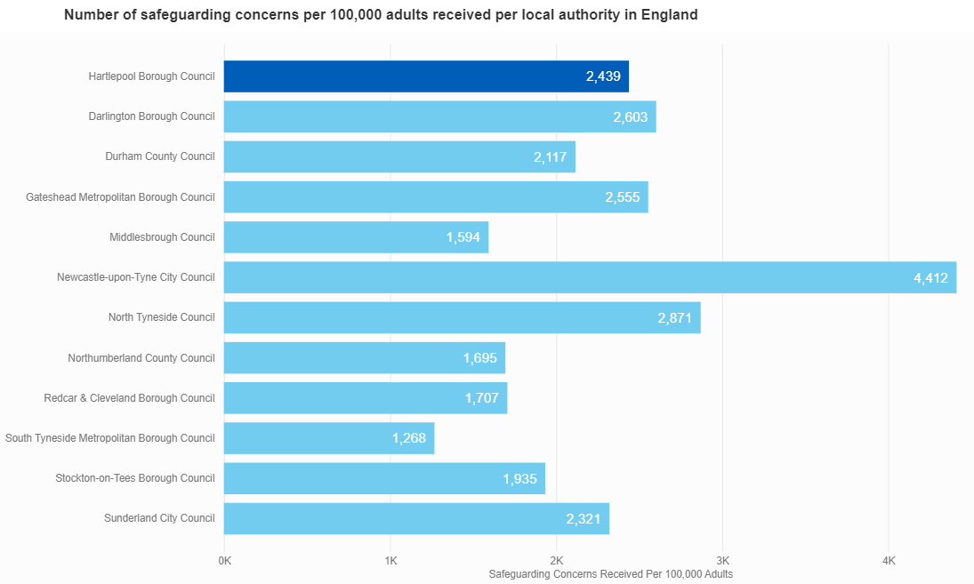
Source: NHS England, 2024

Hartlepool’s rate of 2,439 per 100k is the 5th highest in the North East, comparable with the rates for Darlington, Gateshead and Sunderland. Hartlepool’s 2023/24 rate is the 4th consecutive year of increase, from 841 per 100k in 2019/20, almost a threefold increase in four years.

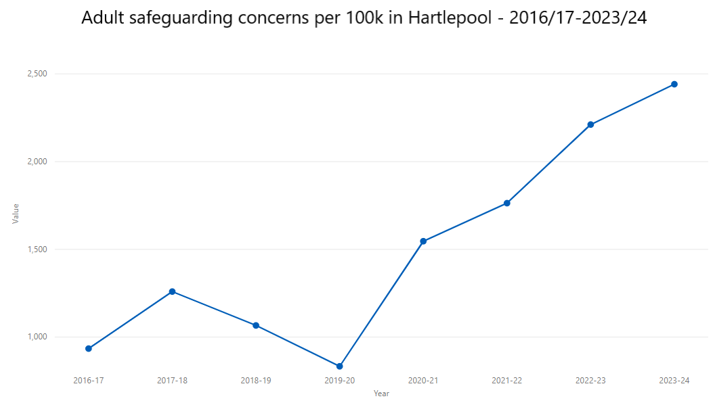
Source: NHS England, 2024

Within those safeguarding enquiries, the rate of Section 42 enquiries in Hartlepool is almost 2.5 times the size of the England rate of 390 per 100k.

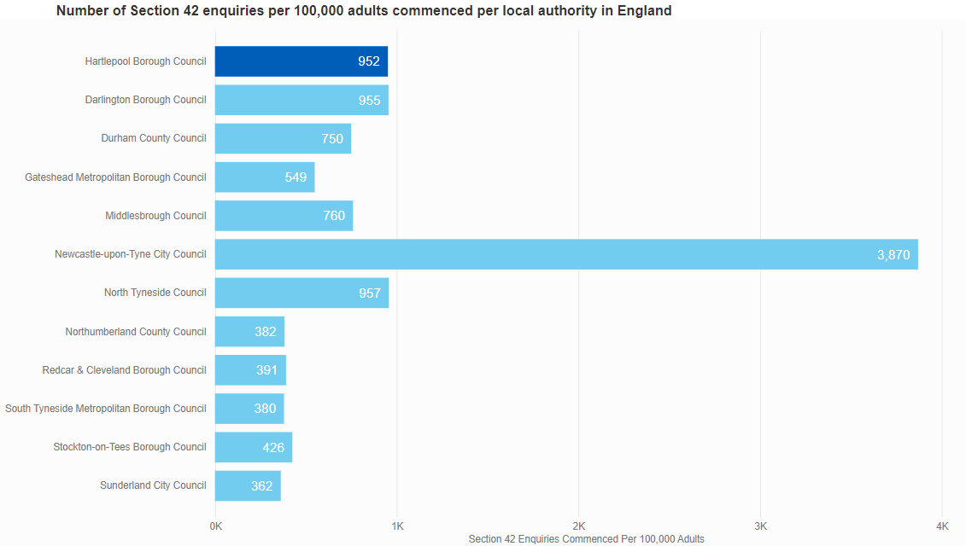
Source: NHS England, 2024

Hartlepool’s rate of 952 per 100k is the 4th highest in the north east, and is comparable to Darlington and North Tyneside. Hartlepool’s 2023/24 rate is lower than the 2022/23 rate, and ends a run of five consecutive years of increase. The 2023/24 rate is almost 25% lower than the previous year.

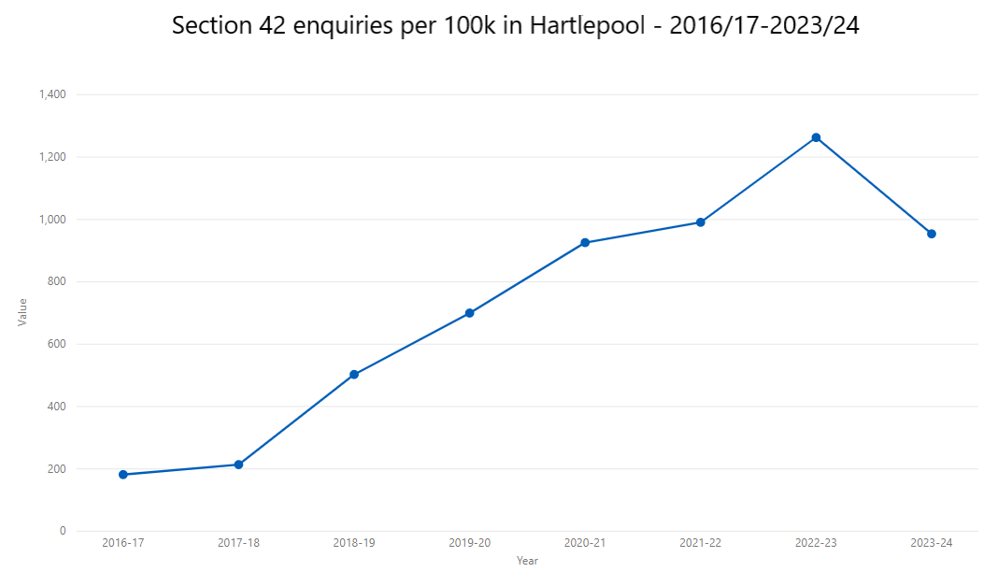
Source: NHS England, 2024

Within Hartlepool’s 2023/24 Section 42 enquiries domestic abuse was recorded as a risk 7.5% of the time.

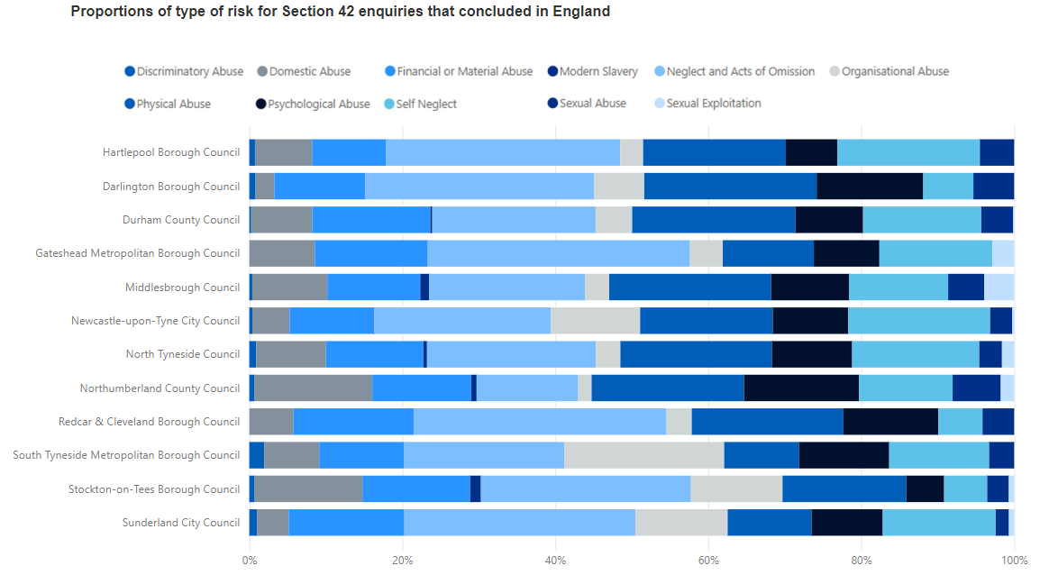
Source: NHS England, 2024

Hartlepool’s proportion of 7.5% of section 42 enquiries relating to domestic abuse is the 7th highest in the north east, comparable to the rates for Durham and South Tyneside. The proportion of section 42 enquires relating to domestic abuse is the 5th largest risk group in Hartlepool.

The proportion of Hartlepool’s section 42 enquiries relating to domestic abuse is at its highest level since 2020/21.
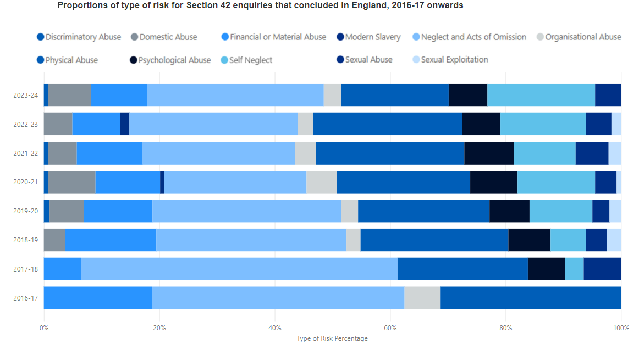
Source: NHS England, 2024

The rate in 2020/21 of 8.21% is the only year in the eight-year reporting period where it is higher than the 2023/24 rate. 2023/24 ended a two-year reduction in the proportion relating to domestic abuse.

It is recognised that the type of abuse recorded from an adult safeguarding referral, is that which the referring agency deems the most suitable. This means that domestic abuse is likely to be under-recorded where there is more than one type of abuse being perpetrated towards an individual, or a professional is recording based on the type of abuse eg) physical or financial. As of April 2025, sub-categories have been introduced for domestic abuse.

The below table shows the number of adult safeguarding concerns and section 42 enquiries during the period 1st April 2023 – 31st March 2024.

Quarter & Year (Fiscal) | Concerns | S42 Enquiries
Q1 2023/24 | 450 | 196
Q2 2023/24 | 503 | 218
Q3 2023/24 | 451 | 159
Q4 2023/24 | 457 | 166
Total | 1861 | 739

Of these, referrals, 105 concerns were identified by the referrer as domestic abuse, 11 of which were a repeat referral within the previous 12 month period.

Quarter & Year (Fiscal) | Concerns | S42 Enquiries
Q1 2023/24 | 24 | 13
Q2 2023/24 | 22 | 12
Q3 2023/24 | 30 | 16
Q4 2023/24 | 29 | 11
Total | 105 | 52

Of the 105 referrals, 81 were female and 24 were male.

The age breakdown of the referrals is shown below -

Age Group | Female No Safeguarding | Male No Safeguarding
18-64 | 57 | 16
65+ | 24 | 8

In terms of the outcomes following a Section 42 safeguarding referral, over half were recorded as either “Managing own risk” (19.2%) or “Inappropriate concern” (17.5%).

Outcome | Number of Cases
Action by provider | 1
Advice and Guidance | 3
Further concerns Raised | 6
Inappropriate Concern | 9
Managing own Risk | 10
Moved | 1
Non engagement | 1
Other | 7
Police Action | 6
Referral for assessment required | 3
Referred to other services including Harbour etc | 3
Review required via Care Management | 2

Homelessness Data

The housing advice team have provided data around homeless relating to domestic violence and abuse in Hartlepool. They have adopted a new system as of June 2023; therefore, data has only been included up to March 2023. Going forward, trends will continue to be monitored on a yearly basis.

Presentations
Data provided by the council’s housing advice team shows that from the period April 2018 to September 2020 that was previously provided, the number of households presenting due to domestic violence and abuse is increasing as shown up to March 2023. The increase shown in the year 2022-2023 could be following the introduction of the Domestic Abuse Act and the updated guidance on responding to domestic abuse in homelessness. It is also worth considering the impact post-covid may have had on presentations.

A relief or prevention duty was accepted in most cases. In the two cases where a duty was not accepted, one had advice or guidance given and the other household withdrew their application.

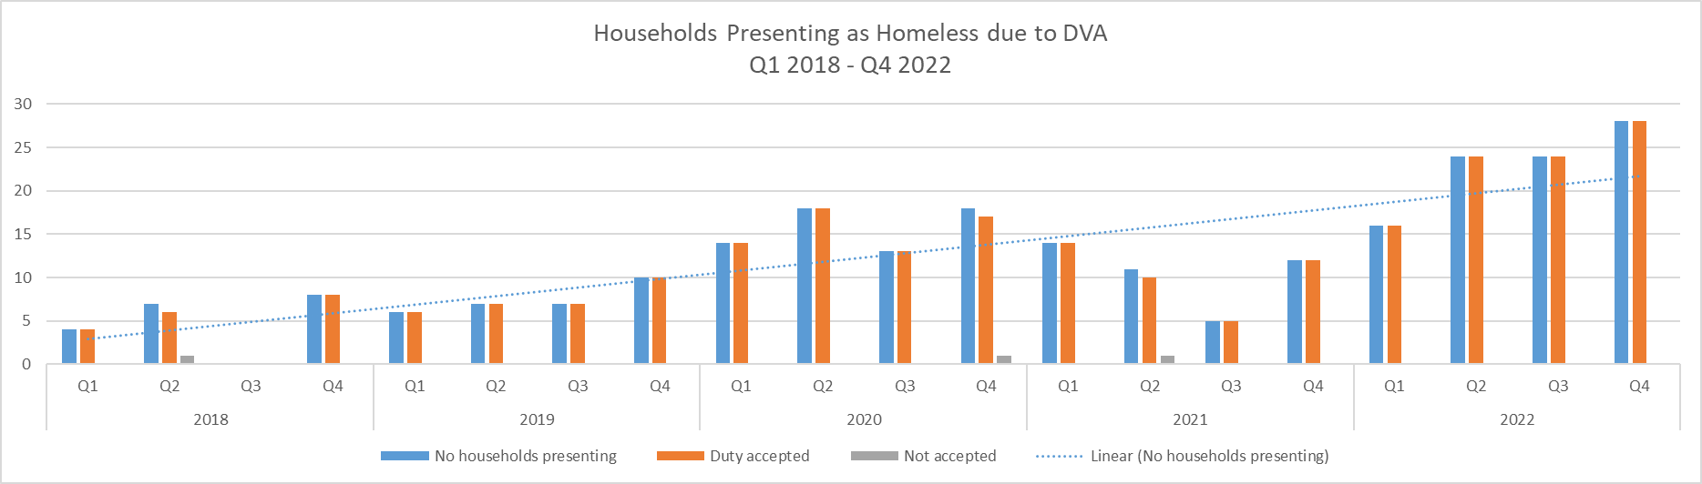

In terms of gender, most individuals presenting as homeless are female (211). In September 2020, 84% of the individuals were female. However as of March 2023 this has increased to 95%. The number of males presenting is the same (11).

The trendlines on the below chart show that the number of female presentations is increasing quite steeply over the reporting period, reflecting the overall increase in presentations. Male presentations are also showing an increasing trend but at a slower rate. However, this is something to be considered as to whether there are fewer safe accommodation options available for men.

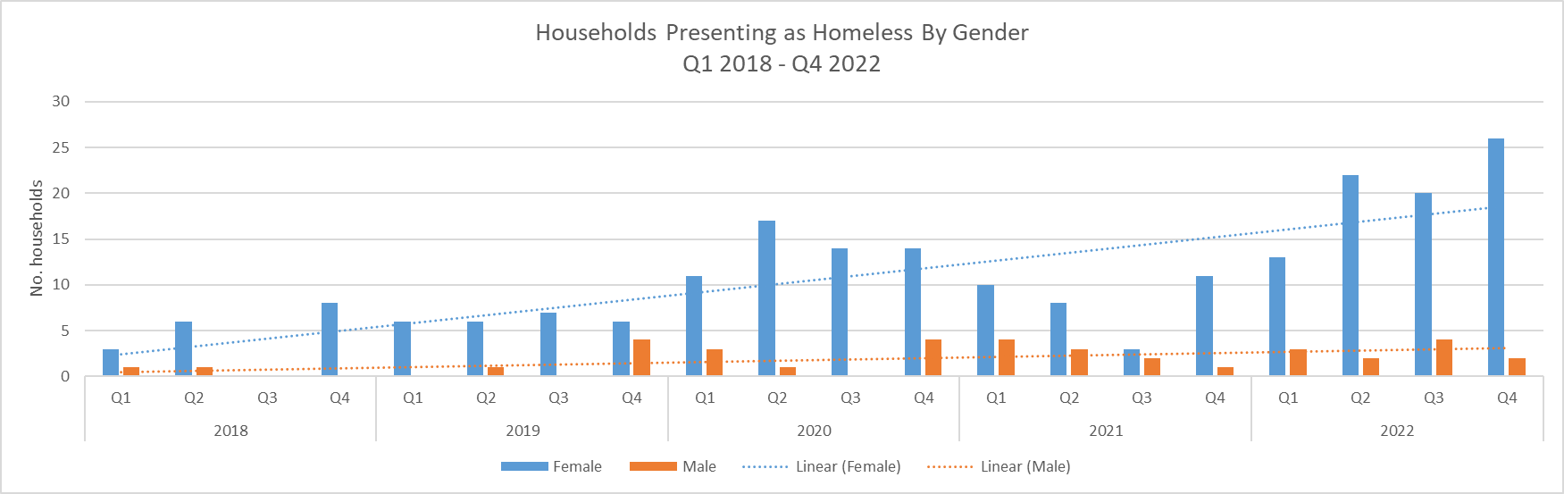

The number of single households continues to show an increasing trend from 2018 to 2023; however, this has slowed slightly since the last reporting period. Whilst both single households and households with children are increasing, single households requiring homeless assistance is increasing at a faster rate.

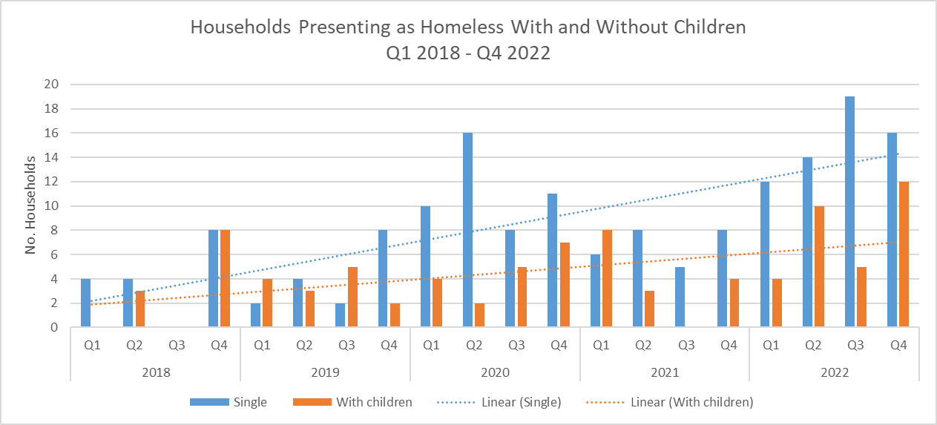

Tenure
The data also shows the tenure of people presenting as homeless as well as the tenure of the accommodation they go on to after support. The chart shows that that the most common tenure for individuals presenting due to domestic abuse was those living in private rented accommodation (30%).

The proportion of clients who were either staying with family and friends or already in refuge at presentation has increased from 12% in 2020 to 42% in 2023. This suggests that they had already been homeless for some time before presenting to Council homelessness services for assistance. It is likely they could be fleeing to family and friends in the first instance, before approaching services for formal assistance.

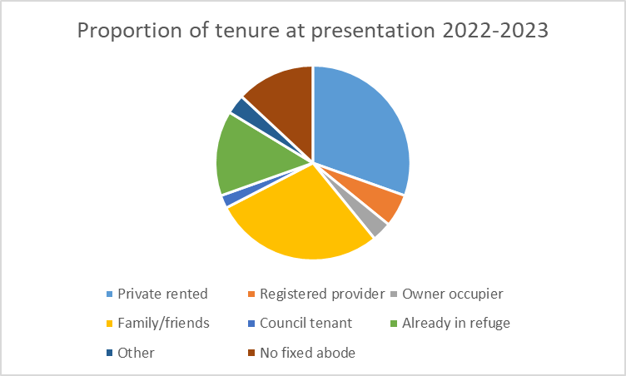

The low proportion of owner occupiers presenting as homeless due to domestic abuse reflects the further difficulty of leaving for survivors who are property owners. Particularly as owner occupiers represent the largest proportion of households in Hartlepool.
Outcomes
Of the 246 households that presented as homeless during the reporting period, 187 (76%) had accommodation secured. This was either by obtaining a private rented tenancy, registered provider or council tenancy or other social rented supported accommodation. Over half (59%) of individuals who received support from the housing advice team were supported to access registered provider tenancies.

Of those who didn’t secure alternative accommodation, 8 stayed with family or friends, 6 were supported to remain safe in their accommodation and the remaining cases were withdrawn or contact lost with the service.

This suggests that the homelessness team have been successful in securing longer-term accommodation for clients presenting as homeless due to domestic abuse in most cases as shown in the chart below.

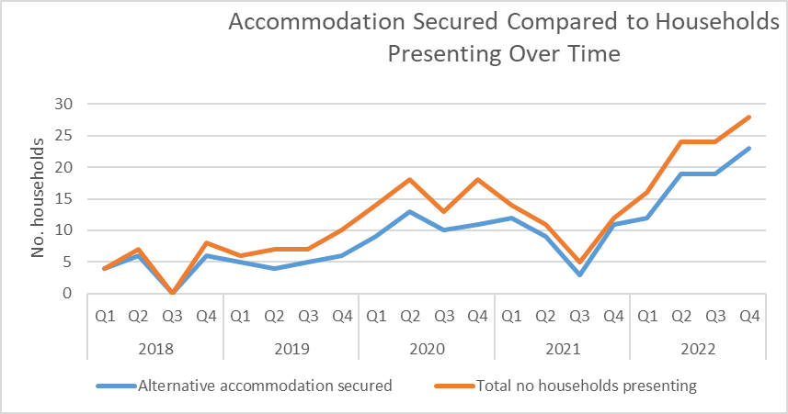

Hartlepool Borough Council moved to a new choice-based lettings system for social housing on the 17th April 2023, Hartlepool Home Search and subsequently left the Tees Valley Home Finder partnership. From April 2023 – March 2024, 174 housing register applications selected domestic abuse as their main reason for moving. Of these, 32 were awarded a Band 1 priority to move due to domestic abuse.

Health data

Tees, Esk and Wear Valleys NHS Foundation Trust provides care and treatment for people with mental health and learning disability needs in Hartlepool. They did not have any available data to provide to the needs assessment due to a system change. This is a gap in assessing the needs of victims and survivors, perpetrators and their children who access mental health services.

North Tees and Hartlepool NHS Foundation Trust have an IDVA co-located within their trust, funded by the Office for Police and Crime Commissioner for Cleveland. They will provide advice and support to patients disclosing domestic abuse. This role is trust wide and therefore it is unable to breakdown which patients were of Hartlepool residence. However, the IDVA completed 162 total interventions in year 2023/2024 in comparison to 115 interventions in year 2022/2023 which is a 41% increase. This can partly be accounted by a dip in interventions during the first quarter of 2022/2023 due to staff sickness. In 2023/2024 most interventions were providing safety planning and advice. However, this funding is due to cease in March 2026.

Data provided by North Tees and Hartlepool NHS Foundation Trust shows there were 89 safeguarding concerns where domestic abuse was a category in 2023/2024 compared to 73 in 2022/2023. This is a 22% increase. However, due to the way the data is recorded this for all presentations to the trust and is unable to be broken down to Hartlepool residents.

Cardiff Model data previously provided in 2021 is no longer available.
Conclusion
Whilst the data shows that domestic abuse continues to be primarily a gender-based crime, perpetrated by men against women, this oversimplifies the situation somewhat. Demographic analysis of the services reviewed in this section shows that some groups are overrepresented in the client / referral data compared to other groups within that same demographic characteristic (e.g. age bracket) or compared to the local Hartlepool population. Additionally, whilst the numbers for some groups remain low, they are making up an increasingly significant proportion of service users.

Based on the evidence reviewed in this section, the following groups are overrepresented in the client data:
- Women – make up 79.8% of referrals to Harbour support services, 95% of homeless presentations due to domestic abuse and 71% of adult safeguarding referrals related to domestic abuse yet just 51.6% of the Hartlepool population
- People aged 19-44 – make up 66.9% of Harbour referrals yet just 30.9% of the Hartlepool population
- People living in social housing or private rented accommodation - make up 66.5% of Harbour referrals compared to 41% of the Hartlepool population
- People who are already homeless (particularly women and single households) – make up 42% of referrals to the Council’s homelessness team
In terms of groups where total numbers remain low but they are representing an increasing proportion of the demographic makeup of referrals:
- Ethnic minorities make up a small proportion of referrals to Harbour but this proportion is increasing and is slightly higher than the local population for all minority groups
  - Black, Caribbean or Black British - 1.2% of referrals / 0.5% local population
  - Asian or Asian British – 1.9% of referrals / 1.7% of local population
  - Mixed or multiple ethnicities – 1.1% of referrals / 0.7% of local population
  - Other ethnicity – 0.7% of referrals or 0.6% of local population
- Males make up an increasing proportion of Harbour referrals. They currently make up 20% of referrals (increased from 18.6%) compared to 48.4% of the local population
Particular groups also make up an increasing proportion of the Safe Accommodation referrals:
- People with complex needs who cannot be admitted into refuge accommodation (increased from 4.2% to 9.8%)
- Women who are pregnant at the time of referral (increased from 8% to 12%)
- People with a disability (increased from 4% to 15%)
- People with mental health issues (increased from 33% to 47%)
Future analysis will show if these trends continue over the longer term. However, in the meantime, consideration needs to be given to how the differing (and intersecting) needs of these groups can be accommodated by services.

- Which population groups are at risk and why?
Whilst national and local data shows that women are most at risk of domestic abuse, unfortunately the lack of demographic data and underreporting means that there may be groups of people who are hidden from services or have additional barriers to accessing support. Individuals also aren’t always asked for their demographic data when accessing services and when they are, they are not obliged to provide this.

Age | The Crime Survey for England and Wales estimates showed that a significantly higher proportion of people aged 16 to 19 years were victims of any domestic abuse (8.7%) compared with those in age categories of 55 years and over, for year ending (YE) March 2024. The percentage of people aged 20 to 24 years who were victims of any domestic abuse (7.1%) was higher than those aged 55 to 59 years (3.8%). For those aged 75 years and over, the percentage of victims was significantly lower than all other age groups (2.1%).  Older people are more likely to be abused by family members rather than intimate partners and experience barriers to accessing support due to abuse being normalised and accepted.  Harbour local data shows that in 2023/2024, 184 referrals were receive for clients aged 55 or over. This is an increase of 9% from 2020/2021.
Children and Young People | Domestic abuse impacts children and young people both as victims when living in a household where domestic abuse occurs between parents or family members and in their own interpersonal relationships.  The Crime Survey for England and Wales only records domestic abuse victims from age 16 onwards. Figures for year ending March 2024 show that 8.7% of people aged 16-19 were victims of domestic abuse in the last year. This is almost double the average for all age groups of 4.8%. When broken down by sex, 11.2% of women aged 16-19 experienced domestic abuse, compared to 5.8% of men in the same age bracket.  Another element of domestic abuse relating to young people that is a hidden harm is child and adolescent to parent violence and abuse (CAPVA). Respect.org.uk defines CAPVA as “where a young person (aged 8-18) engages in repeated abusive behaviour towards a parent or adult carer”. Research suggests that CAPVA, like other forms of abuse, is under-reported with families only contacting the police when the situation has reached crisis point and they are afraid from their safety. CAPVA most commonly involves male children in late adolescence directing physical violence towards their mothers. Due to under-reporting and lack of a standardised definition of CAPVA, data is patchy.  Harbour data shows that in 2023/24, 299 referrals were received for clients aged 18 and under. This represents an increase of 12 (4%) compared to 2020/21).  Additionally, in terms of child referrals:  - 255 were for clients aged under 16  - 21 were accommodated in refuge.  - 15 were accommodated in dispersed accommodation.  - 22 of the referrals were repeats.  - Most referrals were received from Social Services – Child Safeguarding (98), followed by self-referral (56) and Social Services – Early Help (53).  Local data for CAPVA incidents is not available, however, research reported by Respect.org.uk found that:  - In a youth offending sample, Respect and Numbers for Good found the prevalence of CAPVA in caseloads were between 21 and 27%, and between 64 and 67% of police Domestic Abuse incidents where the suspect was under 18. There were also significant levels of CAPVA reported in Children's Social Care, including Early Help caseloads.  - Between 6 March 2019 and 4 January 2020, Northumbria police responded to an average of two incidents of CAPVA per day (515 total).
Disability | The Crime Survey for England and Wales showed that adults with a disability were more than twice as likely to have experienced domestic abuse in the last year than those without, for year ending March 2024 (9.2% and 3.9% respectively).  According to ReducingTheRisk.org.uk, disabled people face additional barriers to accessing services. Someone who is disabled and experiencing domestic abuse may find it harder to protect themselves, access sources of help, or remove themselves from the abusive situation.  People with disabilities may be reliant on the abuser for personal care or mobility.  Learning disabilities can also affect victim-survivors access to support and their understanding of their own abuse.  People with disabilities can be subject to all forms of domestic abuse, but due to their added vulnerability they may also experience:  - An abuser withholding care or medication from them  - An abuser removing mobility or sensory devices that they need for independence  - An abuser claiming state benefits to care for them — enabling them to control the victim-survivor’s finances more effectively  - An abuser using their disability to taunt or degrade them  Disabled people also face difficulties when it comes to disclosing the abuse. Disabled victims may already be socially isolated because of their disability. They may also find it harder to disclose abuse because they have no opportunity to see health or social care professionals without their abuser being present.  For a victim-survivor with disabilities, the concerns about moving out of their homes come with additional and vital concerns about accessibility of a new home or refuge.  Their house may have been specially adapted for them. Care packages have been organised and they may be worried that they will lose their current level of independence if they are forced to move elsewhere.  They may be reluctant to report domestic abuse from a partner whose care they depend on, and which they believe enables them to stay out of institutional care.  Harbour data shows that for 2023/24, 131 clients disclosed that they had a disability (up 37 (39%) compared to 2020/21), while 688 (up 111 (19%) said they did not have a disability, however disability status was unrecorded for 1447 clients (down 378 (21%).  Additionally:  - Of the clients accommodated in refuge in 2023/24, 47% had mental health issues, 15% had a physical disability, 6% have a learning disability and 1% have a sensory impairment.  - Of those accommodated in dispersed accommodation, 63% had mental health issues, 13% had a physical disability, and 0% had a learning disability or sensory impairment.  - Of those clients referred to outreach services, 30% had mental health issues, 2% had a physical disability, 2% had a learning disability and 1% had a sensory impairment.  - Of those clients referred to IDVA services, 32% had mental health issues, 0%- have a physical disability, 7% have a learning disability and 0% have a sensory impairment.  - Of those clients referred for counselling measures, 26% of clients had mental health issues, 5% had a physical disability, and 0% had a learning disability or sensory impairment.  - Of the clients referred for prevention measures, 45% had mental health issues, 5% had a physical disability or a learning disability and 2% had a sensory impairment.  - Of the clients referred for Children and Young People measures, the proportion with mental health issues is not recorded, 1% have a physical disability, 3% had a learning disability and none had a sensory impairment.
Gender | Data from the Crime Survey for England and Wales for year ending March 2024 gives a domestic abuse prevalence of 3% for men, compared to 6.6% for women.  Harbour data for shows that:  - In 2023/24, 451 referrals were received for male victims of domestic abuse.  - This represents 20% of all clients referred.  - The number of males referred remains similar to 2020/21 (462)  Additionally, Adult safeguarding report that 24 males with a care need were referred with domestic abuse concerns during year ending March 2024. This is a 50% increase from 2020.
Ethnicity | The CSEW ending in March 2024 did not find any significant differences across ethnic groups for victims of domestic abuse. Although the percentage of minority ethnic victims accessing support services in Hartlepool is increasing, they often have additional risks including so-called honour-based abuse, female genital mutilation and forced marriage.
Sexual Orientation | The Domestic Abuse Victim Characteristics release from ONS does not include reference to LGBTQ+ victims. However, ReducingTheRisk.org.uk identify that while LGBTQ+ victims experience well-established forms of abuse, they are also subject to other forms of abuse specific to their LGBTQ+ status and a general landscape of discrimination. This may include:  - Homophobia/Biphobia/Transphobia or manipulation of someone’s internalised Homophobia/Biphobia/Transphobia  - Conversion therapy  - Threats to ‘out’ someone to their family/ colleagues/ friends  - Withholding housing or financial support from them  - Withholding medication or access to healthcare  LGBTQ+ people also face difficulties in disclosing abuse. The history of violence and legal discrimination as well as the general homo/trans/biphobia in British society can dissuade LGBTQ+ victim-survivors from disclosing for fear of giving a community already being marginalised a ‘bad name’.  Fear of ‘outing’ themselves by reporting. This is often compounded when living in smaller towns and rural areas and can make it difficult for the abused partner to seek help.  Heteronormative assumptions may lead Police and other agencies to misunderstand the situation as a ‘fight’ between two men or women rather than a violent intimate relationship.  Most information on domestic abuse relates to the experiences of heterosexual women.  This lack of understanding means that some people may not:  - Believe it happens in LGBTQ+ relationships.  - Recognise their experience of domestic abuse as that.  - Know how to respond if they see domestic abuse being experienced by their friends or family.  Harbour data shows that:  - In 2023/24, 649 referrals were recorded as being heterosexual, compared to 607 in 2020/21 (an increase of 7%)  - 10 were recorded as being lesbian / gay - 9 in 2020/21(11% increase)  - 13 were recorded as being bisexual – 6 in 2020/21 (117% increase)  - 123 referrals were recorded as undisclosed – 112 in 2020/21 (10% increase)  - In 1423 referrals no data was recorded – 1772 in 2020/21 (20% decrease)  - 48 referrals were recorded as “other” sexuality – 1 in 2020/21 (4700% increase)

- Consultation and engagement
Building on previous consultations in 2019 and 2021, an online consultation was completed to review whether there were any changes in findings. Service users were invited to share their experiences of accessing domestic abuse services. Nonservice users were asked about the barriers that had prevented them using services available.
Background

The online survey, comprising of multiple-choice questions and free text boxes, ran for 8 weeks until the 30th November 2024. It was promoted widely to the public. The survey was included in the Your Say newsletter which was sent out 3 times during the survey period. The survey was also promoted via the Council’s social media feeds and in the local press. Additionally, the survey was directly promoted to service users via Harbour circulating the link to their clients. On this occasion, only the online version was promoted. Paper copies would have been made available on request; however, no such request was received.

The online survey page was viewed by 111 individual people, of which 23 went on to complete the survey. Twenty-five survey responses were received, so 1 or more participants completed the survey more than once. This could potentially have been a support worker completing the form with one or more clients.

Of the 111 people who viewed the project page:
- 42 came direct via the URL shared by email or QR code
- 55 came via the Your Say newsletter email
- 1 came via the Council website
- 3 via search engine
- 24 via social media (23 via Facebook and 1 via X (formerly Twitter))
- 7 via other websites, including the Hartlepool Mail and MSN websites

Demographic information

Of the 25 survey responses:
- Three respondents skipped the demographic questions
- Twenty-one were female and one male
- All said their gender identity was the same as that registered at birth
- Two were 18-24
  - 4 were 25-34
  - 6 were 53-44
  - 5 were 45-54
  - 3 were 55-64
  - 2 were 65+
- Twenty described their sexual orientation as “heterosexual / straight” and 2 described it as “bisexual”
- Twenty described their ethnicity as “white”, 1 as “black, African, Caribbean, or Black British” and 1 “preferred not to say”
- Ten described their religion as “Christian”, 5 as “no religion”, 4 as “prefer not to say”, 1 as “atheist” and 1 as “Buddhist”
- In terms of whether their day-to-day activities were limited by a health condition or disability:
  - 7 were “not limited”
  - 5 were “limited a little”
  - 8 were “limited a lot”
  - 2 “preferred not to say”
  - This reflects both the fact that people with disabilities are more likely to experience domestic abuse than the general population and also that Hartlepool has a higher rate of disability and ill health than the England rate
- Two respondents had been in the care of the local authority at some stage, while 19 had not and 1 preferred not to say
- All 22 respondents said they had not been subject to immigration control
- Postcode data has been suppressed due to low response numbers to avoid accidental identification of respondents

Findings

There were 25 survey responses from 111 people who viewed the page. The low conversion rate from viewer to participant can potentially be explained by the challenging subject matter and the difficulties of retelling traumatic stories to answer the questions, so should not be taken as indicating a lack of interest or need in this service area.

As this is a small sample size, it is difficult to draw robust conclusions. However, there are useful details included in the survey comments which provide a level of insight into the lived experience of domestic abuse survivors in Hartlepool.

Of the 25 survey responses, half had used DVA services and half had not.

Of those who had not used support services (the non-user group), all were the current or former partners/spouses of the perpetrator. Similarly, all but one of the people who had used a support service (service user group) were also current or former partners of the perpetrator. In the service user group one respondent was the child of the perpetrator.

The reasons given by the non-user group for not using a support service were “not being aware of anything available locally” (3 respondents), “managing the situation themselves” (3) and “other (please specify)” (4). The “other” reasons given were:

My Mother contacted The Police at the time who where[sic] disinterested and not supportive at all to my situation.

Incident was out of hours and didn't want to involve police as there was no violence but threat and controlling behaviour. I dealt with it myself but could have done with having somewhere for him to sober up and stay overnights as he lives out of town and had no where to go so i had no choice but to let him stay (debated dropping off at local hotel)

I made a phonecall to harbour and the woman on the phone was so rude and snappy with me that it put me off following up.

The non-user group were also asked if they had tried to access a service but it had not worked out, what the reason for this had been. The responses were: “I was turned away” (1 respondent), “services did not seem to be suitable for men” (1), “I did not receive a call-back” (1) and “other (please specify)” (2). The “other” reasons are not very useful (“I’m not a victim of abuse” and “see above”).

Finally, the non-user group were asked what could have been done differently to improve their experience. Three responses were received, as follows:

Understand that the victim has limited choices and sometimes does have to return to the home where abuser is. It's not as simple as NOT wanting to press charges, it can be that they are unable to at that time.

Ensure the staff hired are suitable or give them more appropriate training for the job.

I wish I had known were to go for help it would of [sic] meant I left the relationship earlier.

The service user group were asked how recently they had used the service. Ten respondents had used it within the past 12 months, three within the past 1-3 years and one more than 5 years ago. When asked how many times they had used the service, five had only used it once (not surprising given most had only accessed services recently) the other seven had used it more than 5 times. Unfortunately, the small sample size makes it difficult to draw conclusions from this data, but it is hoped that the respondents who used the service more than 5 times did so because they felt confident in the service they received.

The service user group were asked about how easy or difficult they had found it to find information about local services. The options were “finding contact details for services”, “finding information about support”, “finding information that matches your experience of abuse” and “finding information about keeping yourself safe”.

About half of respondents found each element easy/very easy and half found it difficult/very difficult to access. The breakdown is shown in chart 3 below. Although the sample size is small, it still suggests that more could be done to make information easier to find.

Chart 1: Please tell us how easy or difficult you found it to access help when you needed it.

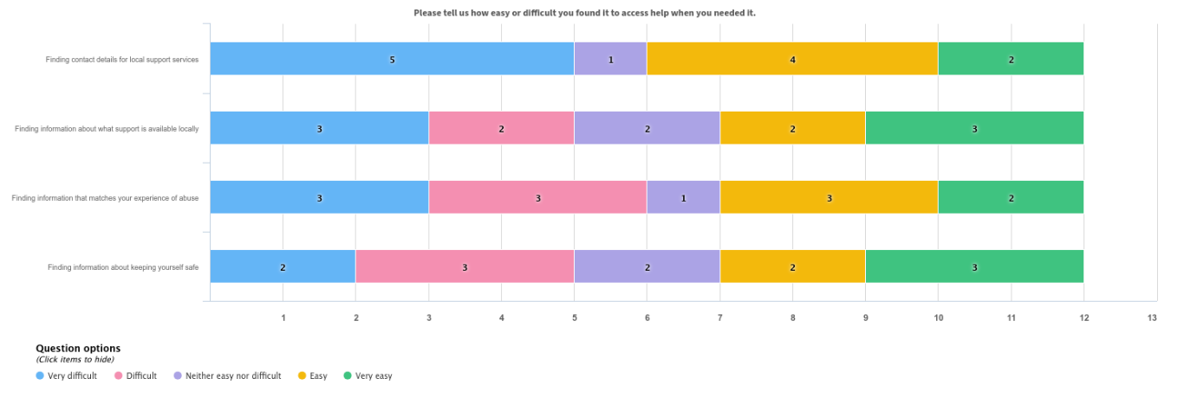

Comments about finding information and support included:

Harbour were fantastic, police were too slow to respond in some events social services were terrible to deal with in regards to protecting my child from domestic abuse.

I suffered every form of domestic/sexual abuse and found myself alone cut off and unable to even speak or receive what was happening to me.

Harbour were useless - long wait lists for counselling and support. Cleveland Police are shameful at handling these cases and got me to drop the case due to insufficient evidence to support my mental health but really it was to save themselves the work. My IDVA and the rape centre in Middlesbrough was amazing.

Services are available but waiting list far too long iv waited over 12 months still not got appointment.

Iv begged for the last few months for help to be told to move on with my life nobody is really interested you get told to phone 111 or samarathons [sic] which don't really help or other on line groups these people aren't supportive of your needs iv.been here twice my first time was ten years ago with my ex husband and agian now with my ex partner

I was referred to social services and given information about the Harbour Domestic abuse services in Hartlepool. Getting in touch with the refuge was very easy and I was able to access help straight away.

Very easy to find the information if you look for it and the posters in healthcare places - getting the help from it is another case.

The service user group were asked who they approached for help. The most common response (almost double the number of responses for any other option) was “Harbour”, the second most popular response was “friends or family” and in third was jointly the “police” and “healthcare practitioner”. They were also asked about the initial response each provider made to their approach. Again, it was roughly a fifty-fifty split between poor/very poor and good/excellent. The breakdown is shown below in Chart 2 (note only those options which received a response are included in the chart):

Chart 2: When you contacted a support service for help, was their initial response…?
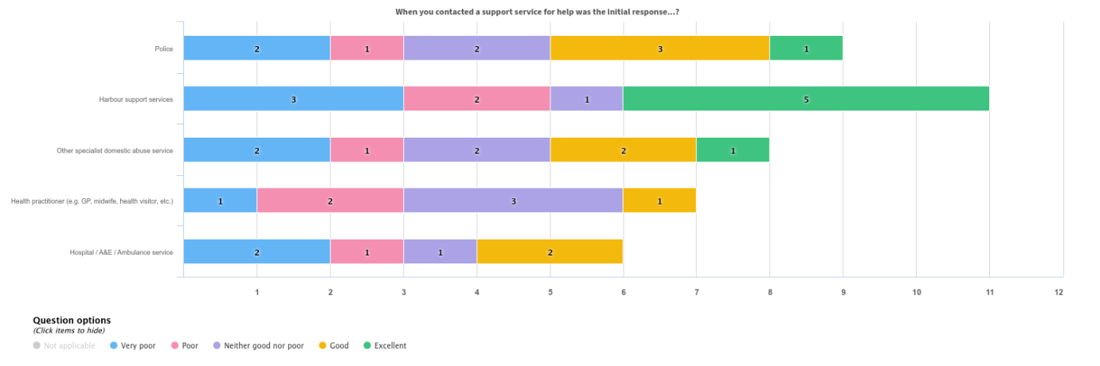

Comments received relating to the initial contact included the following:

Harbour were brilliant very supportive, police did not respond to some incidents as quickly as needed, social services were terrible in communicating, cancelling meetings not turning up for visits etc.

The whole experience was terrible I found myself being misunderstood constantly. I would ask for help by the tie I was contacted back more abuse had taken place and it continued in circles until I had nothing left. (Health, home, family, friends, employment and self respect).

Police not interested the fact your Ben harassed [sic: you are being harassed] by ex partner and family or the fact he already has criminal record for knife crime harbour tell you to move on with your life or put you in s [support] group which involves colouring books in or asking grafts that's not support.

Harbour have been absolutely fantastic in helping me and my young children flee domestic abuse. We would still be with the perpetrator if they hadn’t provided us with shelter and clothed and fed us. I will be eternally grateful to the staff at the Hartlepool refuge. They have saved my children’s future.

Comments relating to other services not listed in the previous question:

Social services were involved but their input was neither supportive or pro active, the would arrange meetings and not turn up or contact myself, did not support myself or my child productively hardly any communication unless Marac meetings were taking place very unprofessional.

I spoke to Samaritans and self referred to my sister place in Middlesbrough. Received therapy but it was stopped and I was told it was by the request of Hartlepool Services. No one contacted me after and I found myself back in the same violent situation and needed to give up work. I then rang local services asking for help or a place in refuge and it took 3 months before I was contacted back.

Although (as already stated) the sample size is small, these responses and comments suggest that initial responses from services can be a bit “hit and miss”; and that where the initial response is not positive, it can cause serious problems for the victim/survivor.

When the service user group were asked about specialist services, only a small proportion of the respondents had used the services on the list. However, for all but one of the specialist services listed several respondents said that they would have used the service if they had been offered it. This suggests there may be a level of unmet need for specialist domestic abuse support services. The fact that no respondents requested men’s services is reflective of the fact that all but one of the survey respondents were female. There may well be more demand from the wider community for specialist men’s services. Chart 3 shows the breakdown of responses. The specialist services listed were:
- BAME services
- LGBTQ+ services
- Men’s services
- Children’s and young people’s services
- Claire’s Law (Domestic Abuse Disclosure Scheme)
- Specialist domestic abuse financial / debt support
- Specialist domestic abuse legal support

Chart 3: Did you use any of these specialist services?

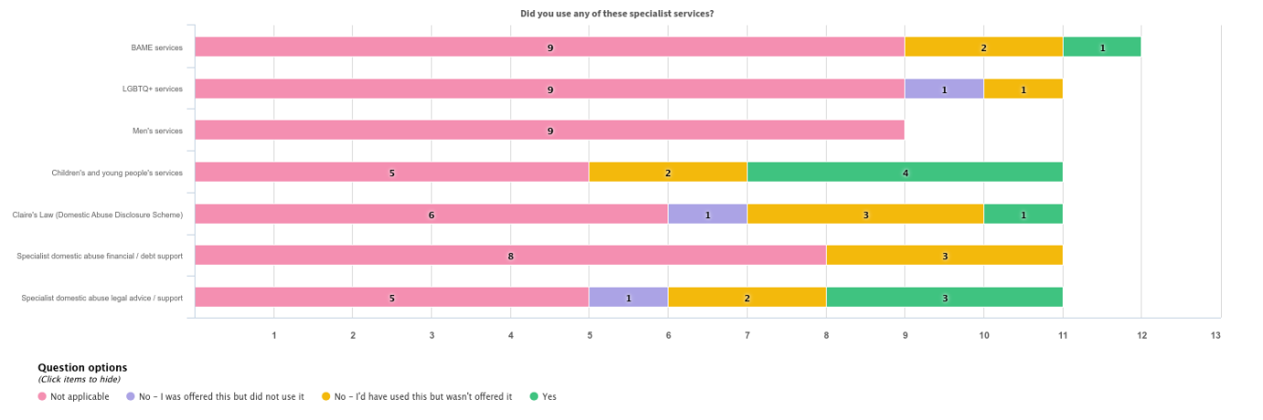

When asked to comment on specialist domestic abuse services, respondents said:

To have been supported in line with the law. My Children have both been affected by my situation but never offered help.

Housing support were great with me and really did help me and support me in finding a place to live

Telephone helplines - Childline listened but I felt like they did not understand and kept telling me to go to the police, even though I had already been, and they did not want to do anything. Need a solution for people who are at a dead end.
Refuge accommodation - the safest I ever felt. I could not be found by him, and there was a system in place if he did find us. The only unnerving thing was that workers frequently came into our flat without knocking or notice, which was embarrassing for me as a teenage girl. It would be good if that could change.
Counselling - I used so many of these and had a consistently poor experience…I was terrified of our social worker who had betrayed my trust every time and made it clear that she did not believe me.

When asked if they had needed to move out of their local area to find safe accommodation, the majority of the service user group (7) had not. Of those that had moved, 2 had moved out of Hartlepool to another area, while 3 had moved into Hartlepool from elsewhere.

The service user group were also asked if they had been offered follow up support once their contact with services had ended. Half of respondents (6) had not been offered follow up support but indicated that they would have used it had it been offered. This suggests that where follow up support is available, and appropriate, service users would appreciate being made aware of it. Of the remaining respondents, 3 indicated that they had been offered follow up support and had used it, while 1 was offered follow up support but declined.

Respondents who had used follow up support made the following comments about the service they received:

Emotional support it helped me having someone to speak too who showed understanding and compassion.

Harbour outreach service was invaluable in helping me regain my independence.

I had a worker come out every week to get me into the community, but it was really hard to click with her and I didn't know what I was supposed to do with her. We usually went to get food and eat in her car, but she didn't like this. I was scared to go anywhere with her because I didn't want anyone at school knowing or my family finding me. It didn't really work, but it did get me a break from home which did help.

When asked about how they felt when their involvement with services ended, the service user group were again split between positive and negative feelings. The two areas where there were more negative feelings than positive ones were that respondents disagreed that they “felt safer” and also disagreed that they felt they had “a say in decisions made about me”. This is concerning because the purpose of domestic abuse support services is to make the people who use them safe; however, the small sample size could be affecting the result and further investigation into client feedback would be required to find out if this is a significant issue for people leaving services. Chart 4 shows the breakdown of responses. The options were:
- I felt safer
- I felt listened to
- I felt services were supportive and appropriate for people like me
- I felt I had a say in decisions that were made about me
- My overall experience of using the service was positive

Chart 4: Please tell us how much you agree or disagree with the following statements when your involvement with services ended.
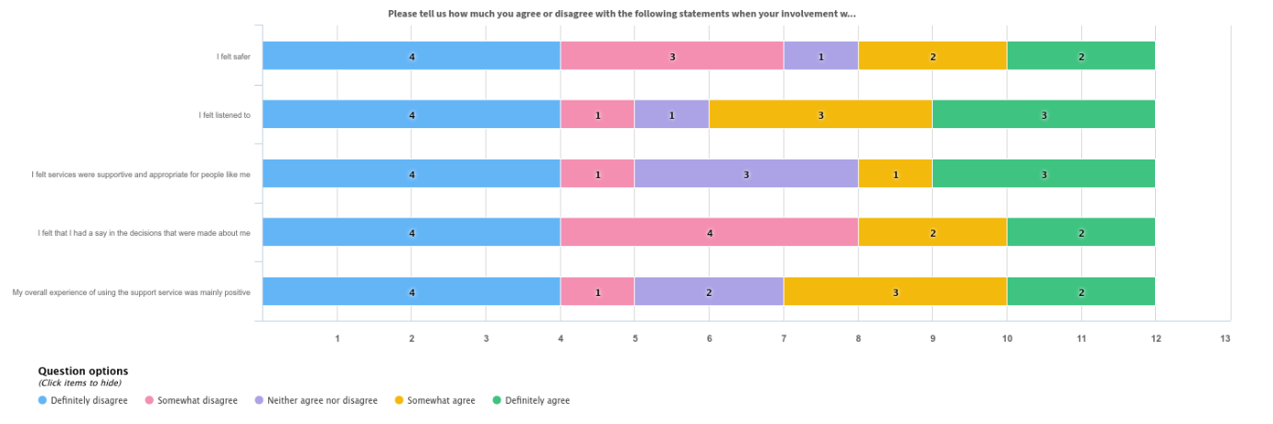

The service user group were also asked about their children and any support offered for them. Just over half the group had children (7 compared to 5 who did not). Of those with children, 5 were offered support for their children (of which 3 used the support and 2 declined it). One was not offered any support and the other skipped this question.

Three comments were received about the support offered:

Children's course.

Social services provided terrible support arranging and cancelling meetings, being met with poor attitude and made to feel like a bad person. Harbour were fantastic with myself and my child and provided a lot of support.

Harbour family support worker.

All the respondents who answered the question (3) said it was either “easy” or “very easy” to access the support for their children they had been offered. Two of the three also said that the support had been “good” or “excellent” and one said it was “neither good nor poor”.

Finally, the service user group were asked if they had any further comments to make about their experience of using domestic abuse support services in Hartlepool. The following are a selection of the comments received:

More needed for Men.

No I have not needed services but believe there needs to be more provision for people with pets as in my experience victims are already subject to trauma without having to leave their pets, therefore more likely to remain in an abusive relationship.

I told a housing officer from the council i needed housing as I'd left my partner, implying abuse and because we owned the house they told me to go back until it sold.

Police should respond to all reports of stalking and domestic abuse and not arrange appointments for the following day, social services should be attending planned meetings and not turning up or supporting children included in domestic abuse cases. Harbour were fantastic and provided all the positive support I needed to get a conviction for my abused which saw him sent to prison and given a restraining order.

The 6 months wait time for eligibility for local welfare support is crippling families that are subject to DA.

I had a girl called Nicola she supported and valued my options,, I will be forever grateful for her time and compassion.. it is so scary when you are living in a abusive relationship and feel you have no one.

Harbour refuge at Hartlepool was absolutely amazing. We arrived with nothing and they clothed and fed myself and my two young children and looked after us until we were able to leave and move into a property of our own. They definitely need more resources as they rely heavily on donations. With a little funding they could work miracles. They saved our lives.

I didn’t know the service was available to everyone. I always thought that the services were only for physical abuse. I have encountered verbal abuse and economic abuse and coercion. I recently had verbal abuse and was made to feel that I was the one with the problem because it was only meant as a joke. Even though it was offensive, derogatory and at the time the situation was frightening. Sadly the effect of husband drinking alcohol. I become the target.

Believe what the children say. My life was immeasurably changed and somewhat ruined by the treatment I received by police, social workers, medical professionals. Also you cannot lump together Harbour and the police for instance. I could not have had a worse experience with the police but Harbour was fantastic and I will always support their work. However, I am terrified of the police…

Conclusions

Unfortunately, the small sample size means that it is difficult to draw meaningful conclusions from the survey data. However, some common threads are apparent such as that early intervention and preventative help would have greatly benefited some respondents. Understanding, empathy and listening to victims were also highlighted as being key things people would like to see from services.

Additionally, the response that people receive when they first contact services is crucial as to whether they go on to access and have a good relationship with that service. Also, where people are made aware of follow up support that is available, they often go on to use this support. These are points that services may like to consider going forward.

The fact that over half of the respondents had some kind of limiting health condition or disability is very important. Consideration should be given as to how domestic abuse services can be made more accessible to people with disabilities (tying in with ongoing work across the Council in light of the recommendations of the Scrutiny Committee investigation into improving disabled access to all our services).

Additionally, Harbour service users are also encouraged to access the recovery service once formal support has ended and contribute to the Service User Panel to inform strategic decisions.

Issue number | Strategic Issues Arising from Consultation  The following strategic issues were identified from the consultation. They have been considered in the overall findings and are represented in the final strategic issues outlined in section 6.
1 | People with disabilities are more likely to experience domestic abuse than the general population and Hartlepool has a higher rate of disability and ill health than the England rate. 59% of the survey respondents reported a limiting health condition or disability.
2 | Services need to be visible and accessible. There needs to be further education and awareness raising to reduce the stigma of domestic abuse and break down barriers. Some respondents in the survey stated they “were not aware of anything locally” or were “managing the situation themselves”.
3 | Services need to be trauma informed and use professional curiosity, including in cases where service users decline to engage. Training should be provided to multi-agency practitioners in recognising and responding to domestic abuse and ensure that practitioners are aware of the many forms of domestic abuse and the definition of ‘personally connected’ covering intimate partners and family members. One respondent highlighted “staff should have more appropriate training”

- Strategic issues
Issue number | Strategic Issue
1 | There is an insufficient availability of support services for victims and survivors of domestic abuse, particularly for those who are hidden from services or have complex needs. This limits early intervention and identification of domestic abuse, recovery, and long-term safety.
2 | Children affected by domestic abuse are not consistently recognised as victims in their own right, and current services are not always responsive to their needs—whether in the home, in their own relationships, or in cases of child/adolescent to parent violence and abuse (CAPVA).
3 | There is a lack of consistent accountability for perpetrators of domestic abuse, and existing intervention services may not be sufficiently effective in changing behaviour or reducing repeat offending.

- Evidence base
Issue number
1 | Source | Robinson, A. L., & Davies, B.
1 | Title incl. web link | ‘Specialist policing units as a pathway towards procedural justice for domestic abuse victims.’
1 | Summary | This study highlights how victims with complex needs often face significant barriers to accessing support. It evaluates specialist policing units in Wales and finds that dedicated, victim-led services with multi-agency collaboration improve outcomes for victims, particularly those who are reluctant to engage due to complex circumstances
1 | Source | Standing Together Against Domestic Abuse
1 | Title incl. web link | ‘In Search of Excellence. A refreshed guide to effective domestic abuse partnership work – The Coordinated Community Response (CCR)’  https://static1.squarespace.com/static/5ee0be2588f1e349401c832c/t/5fd78eaf72a0a65a94da967e/1607962290051/In+Search+of+Excellence+2020.pdf
1 | Summary | Every agency who has a responsibility for dealing with survivors, their children and/or perpetrators, must work effectively within their own agency and with all other agencies who also have that responsibility, to secure the safety of the survivor and their children and hold perpetrators to account. The process by which this work is integrated and managed is known as the CCR.
2 | Source | Domestic Abuse Commissioner
2 | Title incl. web link | ‘Victims in their own right? Babies, children and young people’s experience of domestic abuse’  https://domesticabusecommissioner.uk/wp-content/uploads/2025/06/dac_bcyp_main-report_V6-DIGITAL.pdf
2 | Summary | Victims in their own right?’ examines the current response to children and young people who experience domestic abuse at home or in their family across both the statutory and non-statutory response.
2 | Source | Mayor of London Violence Reduction Unit
2 | Title incl. web link | ‘Comprehensive needs assessment of Child/Adolescent to Parent Violence and Abuse in London’  https://www.london.gov.uk/sites/default/files/comprehensive_needs_assessment_of_child-adolescent_to_parent_violence_and_abuse_in_london.pdf
2 | Summary | The comprehensive needs assessment was commissioned to explore the scale and nature of CAPVA in London, to ensure services and support for children, young people and families is grounded in evidence. The research findings will inform a public health approach to violence prevention and reduction.
3 | Source | Hilder, S., & Freeman, C.
3 | Title incl. web link | ‘Working with Perpetrators of Domestic Violence and Abuse: A UK Perspective. In Domestic Violence and Abuse: Contemporary Issues and Innovations.’
3 | Summary | This chapter explores the evolution of perpetrator intervention programmes in the UK, identifying challenges in holding perpetrators accountable and ensuring programme effectiveness. It stresses the need for evidence-based, coordinated approaches to reduce reoffending
3 | Source | Jane Monkton Smith
3 | Title incl. web link | ‘The Homicide Timeline’  What is the Homicide Timeline | Homicide Timeline
3 | Summary | The Homicide Timeline™ is a new framework for tracking homicide risk in cases of coercive control and stalking.  This eight stage sequence is based on research which looked at over 400 cases of intimate partner homicide to identify a common behavioural pattern that can be used in a practical way by professionals to assess threat and risk.

- What is being done and why?
Overview of current Domestic Abuse services

National Domestic Abuse Services

- Women’s Aid
- Refuge
- Man Kind
- Men’s Advice Line
- Dog’s Trust Freedom Project
- Forced Marriage Unit
- Galop
- Paladin
- Respect

Regional Domestic Abuse Services

There are several agencies who provide specialist services across the Cleveland and Tees area including -

Halo provides safeguarding and on-going confidential advice, help and support to black and minoritised women, girls and children who are at risk of and/or are survivors of domestic and sexual violence and abuse, including forced marriage, honour-based abuse and female genital mutilation. Community support includes refuge accommodation, help to stay safe, practical, emotional and cultural support, including legal, financial and community education.
ARCH Teesside is a specialist sexual violence service offering free and confidential support, help and advocacy to people in the Teesside area who have experienced rape and sexual abuse at any point in their lives.
A Way Out is an outreach and prevention charity which aims to engage, empower and equip vulnerable and excluded women, families and young people to live lives free from harm, abuse and exploitation and to reduce life-limiting choices and behaviour.
Suzy Lamplugh Trust offers expert advice in lone-working and personal safety training, stalking training, as well as consultancy, campaigning, and support services. Across the Cleveland area, Suzy Lamplugh Trust provides support to victims of stalking via an Independent Stalking Advocacy Caseworker (ISAC).

Local Domestic Abuse Services

Harbour is the commissioned service provider for an integrated response to victims and survivors, including children, and perpetrators of domestic abuse in Hartlepool. This includes the provision of safe accommodation comprising of –
- a 7-unit refuge for women and children, inclusive of one space for disabled people and one space to be used for emergency use for a maximum of 7 days,
- a 6-unit refuge for single women with complex needs
- 3 dispersed properties for all victims of domestic abuse

Harbour also delivers a Sanctuary scheme to residents of Hartlepool in tandem with Crime Prevention Officers in Cleveland Police.

The number of units of safe accommodation available in Hartlepool has increased year on year since 2021. However, Hartlepool does not currently have any specialist or second stage (move-on) accommodation.

In addition to safe accommodation, Harbour are commissioned to deliver –
- outreach and assertive outreach in the community,
- empowerment programmes,
- counselling
- a dedicated children and young people therapeutic service
- a preventions service and programme for those who cause harm.
- Three specialist roles for the CHUB, safeguarding and assessment teams and early intervention.

Service users are also encouraged to access the recovery service once formal support has ended and contribute to the Service User Panel to inform strategic decisions.

Harbour offers services to the whole community, including –
- Women, men and trans people
- People from all ethnic groups and backgrounds
- People from the LGBTQ+ community
- Disabled people
- Children

In addition to this, the Office for Police and Crime Commissioner for Cleveland fund an IDVA in each locality, as well as specialist IDVA’s for –
- Mental Health
- Hospital
- Children and Young People
- Court
They are subject to grant funding until March 2026.
The Office for Police and Crime Commissioner for Cleveland has launched a Teeswide Tackling Domestic Abuse Perpetration Strategy for 2025 – 2035.
The Tackling Domestic Abuse Perpetration Strategy identifies three key priorities:
- Prevent – by identifying, responding and referring concerns at the earliest opportunity.
- Protect – by identifying perpetrators and holding abuse behaviour to account.
- Pursue – by using protective measures to disrupt and prosecute perpetrators.

Hartlepool Borough Council has commissioned the Safe and Together Model as framework to improve the response to domestic abuse to families involved in children’s services. An implementation plan is underway to develop this across multi-agency partners.

- What needs are unmet?
Issue number | Unmet need
Hidden victims and victims with multiple and complex needs | Whilst service provisions are available and inclusive for all, the needs assessment has shown a cohort of hidden victims who may face barriers to accessing services. Additionally, local data has shown that victims support needs in relation to mental health, disability and substance use is increasing and becoming more multi-faceted, creating a greater need and demand on services.
Children and young people | The demand for services for children is increasing. There needs to be a focus on children being recognised as victims. Additionally, further work needs to be completed to understand the need of CAPVA. A standalone domestic abuse strategy for children should be considered.
Perpetrator accountability and provision | Data has shown that perpetrators of domestic abuse are committing multiple crimes and repeating this pattern of behaviour. The current perpetrator provision has seen an increase in repeat referrals therefore the effectiveness of the provision needs to be considered.

- What needs to be done and why?
Issue number | What needs to be done? | Why?
1 | - Early intervention and prevention. Awareness raising and promotion of services, especially with hidden victims (such as those with disabilities, from ethnic minority groups or different cultural backgrounds and male victims) and those with complex needs  - Utilise existing service user forums to ensure that victim and survivor voice informs the commissioning and delivery of services  - Ensure services are accessible, trauma-informed and use professional curiosity when individuals decline their service or do not engage  - Provide training to multi-agency practitioners in recognising and responding to domestic abuse and ensure that practitioners are aware of the many forms of domestic abuse and the definition of ‘personally connected’ covering intimate partners and family members  - Ensure pathways and information sharing is robust, including MARAC, MATAC and HRAP  - Consider alternative safe accommodation options including specialist, by and for and move-on.  - Review the proportion of out of area referrals both in and out of Hartlepool.  - Consider a multi-agency dashboard to create consistency in the recording and reporting of data relating to domestic abuse  - Understand the effectiveness of the Domestic Violence Disclosure Scheme (Clare’s Law).  - Continue to implement the Safe and Together model across multi-agency partners to standardise the response victims receive | Domestic abuse has a devastating impact on both the victims and the wider community. Providing early intervention and prevention approaches are both life saving and will be cost effective in improving the health and wellbeing of the community.  In view of the fact that disabled people are more likely to be victims of domestic abuse and individuals in Hartlepool are more likely to have a disability or report poor health, it is vital that we have accessible services and information.
2 | - Focus on early intervention and prevention to ensure all children understand healthy relationships  - Ensure all services are recognising children as victims in their own right  - Ensure therapeutic support services are available for children  - Review the prevalence of CAPVA, the demand on services and ensure that the offer in place can meet the need of children and their parents.  - Understand the effectiveness of Operation Encompass  - Continue to implement the Safe and Together model across multi-agency partners to standardise the response children as victims receive | Children experience domestic abuse both in their family homes and in their own interpersonal relationships. This can have a lasting adverse impact through childhood and into adulthood.
3 | - Support the OPCC Perpetration Strategy  - Review the criminal justice response to perpetrators within Hartlepool  - Monitor the effectiveness and engagement of perpetrator provision  - Reduce repeat offending and the number of repeat high risk MARAC cases  - Continue to implement the Safe and Together model across multi-agency partners to standardise the response perpetrators receive | Without addressing perpetrators behaviour, the cycle of abuse will continue.

- What additional needs assessment is required?
Firstly, there will continue to be an underreporting of domestic abuse.
The data that is currently available from different sources has issues relating to
- Collection periods
- Data quality and quantity
- Interpretation of data
- Recording of demographics
To effectively understand the need of domestic abuse within Hartlepool, an agreed set of data standards across all services would need to be developed.
Review the need, demand and effectiveness of –
- Operation Encompass
- CAPVA
- Domestic Violence Disclosure Scheme (Clare’s Law)
- Perpetrator interventions
Response to consultation is low, therefore further consideration should be given for how to incorporate the victims voice to inform the commissioning and delivery of services.

- Key contacts and references

Key contact

Name: Olivia Highley
Job title: Domestic Abuse Coordinator
Organisation: Hartlepool Borough Council
Email: Olivia.Highley@hartlepool.gov.uk
Phone number: 01429523919
Contributor/s:
Hartlepool Borough Council
Cleveland Police
Harbour Support Services
Halo
North Tees and Hartlepool NHS Foundation Trust
Tees, Esk and Wear Valley NHS Foundation Trust

References

See end of document for references

Appendices
Appendix 1

Definition

The Domestic Abuse Act 2021 created a statutory definition of domestic abuse, emphasising that domestic abuse is not just physical violence, but can also be emotional as well as coercive and controlling behaviour. Section 1 sets out the definition as follows –

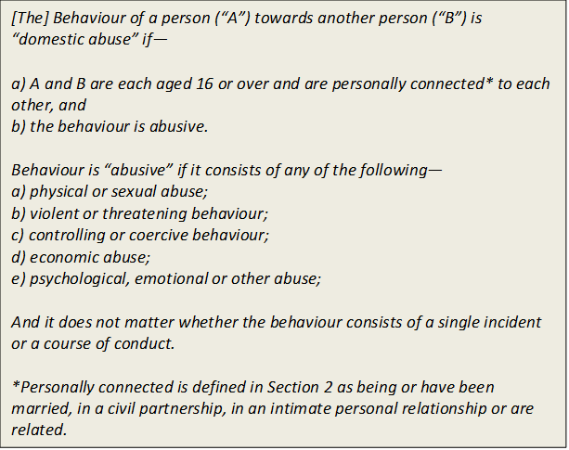

Section 1 of the Act also gives a statutory definition to economic abuse for the first time as:

“Economic abuse” means any behaviour that has a substantial adverse effect on B’s ability to—
(a) acquire, use or maintain money or other property, or
(b) obtain goods or services.

The Act also defines child victims of domestic abuse in Section 3:

1) This section applies where behaviour of a person (“A”) towards another person (“B”) is domestic abuse.
2) Any reference in this Act to a victim of domestic abuse includes a reference to a child who—
a) sees or hears, or experiences the effects of, the abuse, and
b) is related to A or B.

Coercive and controlling behaviours within an intimate or family relationship are defined in Section 76 of the Serious Crime Act 2015:
A person (A) commits an offence if— a) A repeatedly or continuously engages in behaviour towards another person (B) that is controlling or coercive, b) at the time of the behaviour, A and B are personally connected, c) the behaviour has a serious effect on B, and d) A knows or ought to know that the behaviour will have a serious effect on B. A and B are “personally connected” if— a) A is in an intimate personal relationship with B, or b) A and B live together and— i. they are members of the same family, or
ii. they have previously been in an intimate personal relationship with each other. A’s behaviour has a “serious effect” on B if— a) it causes B to fear, on at least two occasions, that violence will be used against B, or b) it causes B serious alarm or distress which has a substantial adverse effect on B’s usual day-to-day activities.

Appendix 2
Domestic Abuse Act and Statutory Guidance
The Domestic Abuse Act received Royal Assent in 2021 and as well as setting out a legal definition of domestic abuse and recognising children as victims it also –
- Appointed the Domestic Abuse Commissioner and set out their functions and powers
- Introduced Domestic Abuse Protection Orders and Domestic Abuse Protection Notices
- Placed a duty on local authorities to provide safe accommodation with support to victims and children
- Prohibit perpetrators from cross-examining victims in civil and family courts and provide special measures to victims in criminal, civil and family courts
- Created a new offence of non-fatal strangulation
- Extended coercive and controlling behaviour to cover post separation abuse
- Extending the ‘revenge porn’ offence to cover threats to disclose material
- Reinforcing that an individual cannot consent to their own death to eliminate the ‘rough sex gone wrong’ defence.
- Provide eligible homeless victims with ‘priority need’

Part 4 of the Domestic Abuse Act sets out the statutory duties on local authorities to –
- Carry out a needs assessment for accommodation based support and use this needs assessment to;
- Publish a strategy and monitor and evaluate the effectiveness of the strategy in providing safe accommodation
- Appoint a multi-agency Domestic Abuse Partnership Board including representation of victims and children of domestic abuse
- Present an annual report to the Secretary of State
The Domestic Abuse Partnership Board meets quarterly to monitor the implementation of the Domestic Abuse Strategy and Action Plan and reports into the Safer Hartlepool Partnership.

The statutory guidance was published in July 2022 and includes agency and multi-agency response to domestic abuse. Following this, the Government published their Tackling Domestic Abuse Plan which focuses on prioritising prevention, supporting victims, pursuing perpetrators and a stronger system

Each individual agency should have provisions in place in responding and identifying domestic abuse, including the use of the DASH risk assessment when professionals are trained to use the tool, using professional judgment and indicators to identify and manage risk.

The statutory guidance of Working Together to Safeguard Children (2023) should be used in conjunction with the Domestic Abuse Act (2021) when responding to abuse involving children under the age of 18.
Other relevant legislation -
- Serious Violence Duty
- Victims and Prisoners Act
- The Care Act
- Homelessness Code of Guidance
- National Statement of Expectations
Appendix 3
Glossary
Physical abuse
Physical assault including hitting, shoving, kicking, head-butting, slapping, hair pulling and assault with weapons. Also includes threatening to carry out any of these actions.
Sexual abuse
Any unwanted sexual contact including rape.
Verbal abuse
Shouting, swearing, calling names.
Economic abuse
Taking away someone’s resources or economic independence. May involve actions like preventing the victim going to work or taking away their wages; taking out debt in the victim’s name (with or without their knowledge); ruining the victim’s credit score to make it difficult for them to access credit; damage to possessions and property.
Emotional abuse
Attacking the victim’s personality by insulting or demeaning the victim, telling them they are worthless or unlovable, that everything is their fault, that they are a bad spouse/partner/parent, etc.
Gas lighting
A form of emotional abuse where the perpetrator causes the victim to doubt their own thoughts, memories, the events happening around them and even their own sanity.
Child contact abuse
Using child contact arrangements to abuse or harass the victim, for example, telling the victim they will report them as a bad parent to have the children removed or if they have been removed that it was the victim’s fault; repeatedly taking the victim back to Family Court (particularly if the victim does not have access to legal aid); making malicious reports to social workers about the victim; encouraging the children to abuse the victim as well.
Online abuse
Using social media to stalk or harass the victim; posting or threatening to post indecent images of the victim online (revenge porn); installing “spyware” software on the victim’s computer and/or smart phone to monitor their online activity or to track their “real-world” movements.
Stalking
Following, watching or spying on the victim - can be “real world”, online or both.
Harassment
Repeated attempts to force contact or communication with the victim – can also include attempts to contact others connected with the victim e.g. family members, friends and co-workers.
LGBTQ+
Abuse based around an individual’s sexuality e.g. saying the individual is “too gay” or threatening to “out” the survivor to family, co-workers, etc. who are not aware of their sexuality. LGBTQ survivors can face abuse from their partner and / or their family. They can also face hostility and prejudice from services.
Child-to parent abuse
A pattern of abuse that causes the parent(s) to fear the child. In the context of young people and family violence, this can also extend to siblings and other members of the household. In an adult child-to parent-abuse context the abuse may revolve around the elderly parent(s) care needs, for example, the adult child’s refusal to allow care for their parent as the cost will reduce their inheritance.
Disabled people
Disabled people can face abuse related to their disability and / or care needs, for example withholding medication; removing a disabled person’s wheelchair or placing obstacles in the path of a blind person to restrict their mobility; using abusive language when talking to or about the survivor e.g. saying they are a burden. If the abuser is also the carer then the risk to the victim is even greater.
Older people
Similarly to disabled people, older people can face abuse related to their care needs, particularly if the abuser is also the person’s carer. They can also face abuse from their adult children. Services can confuse signs of abuse for age-related infirmity.
Young people
Young people in abusive teen relationships face similar types of abuse as adults. As young people often have a large online presence they may also experience additional types of abuse related to this e.g. sexting, revenge porn and online stalking and harassment. Young people may also face abuse within a family context from siblings. They may also experience abuse from a parent if they are still living at home beyond age 16 (for purposes re: domestic abuse below age 16 would be classed as child abuse not domestic abuse however it also needs noting that a child aged 16-18 can still be defined as child abuse).
Honour-based violence (HBV)
HBV is motivated by a desire to preserve the “honour” of the perpetrator and / or the wider family. HBV can be perpetrated by the intimate partner and / or other family members. HBV victims are more likely to experience abuse from multiple perpetrators. Factors such as disability, sexuality and being “Westernised” can increase the risk of HBV. Forced marriage and FGM is a significant part of the abuse for many victims of HBV
Female Genital Mutilation (FGM)
FGM involves any procedures involving partial or total removal of the external female genital organs or any other injury to the female genital organs for non-medical reasons. It is most often carried out on young girls aged between infancy and 15 years old. This is child abuse and must be treated as such. Forced marriage A forced marriage is where one or both people do not or (in cases of people with learning disabilities or reduced capacity) cannot consent to the marriage and they are pressurised, or abuse is used, to force them to do so. Rejecting a forced marriage can be a trigger for HBV.

Office for National Statistics https://www.ons.gov.uk/peoplepopulationandcommunity/crimeandjustice/bulletins/domesticabuseinenglandandwalesoverview/november2024 (Accessed July 2025)
Office for National Statistics https://www.crimesurvey.co.uk/en/SurveyResults.html (Accessed July 2025)
Office for National Statistics https://www.ons.gov.uk/peoplepopulationandcommunity/crimeandjustice/bulletins/crimeinenglandandwales/yearendingmarch2024#domestic-abuse (Accessed July 2025)
The Home Office https://assets.publishing.service.gov.uk/media/5f637b8f8fa8f5106d15642a/horr107.pdf (Accessed July 2025)
Nomis https://www.nomisweb.co.uk/sources/census_2021/report?compare=E06000001 (Accessed July 2025)
Office for National Statistics https://www.ons.gov.uk/peoplepopulationandcommunity/crimeandjustice/articles/domesticabuseprevalenceandtrendsenglandandwales/yearendingmarch2024#data-on-domestic-abuse-in-england-and-wales (Accessed July 2025)
Public Health England https://fingertips.phe.org.uk/search/domestic%20abuse%20rate (Accessed July 2025)
Safer Hartlepool Partnership https://www.hartlepool.gov.uk/meetings/meeting/4471/safer_hartlepool_partnership (Accessed July 2025)
Office for National Statistics https://www.ons.gov.uk/peoplepopulationandcommunity/crimeandjustice/datasets/domesticabuseinenglandandwalesdatatool (Accessed July 2025)
Operation Encompass https://www.operationencompass.org/why-was-operation-encompass-created (Accessed July 2025)
Safe Lives https://safelives.org.uk/about-domestic-abuse/domestic-abuse-response-in-the-uk/what-is-a-marac/ (Accessed July 2025)
Teeswide Safeguarding Adults Board https://www.tsab.org.uk/key-information/policies-strategies/high-risk-adults-panel/ (Accessed July 2025)
Local Government Association https://www.local.gov.uk/publications/domestic-homicide-review-survey-2024 (Accessed July 2025)
Domestic Abuse Commissioner https://domesticabusecommissioner.uk/domestic-abuse-commissioner-responds-to-new-report-revealing-the-scale-of-domestic-homicide-and-suicide/ (Accessed July 2025)
NHS England https://digital.nhs.uk/data-and-information/publications/statistical/safeguarding-adults (Accessed July 2025)
Tees, Esk and Wear Valley NHS Foundation Trust https://www.tewv.nhs.uk/ (Accessed July 2025)
North Tees and Hartlepool NHS Foundation Trust https://www.nth.nhs.uk/news/new-domestic-violence-advocate-supporting-teesside-patients-and-staff/ (Accessed July 2025)
Office for National Statistics https://www.ons.gov.uk/peoplepopulationandcommunity/crimeandjustice/articles/domesticabuseprevalenceandtrendsenglandandwales/latest (Accessed July 2025)
Hourglass https://wearehourglass.org/domestic-abuse (Accessed July 2025)
Respect https://www.respect.org.uk/pages/114-capva (Accessed July 2025)
Reducing The Risk https://reducingtherisk.org.uk/disabilities-and-domestic-abuse/ (Accessed July 2025)
Reducing The Risk https://reducingtherisk.org.uk/lgbtq/ (Accessed July 2025)
Cleveland Police and Crime Commissioner https://www.cleveland.pcc.police.uk/wp-content/uploads/2025/04/Tees-wide-Tackling-Domestic-Abuse-Perpetration-Strategy-2025-2035-1.pdf (Accessed July 2025)
Safe and Together Institute https://safeandtogetherinstitute.com/ (Accessed July 2025)
Home Office https://www.gov.uk/government/publications/domestic-abuse-bill-2020-factsheets/domestic-abuse-bill-2020-overarching-factsheet (Accessed July 2025)
HM Government https://assets.publishing.service.gov.uk/media/624422988fa8f527785ed11c/E02735263_Tackling_Domestic_Abuse_CP_639_Elay__002_.pdf (Accessed July 2025)
Home Office https://www.gov.uk/government/publications/domestic-abuse-act-2021/domestic-abuse-statutory-guidance-accessible-version (Accessed July 2025)

