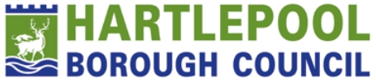

Hartlepool Gambling Health Needs Assessment

Contents
Glossary 3
An introduction to Gambling 4
Method 6
What is gambling and why do people gamble? 7
How do people experience gambling harm? 15
Where do people gamble? 22
How do people get support? 26
Data Gaps and Recommendations 32
Bibliography 35
Appendix 40

Glossary
ADPH NE: The Association of Directors of Public Health North East, who provide a collaborative network working in partnership with the wider North East Public Health Community to strengthen the voice for public health across the region.
Affected other: a term used to describe those who may be affected by someone who is experiencing gambling harms and can refer to friends, family and those in someone’s wider circle, such as colleagues.
Gambling-related harms: The negative impacts from gambling on the health and wellbeing of individuals, families, community and society.
Gambling harms network: A network with representation from the 12 local authorities in the North East to share best practice.
Health inequalities: Unfair and avoidable differences in health across the population, and between different groups within society.
Health needs assessment: A systematic approach to understanding the needs of a population, involving the assessment of local, regional and national data, and direct engagement with the communities of interest.
IMD: The Index of Multiple Deprivation (IMD) is a measure of relative deprivation in England, and broadly defines deprivation to encompass a wide range of an individual’s living conditions. Nationally, deprivation quintiles can be used to categorise relative deprivation, meaning the population is split into five equal groups based on deprivation score.
Lived experience forum: A group of individuals who have experienced gambling harms or are an affected other in the North East.
MECC: Make Every Contact Count is a recognised model of secondary prevention, designed to encourage brief interventions based on asking, assisting and acting.
NECA: A registered charity that provide treatment and support, raising awareness of gambling harms in the North-East.
NHS Northern Gambling Service: An NHS clinic that specialise in delivering support and treatment for gambling-related harms across Northern England.
NSPCC: The National Society for the Prevention of Cruelty to Children, a child protection charity.
OHID: The Office for Health Improvement and Disparities, part of the Department of Health and Social Care.
Problem Gambling Severity Index (PGSI): A validated screening tool designed for use amongst the general population.
Suicidal ideation: Thoughts about taking own life.
Unhealthy commodity: A product that is harmful to health.
VCSE: Voluntary, community and social enterprises.

An introduction to Gambling
This needs assessment aims to collate local and regional evidence and data to describe gambling and gambling harms in Hartlepool. Evidence and data are taken from literature and the Regional Health Needs Assessment (for Gambling).
The health impacts of gambling at elevated risk levels are widespread. Gambling has broad impacts at both an individual and community health and wellbeing level. The total excess cost of health harms (governmental and wider societal) from gambling is estimated to be between £754.4 - £1,475.0 million (OHID, 2023). In the North East, it is estimated that 4.9% of the population (aged 16+) are at-risk gamblers, where they experience some level of negative consequences due to gambling (OHID, 2023). This is the highest estimate of at-risk gambling for any region in England.
This needs assessment aims to determine the at-risk groups to inform decision making and support front-line teams across health, community, voluntary and public services to better understand gambling harms in Hartlepool. This assessment is split into the following five sections.
- What is gambling and why do people gamble?
Gambling is staking money, or something of value, on the outcome of something involving chance (Lostutter et al., 2019). Reasons for gambling by sex and age are presented alongside data, as well as economic, social, familial and environmental reasons to gamble. Gambling and the commercial determinants of health are reflected upon in this section. The prevalence of gambling by participation is presented by age, sex, ethnicity, alcohol consumption, cigarette smoking, index of multiple deprivation and economic activity. Data is then presented from the 2021 Health Survey for England for Hartlepool participation in gambling activities.
- How do people experience gambling harm?
The scope of harms experienced from gambling can be varied and long-lasting. Key potential harms related to gambling can include:
- Decline in mental and physical health and wellbeing,
- Financial harm,
- Relationship disruption, conflict or breakdown,
- Criminal activity,
- Reduced performance in education or employment,
- Cultural harms, including stigma and isolation (Langham et al., 2015).
Gambling harms can be experienced episodically or chronically and can have generational and intergenerational harm (Langham et al., 2015). Furthermore, for each person that gambles with negative consequences, there are negative externalities to society and approximately 6 other people are affected, know as affected others (Goodwin et al., 2017). For many gambling harms leave a legacy and may be experienced for many years after the event.
- Where do people gamble?
Gambling activity is split by land-based and online or remote. Data has been mapped and collated for the 375 open land-based gambling premises in the North-East, finding clustering in areas of higher deprivation, coastal areas and in close proximity to football stadiums. Data has been mapped for open land-based gambling premises in Hartlepool and findings show the majority of premises are located in Victoria and Burn Valley. Clustering in Hartlepool is similar to the North-East with areas of clustering in coastal areas, in proximity to the football grounds and in areas of higher deprivation. There are challenges to reporting on online gambling participation locally and regionally, but national statistics have been reported.
- How do people get support?
Treatment for gambling harms varies across England. There is data available regionally on treatment and support for gambling harms in the North East, including from the NHS Northern Gambling Service and NECA, the community treatment provider. This needs assessment will highlight the data available for Hartlepool. The low uptake of prevention and treatment services is noted regionally.
- Data gaps and recommendations.
This needs assessment then lays out data gaps and recommendations to improve those gaps, covering each of the above four areas.
Contributors
With thanks to those who have contributed to this needs assessment, through their lived experience of gambling harms or their professional insight into preventing, supporting or treating those experiencing gambling harms.

Method
This needs assessment presents a variety of data, insights and evidence collated from a range of sources.
- Quantitative data was collated from the NHS England Digital service on the NHS Northern Gambling Clinic and from NECA, the community treatment provider for gambling harms in the North East. Additionally, data from Health Survey England 2021 and the 2023 Gambling Survey for Great Britain was analysed.
- Qualitative data was collated from the ADPH NE Regional Gambling Programme Lived Experience Forum, which is made up of both individuals experiencing gambling harms and affected others (n=7). These included discussions around the influencing factors and harms associated with gambling, access to treatment and support, and ideas to tackle gambling harms across the North East region.
- Wider stakeholders across the region were also asked to comment on experiences of working with those who present with gambling harms to various services across the region, such as University Wellbeing services and gambling support services (n=4).
- A literature review was conducted via Google Scholar and PubMed to provide a supporting evidence base.

What is gambling and why do people gamble?
What is Gambling?
Gambling is staking money, or something of value, on the outcome of something involving chance (Lostutter et al., 2019). There are some activities that have similar traits to gambling, such as computer games, loot boxes, skins trading and day trading on stocks, but are not classified or regulated as gambling (Chapter One, 2024). For common examples of gambling please see Appendix 1.

Why do people is gamble?
There are a variety of reasons why people gamble. These can include economic, social, familial and environmental reasons. The 2023 Gambling Survey for the north east region found the below reasons in Figure 1 where the most frequently cited reasons are to ‘win big money’, ‘because its fun’ and ‘to make money’ (Gambling Commission, 2023). The reason with the greatest difference between males and females is ‘as a hobby or pastime’ where males are 32% and females only 23%. Both ‘To make money’, males 63% and females 55%. And ‘To escape boredom’, males 28% and females 20%, have similar sized gaps between the sexes. However, for both ‘To impress others’ and ‘To compete with others’, the two reasons where the opinion of another person is the driving factor, males are more than twice as likely than females to gamble for these reasons. This data does not categorise responses by gender, so for those who do not identify with their sex may not be represented accurately.
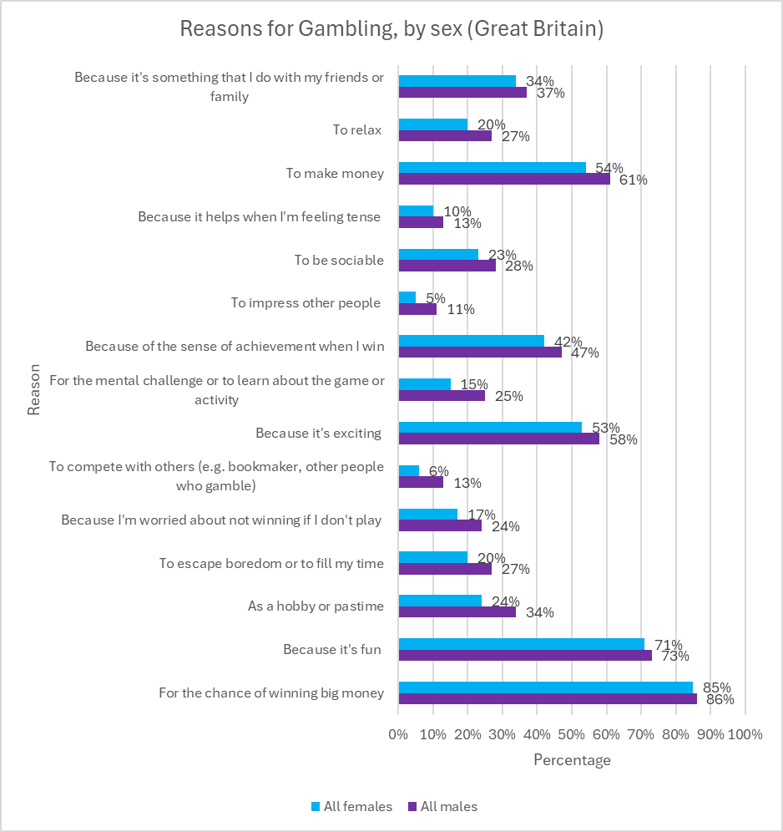
Figure 1: Reasons for Gambling in the past 12 months, by sex for Great Britain (Gambling Commission, 2024)
The most common reasons for adults to participate in gambling in Great Britain is the same for both males and females:
- For the chance of winning big money (f=85%, m=86%).
- Because it’s fun (f=71%, m=73%).
- To make money (f=54%, m=61%).
The local figures for Hartlepool for reasons for gambling by sex differ as shown in Figure 2.

Figure 2: Reasons for Gambling by Sex in Hartlepool
The most common reasons for adults to participate in gambling at least sometimes (in Hartlepool) for combined financial years April 2019 to March 2024 were:
- chasing losses/wins (26%)
- boredom (14%)
- habitual (14%)
- financial difficulties (13%)
The reasons for gambling in the North-East differ from reasons for gambling in Hartlepool as shown above. For both male and female clients, the most common reason for gambling in Hartlepool was ‘chasing losses/wins’. Only male clients responded with ‘influence of others’ and only female clients responded for ‘alcohol use’ and ‘mental health – diagnosed’. The highest proportion of responses for reasons for gambling was chasing losses/wins (26%), loss-chasing is considered a defining feature of disordered gambling often indicating the transition from recreational to disordered gambling (Zhang & Clark, 2020).

Reasons for gambling are also shown by age from the 2023 Gambling Survey for the region. Figure 3 shows the data for the North East and Figure 4 shows the data for Hartlepool for combined financial years April 2019 to March 2024.
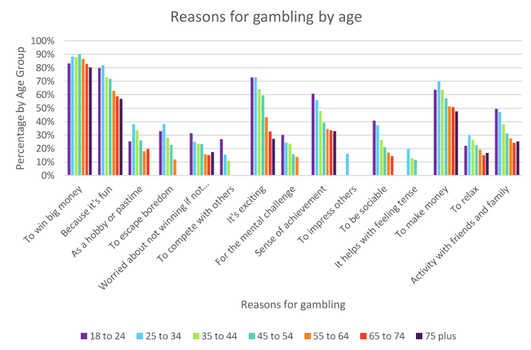
Figure 3: Reasons for gambling by age for the North-East (Gambling, Commission, 2023)

Figure 4: Reasons for gambling by age for Hartlepool
The greatest number of responses for Hartlepool was seen in the 25-34 age group, followed by the 35-44 age group. This mirrors the north east, where 25-34 is predominantly in the top two age brackets for each reason. The difference between the 25-34 and the rest of the age groups is a lot more pronounced in Hartlepool than in the north east, where there tends to be a grouping of ages up to 54 years old.

Economic
The data above for Hartlepool for reasons by gambling by age and sex indicate money as one of the most frequently cited reasons, particularly in the 25-34 age group as shown in Figure 4. Chasing losses/wins (26 responses) and Financial difficulties (13 responses) as among the highest responses could be considered concerning due to the current cost of living (Gambling Commission, 2023).
Social and Familial
The social and familial reasons for gambling in Hartlepool include ‘family/relationship problems’, ‘feeling isolated/lonely’ and ‘influence of others’. The number of responses for social and familial reasons are among the lowest across all responses. With 4 responses across age groups 25-34, 35-44 and 45-54 for both ‘family/relationship problems’ and ‘feeling isolated/lonely’, and only 1 response in the 35-44 age group for ‘influence of others’. Research has shown that romantic conflict and gambling-related problems are linked (Hagen et al., 2023).
Environmental
The advertising and marketing of gambling products in the UK can be a stimulus to increase gambling behaviour (Griffiths, 2005). Studies have shown that media influences children predominantly via marketing, shaping their gambling attitudes, behaviours and consumption intentions (Pitt et al., 2017). Marketing tactics used by the gambling industry work to normalise harmful gambling products as embedded in everyday life, including in sport (Pitt, McCarthy & Thomas, 2023). Celebrity endorsement of gambling products has been noted as adding to the normalisation of gambling and making it seem ‘like a cool thing to do’ (Torrance et al., 2020).

  - Gambling and the Commercial Determinants of Health
The ‘Commercial Determinants of Health’ (CDOH) are ‘the private sector activities that affect people’s health, directly or indirectly, positively or negatively’. The actions and behaviours of private sector organisations influence individuals and their health throughout their lives. They contribute to the conditions in which individuals are born, grow, work, live and age.
Promoting unhealthy products and practices has vast negative consequences including avoidable ill health, planetary damage and social and health inequity. Through heavy promotion and offer based incentives, private gambling sector organisations influence gambling activities.
Developing Products and Promotion
(Gateshead Director of Public Health, 2023) The industry uses similar tactics to other health-harming industries by developing innovative products and promotions, appealing to new markets, co=opting the production of research and knowledge through corporate political activities (van Schalkwyk et al., 2021).
The gambling industry invest in research to design games to be addictive as possible to maximise profits (Schull, 2012) (Cassidy, 2020). Gambling formats such as online slots and online casino games are an example of this, many of which are currently not regulated against in the UK. The following elements of design increase the addictive nature of these gambling forms (Parke & Griffiths, 2007) (Livingstone & Woolley, 2008) (Yucel et al., 2018):
- Speed of play, meaning the time gap between each gamble and the time between placing the bet and the result
- Free or bonus ‘spins’
- Stake sizes, many online games have unlimited stake sizes, higher stake limits are linked to higher rates of harm
- Losses disguised as wins, these are designed to impact the brain’s reward function
- Near misses, creating a feeling that a win was close, encouraging further play
- Psychological design features – lights, colours, sounds, ergonomic features
Current regulation fails to protect people from harmful products and practices of the gambling industry (van Schalkwyk et al., 2023). By becoming one of the main funders of gambling related research, the gambling industry is able to cast doubt on gambling related harms and create entire knowledge gaps. This can allow harms to be dismissed, leading to a tolerance of harm, and presenting the industry as part of the solution (van Schalkwyk & Cassidy, 2024).
Gambling Marketing, Messaging and Advertising
The gambling industry relies on marketing to simulate demands for its products, to normalise gambling as a leisure activity and to promote its image as a responsible corporate citizen (Thomas et al., 2023).
Evidence from a study of gambling marketing on twitter/X found the fie largest online betting operators in the UK send an average of 78 tweets per day and a study from 2021 found that 63.3% of adults (over 25) reported seeing gambling ads on social media at least once a week, this was 72.4% for 18–24-year-olds (Rossi & Nairn, 2022). Currently, direct marketing can be sent through text, apps or emails, often offering free spins. Gambling companies have also taken advantage of new technologies and use Artificial Intelligence to target customers with ‘bespoke ads and incentives’ (Busby, 2018). Data shows people suffering harm are 9 times more likely to be offered free bets than people who are not, and those people receive an average of 7 offers a week (Chapter One, 2024). Receiving direct marketing is also associated with reporting unplanned spending (Wardle et al., 2022). Members of the North East Lived Experience Gambling Harms Forum have given reflections on their experience of how gambling marketing and advertising impacted them:
“Marketing and advertising normalised and glamorised the gambling experience. It showed me by glamorising it everything that I believe I was missing or struggling with. It showed me a way to “fit in”.”
“I felt like I was trapped, there didn’t seem to be any advertisements to look for help but always ones on the next odds.”
Messaging from the gambling industry often places responsibility onto the individual. ‘Responsible gambling’ is often coined by the industry which blames ‘problem people’ rather than a problem industry (Miller, Thomas & Robinson, 2018). Examples such as ‘When the fun stops stop’ campaign in the UK, portray that any harms caused by gambling products are limited to an atypical minority, rejecting upstream determinants of harm and promote individually targeted measures (van Schalkwyk et al., 2021).
The gambling industry also run VIP schemes for select customers. The Gambling Commission reported in January 2020 that whilst just 2% of customers at nine leading operators were VIPS, they accounted for 83% of deposits. Members of the North East Lived Experience Gambling Harms Forum have given reflections on their experience of how gambling VIP schemes impacted them:
“VIP experiences have played a huge part in my journey. When seeking and having a desire to feel like I fit in more in life and feel accepted by circles of friends… It felt perfect.. In order to maintain this “status” – however we all know what I had to keep doing, staking at levels that warrant a company to fund these days out.”
Gambling and Football
Harmful commodities have been known to sponsor sporting events, famously Tobacco and Formula One with branding on uniforms, cars and trackside advertising (University of Bath, 2023). The link between gambling and football is also a prominent one. It is estimated that a gambling logo is shown every 20 seconds during a football match and almost every 10 seconds in boxing matches (Purves et al., 2020). (Bunn et al., 2019) The English Premier League has however committed to no more front gambling shirt sponsors which will commence as of 2026. This does still mean that clubs will continue to feature gambling brands in other areas, including shirtsleeves and LED advertising (Sky News, 2023).
The close relationship between gambling companies and football in the UK, through shirt sponsorship or other media, arguably support the normalisation of gambling (Ireland, 2023) (Bunn et al., 2019). Sponsorship form gambling firms is also being linked to ‘white label’ arrangements, whereby a gambling firm is operated by someone other than the brand owner. These companies such as ‘Net88’ or ‘Debet’ do not have UK-functioning websites and therefore hope to appeal to Asian markets such as China and Vietnam where gambling is largely illegal (Woosnam, 2024). Members of the North East Lived Experience Gambling Harms Forum have given reflections on their experience of how gambling impacted their relationship with sport:
“In terms of the impact on my relationship with sport, that has been rather dramatic now. I used to watch every sport, intently, gambling on everything, attending so much also. I now go to very little and have lost the love in so many major sports to feeling the need to protect myself from it all.”
“I stopped watching football for a while, not because I felt the need to bet, but because I was sick of the advertisements. Luckily for me my club has decided against a betting firm as their sponsor so I can now purchase the shirt.”
  - Prevalence of Gambling
Regionally
In the North East, in 2023, it was estimated that 4.9% of the population (aged 16+) are at-risk gamblers, where they experience some level of negative consequences due to gambling. This equates to 105,437 people of those over 18 (ONS, 2024). This is the highest regional estimated prevalence of at-risk gambling in England (OHID, 2023).
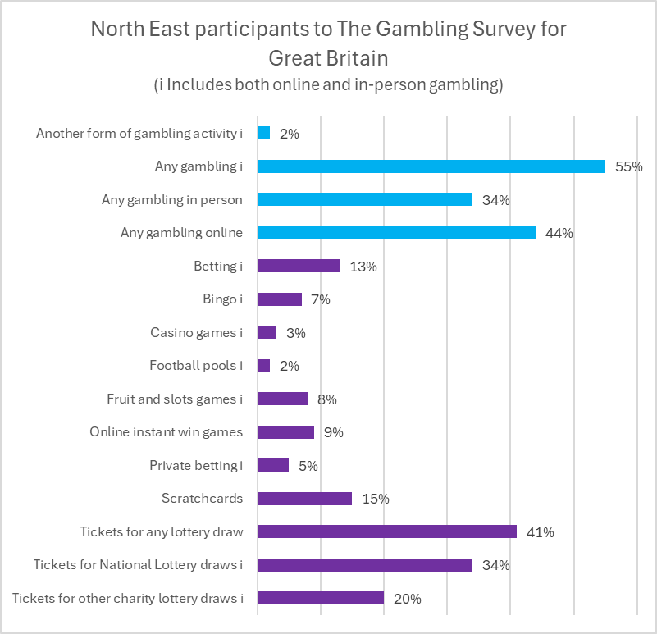
Figure 5: North-East participation in gambling activities in the last 12 months from The Gambling Survey for Great Britain (Gambling Commission, 2024).
Figure 5 displays the North East participation where any gambling online (44%) was higher than any gambling in person (34%). The highest participation by type was Tickets for any lottery draw (41%) and the lowest was football pools online or in-person (2%).
Locally

Figure 6: Client Gambling Activity Count for combined financial years April 2019 to March 2024
Figure 6 shows client gambling activity count for Hartlepool for combined financial years April 2019 to March 2024. ‘Casino (slots) – Online’ account for the highest participation at 29.5%. Followed by ‘Sports Events – Online’ at 12.4% and ‘Sports or other event – Bookmakers’ at 9.5%. Similarly to the regional statistics the highest levels of participation are primarily online, however 3rd highest levels of participation are within the bookmakers which differs from the North East activity.

How do people experience gambling harm?
Gambling can be highly addictive, and many may suffer extreme ill health as a result. Gambling harms are any negative consequence or side effect experienced as a result of gambling. Gambling harms are not only felt by the person who gambles but also affected others. There is a vast scope of harms that come from gambling. These can include the harms portrayed on Figure 7.
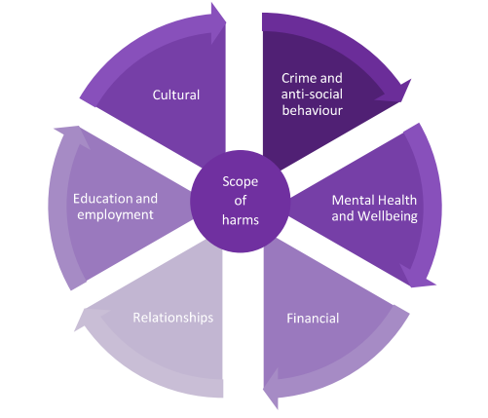
Figure 7: Scope of Gambling Harms
There are many comorbidities of gambling harm. Often those experiencing gambling harm will have multiple areas of harm to burden at once, such as financial challenges and anxiety and stress. Anyone can be harmed by gambling; however, harms are not evenly distributed. Vulnerable groups for harmful gambling include those who experience harms from alcohol and drugs, have mental health difficulties, lower socio-economic status or are unemployed.
Gambling and Financial Challenges
Many people experiencing gambling related harms are also from backgrounds of socioeconomic disadvantage (Rintoul et al. 2013). Debts and financial hardship can be experienced by gamblers and affected others. These harms can often be severe and impact the children of gamblers (Darbyshire, Oster & Carrig, 2001). In their 2023 report of the economic and social costs associated with gambling in England, OHID (OHID, 2023) state that, in extreme cases, some people who gamble may lost the ability to meet their basic needs such as food, children’s school items, medication and transport costs. Such financial challenges can lead to asset losses and several studies report that gambling leads to housing problems including homelessness (Vandenberg et al., 2022). There is currently limited data collected on financial challenges where gambling is the primary factor in the North-East or nationally. Members of the North East Lived Experience Gambling Harms Forum have given reflections on their experience of financial challenges as a result of gambling:
“My 1st period of gambling caused financial challenges at 18 years old. I had to use pay day loan companies and maxed out overdrafts whilst on an apprentice wage at the time.”
“Gambling resulted in major financial problems. I committed fraud to fund my addiction. Stole hundreds of thousands of pounds to fund this addiction from a company that I had worked with since 17. A company full of people I love dearly. A company ran by a father and son that I consider a father like figure and a best friend.”
Gambling and Relationship Harms
Relationships can also be negatively impacted as a consequence of gambling (Marionneau et al., 2023). Studies have noted that partners of someone gambling can experience a wide range of negative effects, including on their financial security, their emotional, mental and physical health, and on their relations (Holdsworth et al., 2013). Some partners were forced to take up extra employment to cover household expenses and pay gambling related debts. Others lost savings, homes, belongings and established ways of life.
Domestic violence and abuse (DVA) have also been identified as a harmful impact of gambling (Roberts et al., 2016). Studies have found an increased risk of intimate partner violence among people experiencing gambling addiction (Dowling et al., 2016). Additionally, gambling activity is linked to a greater likelihood of perpetrating intimate partner violence (Suomi et al., 2019). There is currently limited data collected on gambling related domestic violence in the North East or nationally.
There is also a growing evidence base about the effect growing up in a home impacted by gambling harms can have on children and young people. Studies have reported that adult gamblers can neglect their duties to their children such as failing to provide food or collect them from school (Public Health England, 2021). The NSPCC have reported that child cruelty and neglect cases in the North East and Cumbria have increased by 22% in five years (2018-2023) and there were 1,128 cases in 2022/23 recorded by Northumbria Police, Durham Constabulary, Cumbria Police and Cleveland Police. There is currently no data collected in the North East to confirm whether any of these cases were linked to gambling harms.
Gambling and Crime
Gambling has been linked to crime and anti-social behaviours (Granero et al., 2015). Gabling at harmful levels has been linked to fraud, theft, embezzlement, domestic abuse, blackmail and harassment (Dougherty et al., 2021). These crimes can happen when people try to raise funds to support a gambling habit (Arthur, Williams & Belanger, 2014). Those impacted by these crimes can be close family members, friends, wider circles and employers.
Currently there is no nationally available data on crime that has been influenced by gambling harms.
GamLEARN, a UK based Lived Experience and Recovery Network support and empowers those who have experienced Gambling Related Harm, launched their criminal justice support programme in September 2023 and currently support people in the UK, including some people in the North East. The split of these people is 50/50 male and female. Ages of those seeking support from GamLEARN vary from 20 to 65. The most common crimes are theft and fraud and 80% of these people have never committed a crime before. Crime amounts range from £1,750 to £2,000,000.
The North East Gambling Harms Lived Experience Forum shared an example of a gentleman carrying out an armed robbery in an attempt to be able to pay back his loans from illegal money lenders, as they felt it was the only option they had left. Data on the links between gambling and illegal money lenders is currently limited nationally and regionally. Members of the North East Lived Experience Gambling Harms Forum have given reflections on their experience of gambling related crime in the North East:
“I was always in the pocket of various “loan sharks” within the casino environment that I was often found. Fortunately, I don’t have any horror stories to tell about this, quite simply because I was stealing money that got these paid and off my back.”
“I received a prison sentence for 4 years and 8 months, serving 2 years and 4 months in prison and the other half on probation in the community. During my time in Prison, there was plenty of opportunity to Gamble, however in truth Gambling is the least of the problems when considering Drugs and Violence.”
Gambling and the Criminal Justice System
There is a relationship between gambling harms and people within the criminal justice system. Research indicates that 5.4% of male and 3% of female prisoners believe that their current sentence was linked to gambling (May-Chahal et al., 2015). Members of the North East Lived Experience Gambling Harms Forum have given reflections on their experience in the criminal justice system in the North East:
“Gambling is more in your face in prison than it is on the outside world, which is saying something given the level of advertising and marketing you see for gambling. From betting on pool table results to whose door will get unlocked first in the morning; noodles, vapes, canteen are used as currency. When big events are happening on the outside world, inmates will be phoning out of the prison to their friends and relatives to place bets on for them. I think it was boredom and addiction.”
“People going into prison because of gambling get no support and then often come out worse, reoffending. The cycle of harm isn’t broken because there are no support services, like you might get for other addictions, such as alcohol.”
“I asked for support several times in Durham Prison and HMP Northumberland. No support was given. I ended up spending £25 a week on phone calls out of prison to my own support network on the outside world to help me through this time.”
“The only time the criminal justice system asked me about gambling, despite it being the reason for my offence, was in the probation system after I’d been to prison. Here on one of the final pages of the form it asked, “Do you have a problem with gambling?” – I only answered this honestly because I’d received support prior to going into prison. If I was in active addiction, there’s very little chance that I would have been able to answer that honestly.”
The North East Lived Experience Gambling Harms Forum have been asked what changes they would like to see in the criminal justice system in relation to gambling:
- Full time members of staff trained on gambling harms
- Full time members of staff for recovery and treatment support, in the same way that there are teams for drugs and alcohol support
- One to one support on a frequent basis in order to build up rapport for a better treatment outcome and long-term recovery
- Group support, potentially led by lived experience.
There is a lack of routinely collected data that presents the prevalence of gambling harms in criminal justice settings.
Gambling Harms and Stigma
Gambling harms can include cultural harms, such as stigma, shame and isolation. Stigma has been identified as a major barrier to help-seeking, treatment and recovery from gabling harms (Hing et al., 2014) Stigmatising attitudes towards those experiencing gambling related harms can often be based on the belief that gambling is a choice that is entirely under the individual's control (Blaszczynski et al., 2011). Blame and shame are also linked to gambling severity (Estevez et al., 2022). Public stigma for both the person experiencing gambling related harm and affected others can create isolation, risk of status loss, social exclusion and discrimination (Takiguchi, Kawanishi & Samuelsson, 2022). It is currently unclear how gambling related harms are felt in different communities both nationally and regionally, but stigma and shame may be felt in some environments more than others, presenting additional barriers to seeking help that are currently not fully understood. Members of the North East Lived Experience Gambling Harms Forum have given reflections on their experience of stigma in relation to gambling:
“Stigma played a big part in me never reaching out for help as I thought it was just me suffering.”
“Schools recognising it in the same way as drugs and alcohol would help, real life stories in local schools might help.”
“I felt stigma because gambling is just normalised as having fun.”
Gambling Harms and Suicide
There is an established link between gambling addiction and suicide attempts and ideation, represented in the national suicide prevention strategy 2023-2028. The Gambling Survey for Great Britian found that of the 11.4% of participants who had thought about or attempted taking their own life, 4.9% reported that this was related to their gambling either a little or a lot, with 1.1% reporting that this was related to their gambling a lot (Gambling Commission, 2023). It is estimated that between 240 and 700 people take their won life every year in England related to gambling (Public Health England, 2021). Studies of young people show people (aged 16-24) who have experienced gambling addiction found men were 9 times and women 5 times more likely to attempt suicide than those who have not experienced any problems with their gambling (Wardle & McManus, 2021). (Karlsson & Hakansson, 2018) (Marionneau & Nikkinen, 2022).
Gambling Harms and Depression
Depression is among the most common comorbid conditions associated with harmful gambling (Quigley et al., 2015). In England, it is estimated that there are 69,099 people with depression associated with moderate-risk and harmful gambling (OHID, 2023). There are links that depression can lead someone to gamble and depression can also be a consequence of gambling at harmful levels (Martin et al., 2014). Currently, there is no regularly published data on the comorbidity of gambling and depression either at a population or treatment level.
Gambling Harms and Stress, Sleep Deprivation and Exhaustion
Gambling and stress can intersect, whereby gambling can be used to escape stress and gambling can be a stressor (Buchanan et al., 2020). Australian studies have found a positive correlation between gambling at elevated risk levels and financial stress (Koomson, Churchill & Munyanyi, 2022). Additionally, close to 50% of people of gamble at elevated risk levels report loss of sleep due to stress or worry about gambling (Buchanan et al., 2020).
Gambling Harms and Alcohol and Substance Misuse
Drinking higher levels of alcohol has been connected to harmful gambling (Martinac et al., 2019). Public Health England identified an association between harmful gambling and increased alcohol consumption, where people who regularly consume more alcohol than the recommended weekly intake are 2.2x more likely to experience harmful gambling. Additionally, that the heaviest drinkers (over 50 units per week) are 7.8x more likely to experience harmful gambling (Public Health England, 2021). OHID also report on the economic and social cost of harms associated with gambling in England, finding that there are an estimated 1,312 people aged 16-24 who use illicit opiates and or crack cocaine associated with at-risk and problem gambling in England. Despite the links between alcohol or substance misuse and harmful gambling, there is no mandated data collection in either drug and alcohol services concerning gambling harms, and vice versa for alcohol related harms in gambling treatment settings.
Gambling Harms and Education/Employment
Gambling can have harms on employment for both the gambler and affected others. Gambling is associated with higher risk or future unemployment in the UK (Muggleton et al., 2021). There’s an estimated 22,932 unemployment benefit claims associated with gambling related harms (OHID, 2023).
Absenteeism is also linked to gambling, whereby the gambler may be absent from their place of work or education as a direct consequence of their gambling. This could occur if the person has spent long periods of time gambling during the night, either at a casino or online gambling, which can be accessed around the clock (Latvala, Lintonen & Konu, 2019). Additionally, they may be absent from work due to experiencing any of the other harms, which may be impacting their physical or mental health.
Absenteeism can also impact the children of gamblers whose school attendance and therefore educational attainment can suffer as a consequence of being in a home environment impacted by gambling harms. This then links to under-performance at places of education or employment which can be a consequence of gambling harms (Shaw et al., 2007). Members of the North East Lived Experience Gambling Harms Forum have given reflections on their experience of education and employment harms as a result of gambling:
“My education for sure suffered due to gambling from around 14/15 years old in school. This ramped up to serious levels around 6th form where I ended up dropping out due to quite frankly gambling instead of attending classes.”
Gambling Harms and Young People
Children and young people also experience gambling harms, either through their own gambling or as an affected other. An estimated 55,000 children aged 11-16 in the UK are addicted to gambling (Children’s Commissioner, 2019). Additionally, 26% of 11-17 year olds had spent their own money on some form of gambling activity in 2023 (Gambling Commission, 2023).
Early gambling exposure is a risk factor for being impacted by gambling harms in later life. Playing games that combine gambling and gaming is associated with increased risk for children and young people (Stark, Reynolds & Wiebe, 2021). There are many links between gambling and gaming, which inadvertently expose children and young people to gambling practices. Examples of these include:
- Skins – Decorative virtual weapons, equipment or characters acquired in a game. Skins can be sold for real money on third party sites and can be used to place bets on e-sports and casino style games.
- Loot boxes – A virtual box contains random items such as a rare skin. People who are spending more on loot boxes are more likely to migrate or initiate gambling (Brooks & Clark, 2019).
- People buying loot boxes had more severe problem video gaming and increased risks of gambling harms (Li, Mills & Nower, 2019).
- Card packs – Contain randomised in game items that are not visible to the player before they are opened. They can be purchased by in-game currency.
There is a lack of regularly published data to understand the level of need of young people for gambling treatment services.
University students also experience gambling harms (Williams, 2006). For many it is the first time they may be living away from home or in charge of a large sum of money through their student loan. Approximately 80% of students have participated in gambling, with nearly half doing so to make money (Ygam and GAMSTOP, 2023). In the North East, there is a combined student population of approximately 117,904 across Teesside University, University of Sunderland, University of Durham, Newcastle University and the University of Northumbria. Students have presented to university financial wellbeing services in the North East.
“We do see students that are at high risk of experiencing gambling harms where they have gambled £2000 in three or four days.”
“We’ve seen cases where students have stopped taking medication and then had very high periods of gambling activity.”
“As I work in the “Hardship” Team, students are asked to submit bank statements when they apply, just so we can see their relative spending across a 3-month period. I have spoken to many students this academic year (23/24) where the level of gambling is a concern, but interestingly the majority of students don’t think that they have a problem. We give students resources (including the ones you gave us) to help them should they need the support. It’s interesting looking through their bank statements as we tend to see that a range of behaviours that we might consider a risk, occur in their transactions, for example you may see a pattern of gambling, buying takeaway and buying alcohol. These three things seem to occur a lot together.”
Despite the qualitative information above, there is limited data currently being collected by Universities and higher education establishments when students present with gambling harms.

Where do people gamble?
The gambling environment is divided into land-based gambling activity and online/remote gambling activity. Land-based gambling includes betting shops, arcades, bingo halls and casinos. Figure 8 shows the prevalence of betting premises in the North East region. Please note for the purpose of mapping and prevalence, betting premises include all open betting shops, casinos, bingo venues, horse racecourses and greyhound tracks. This does not include all places that have slot machines for example, such as pubs or all of the shops that sell gambling products such as scratch cards.
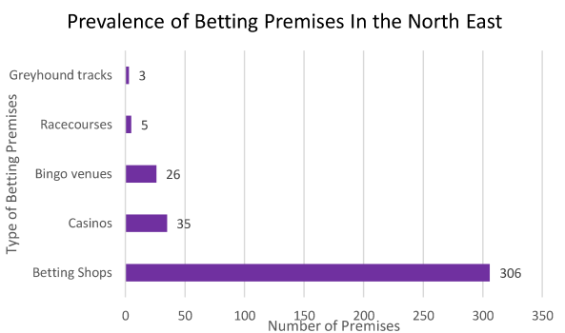
Figure 8: Prevalence of betting premises in the North-East
As of May 2024, there are 375 open gambling premises in the North East region. This figure represents a partial picture with only betting shops (307), casinos (35), bingo venues (26), horse racing venues (5) and greyhound tracks (3) included. There will be other opportunities to gamble through the purchasing of scratch cards and the prevalence of gaming machines in pubs.
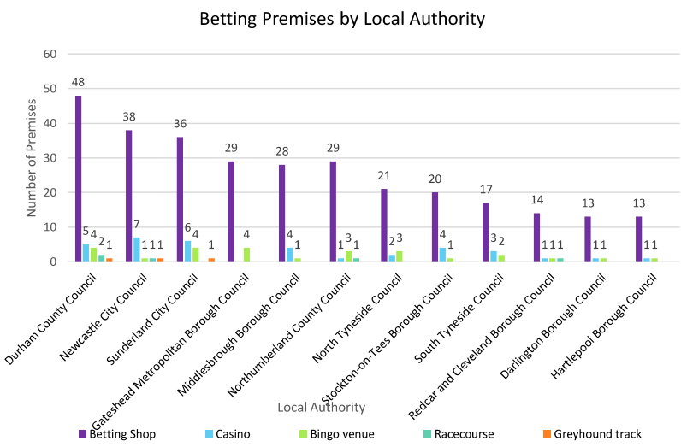
Figure 9: Betting Premises by Local Authority
Figure 9 shows the types of betting premises across the North East broken down by each of the 12 local authorities. Some local authorities have much higher numbers of betting shops than others, however, this may reflect the size of the local authority and the population it serves. Figure 10 below indicates the betting premises distribution across Hartlepool.
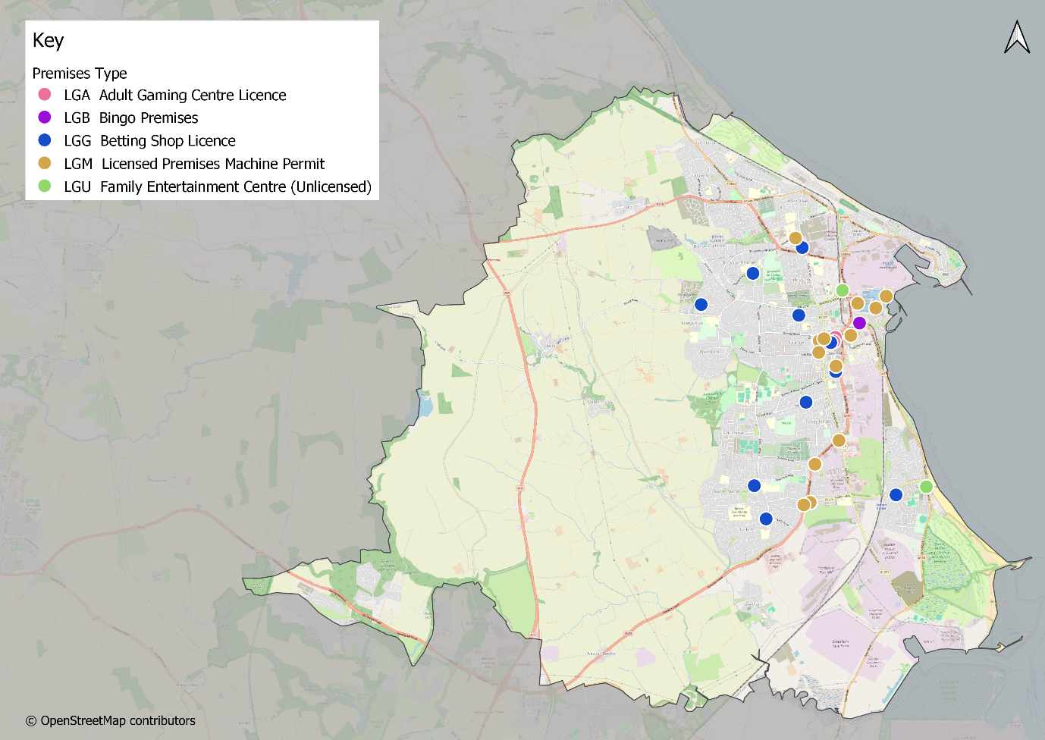
Figure 10: Mapping of Gambling Premises in Hartlepool
Clustering
In almost all of the local authorities in the North East region, there are clusters of betting shops, whereby there is more than one betting shop within a 10 minute walk of each other (Todd et al., 2018). Examples of clusters within the region include Linthorpe Road in Middlesbrough’s Centre. These premises are in close proximity to the Riverside Football Stadium where Middlesbrough Football Club play. Clustering can also be seen on Newcastle’s Clayton Street and enroute to Hartlepool’s football stadium. Coastal areas also appear to have multiple gambling clusters, in areas across North Tyneside, such as Whitley Bay and coastal towns in Northumberland, such as Ashington and Blyth.
Additionally, clustering of gambling outlets in areas of higher deprivation may increase gambling among more deprived populations, contributing to health inequalities. A mapping exercise undertaken for the Regional Gambling needs assessment, complemented by local authority needs assessments, has identified that gambling opportunities are disproportionately located in deprived areas in the North-East.
Figure 11 below shows all licensed gambling premises in Hartlepool by middle layer super output area (MSOA) and corresponding levels of deprivation (IMD). A higher concentration of gambling premises in more deprived areas can be seen. For example in the town centre.
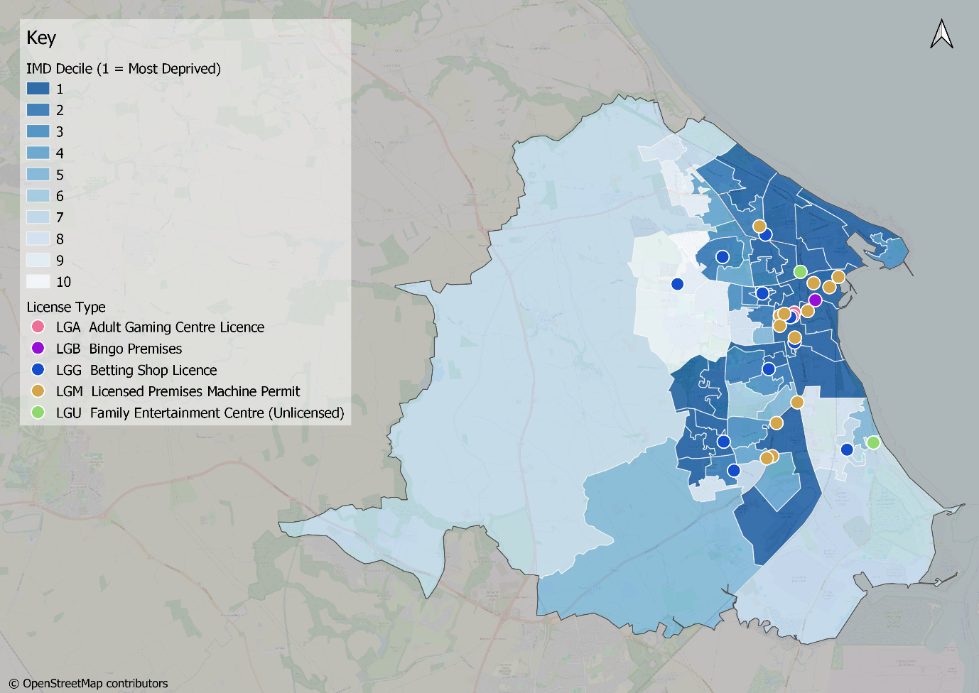
Figure 11: Gambling Premises and Deprivation Deciles - Hartlepool
Online
Figure 12 shows national online gambling activity to March 2023, collated by the Gambling Commission. Data is from the largest operators and is estimated to cover 80% of the online gambling market. The chart shows the number of players per gambling vertical (a player can be active in more than one vertical, so this data is not reflective of the overall number of players). A gambling vertical is a category or gambling products which require specific safeguards in order to ensure that they are offered in a manner which adheres to the law and the regulatory objectives. Slots have increased in popularity by 101% from March 2019 to March 2023. Similarly, other gaming (including casino), betting (real event), betting (virtual) and poker have increased by 58%, 22%, 13% and 13% respectively.
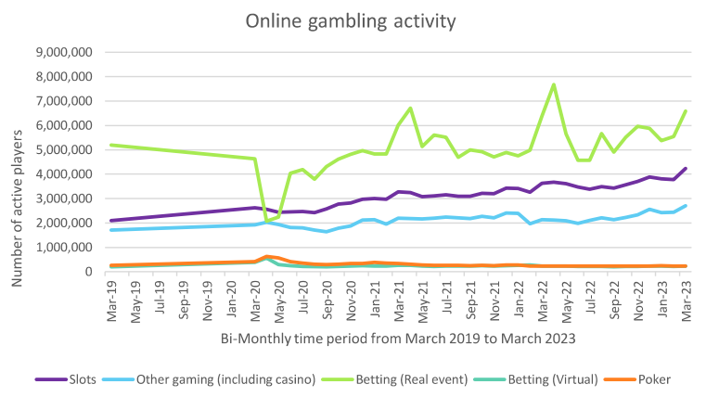
Figure 12: Online Gambling Activity by number of active players by gambling type (Gambling Commission, 2023)
Licensing
Gambling Harms is a topic that impacts multiple local authority departments, including planning and licensing. Licensing teams across the North East abide by the regulations set out in the Gambling Act (2005). The Gambling Act (2005) has three main aims:
- Prevent gambling from being a source of crime and disorder
- Ensure gambling is conducted in a fair and open way
- Protecting children and other vulnerable persons from being harmed or exploited by gambling
This does not currently acknowledge the scope of gambling harms. The ADPH Yorkshire and the Humber Public Health Framework for Gambling Related Harm Reduction, recommends that, ‘Licensing policy Statement of Principles should reflect local need to reduce gambling-related harm through effective regulation, risk assessment, and monitoring of the gambling environment and should expect operators to deliver safeguarding awareness training to their staff,’ (ADPH Yorkshire and Humber, 2019). There are therefore ways in which local authorities can attempt to influence the current environment locally and work alongside colleagues in planning and licensing departments.

How do people get support?
NHS Northern Gambling Service
The NHS Northern Gambling Service is based in Newcastle upon Tyne and provides free to access support to those affected by gambling addiction.
Data has been provided for the five financial years, from 2019 to 2023, since the Northern Gambling Service began treating those in the North East. In total there were 574 referrals to the NHS Northern Gambling Service spread across the 12 local authority areas in the North East. Figure 13 shows the number of referrals for each local authority over the 5-year period. It shows that Hartlepool, Redcar and Cleveland and Stockton-on-Tees have the lowest referrals into the NHS Northern Gambling Service. As the service is based in Newcastle upon Tyne a reason for lower referrals in the Tees Valley could be related to geographical distance to the service.
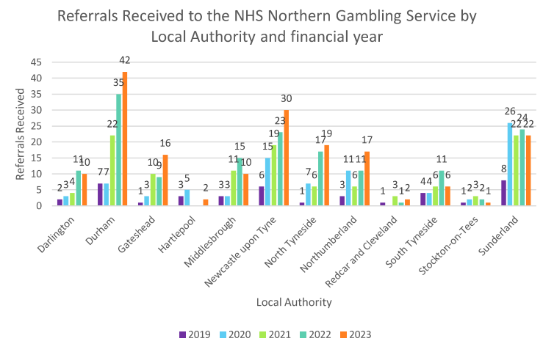
Figure 13: Referrals received to the NHS Northern Gambling Service by Local Authority and Financial Year (NHS Northern Gambling Service, 2024)
Figure 14 below shows the number of referrals for Hartlepool alone between 2019 to 2023 to the NHS Northern Gambling Service. The reasons for referrals were ‘No data’ (n=3), ‘Gambling disorder’ (n=2) and ‘All other presentations’ (n=5).
Referrals received | 2019 | 2020 | 2021 | 2022 | 2023 | Summary
 | 3 | 5 |  |  | 2 | 10
Figure 14: Referrals received to the NHS Northern Gambling Service for Hartlepool
As shown in Figure 15 the referral sources for other Local Authorities in the North East vary with the leading referral source being ‘Self-Referral’. However, unlike the other authorities in the north east, Hartlepool relies almost exclusively on self referrals, with only one referral coming form anorganisation. This may be another reason why referral for Hartlepool are so low, as it demonstrates that the organisations providing referrals for other authorities are not engaging with the system in the same way in Hartlepool.
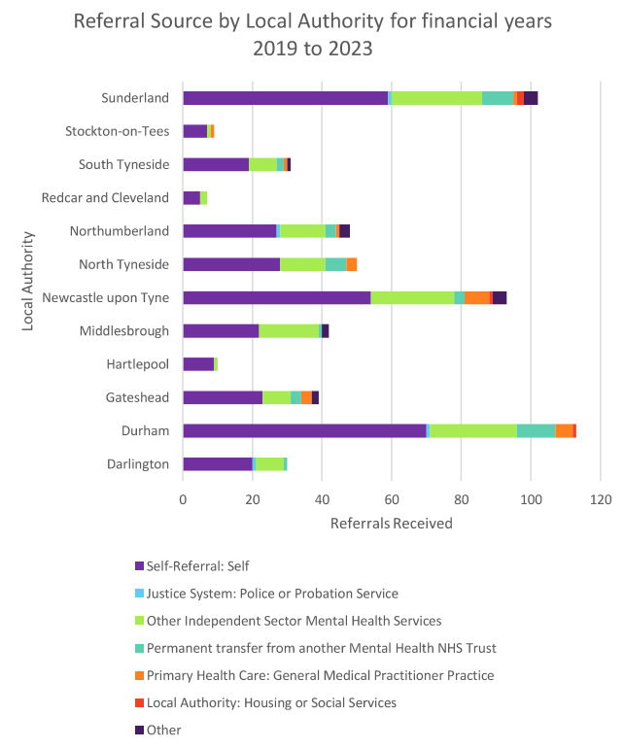
Figure 15: Referral Source by local authority for financial years 2019 to 2023 (NHS Northern Gambling Service, 2024)

Figure 16: Referrals by Age for Hartlepool for the time period financial years 2019 to 2023 (NHS Northern Gambling Service, 2024)
The age group with the highest number of referrals into the NHS Northern Gambling Service from 2019 to 2023 was ’25-29’ with 6 referrals, followed by the ’20-24’ group (2 referrals).

Figure 17: Male (including trans men) and Female (including trans female) referrals for financial year into the NHS Northern Gambling Service for Hartlepool (NHS Northern Gambling Service, 2024).
Figure 17 shows the number of referrals to the NHS Northern Gambling Service by gender for financial years 2019 to 2023 in Hartlepool.

Figure 18: Referrals received by Ethnicity and Financial Year for Hartlepool (NHS Northern Gambling Service, 2024)
Figure 18 shows the number of referrals to the NHS Northern Gambling Service by Ethnicity (where known). The majority of referrals to the service from Hartlepool were White – British.
Employment Status | Status | 2019 | 2020 | 2021 | 2022 | 2023 | Total
Not known | Not known | 3 | 5 |  |  |  | 8
Not known | Summary | 3 | 5 |  |  |  | 8
Employed | Not known |  |  |  |  | 2 | 2
Employed | Summary |  |  |  |  | 2 | 2
Summary |  | 3 | 5 |  |  | 2 | 10
Figure 19: Referrals received by Employment Status by Financial Year for Hartlepool (NHS Northern Gambling Service, 2024)
Figure 19 shows referrals received by Employment Status by Financial year for Hartlepool, however as shown the data cannot provide employment status.

Figure 20: Pre and Post Treatment PGSI Score by Financial Year in Hartlepool (NHS Northern Gambling Service, 2024)
Figure 20 shows the PGSI scores pre-treatment were higher than post treatment for financial years 2020 and 2021. Data is not available for financial years 2022 and 2023. For all 12 local authorities in the North East pre-treatment PGSI scores were higher than post treatment showing a degree of success.
NECA
NECA has various locations across the North East, providing specialist treatment for gambling harms for both the individual and affected others. They provide a range of free gambling support, gambling advice and gambling treatment options for gamblers, as well as friends and family who are affected.
The National Helpline which is open 24 hours a day 7 days a week refers into NECA as the North East treatment provider. NECA in the North-East received 77% of referrals from the National Gambling Helpline for the North East region in the 2021-2022 period (OHID, 2024).
The North East Gambling Harms Lived Experience Forum have reflected upon their experience of seeking support in relation to gambling harms:
“I recall when everything happened to me, arrested, moved back in with parents that same day. Their world turned upside down also. I remember them sitting up late on an evening, googling… essentially “What on earth do we do with my son”. There still now is no real clear pathway of the support on offer. There is also not one size fits all option and a range of support is available but not really readily available in a “here’s your options” kind of black book of contacts.”
“I felt like no one listened.”
“Awareness is the starting point here. Not the odd member of staff that may have seen someone impacted by gambling before. It needs to be statutory for courts, judges and probation staff to be trained on gambling harms.”
The Gambling Survey for Great Britain (Gambling Commission, 2023) found that overall, 3.2% of adults who had gambled in the past 12 months had sought support because of their own gambling.
Low uptake of preventative and treatment services
Compared to the estimated numbers of people affected by gambling harms, only a small number of residents access gambling services. This may indicate potential unmet need for those impacted by gambling harms in the North East. The OHID Gambling Treatment Report found that barriers to accessing treatment included: stigma, low public and professional awareness, unclear treatment pathways and lack of resources for complex cases. Gambling harms are not recognised in a universal way and therefore local systems may not be recording each time support services are accessed. A reason being that gambling harm manifests itself in a scope of ways, such as financial or relationship harms and therefore the applicable services may not record cases as accessing support for gambling harms even when that is a relevant factor.
The report also notes that lived experience stakeholders, support prevention activities to raise awareness of gambling harms via public health campaigns, low-risk gambling guidelines, independent education for children and young people, training for frontline professionals and community leaders (OHID, 2024).

Data Gaps and Recommendations
Data Gaps and Limitations
This needs assessment has endeavoured to present the available data on gambling harms at both regional and local level. However, significant gaps remain:
- There is limited population data to understand the scale of gambling harm when it interacts with other poor health outcomes such as housing, homelessness or domestic abuse.
- Currently, there is no consistent collection of gambling harms prevalence data which can enable year-on-year comparison or examination of trends.
- There is limited evidence of how game design proliferates harm, and what alternative game design features could prevent and minimise harm.
- Availability of treatment data is insufficient, with no regular public publications available as there are for other services such as stop smoking services.
- Whilst there is an established relationship between gambling and sports, there is limited evidence of how this relationship proliferates gambling harms. Moreover, there is limited data which demonstrates the impact of marketing/advertising restrictions on harms.
- Data is not collected on prevalence of gambling harms in key settings where established links are recognised, including financial services, drug and alcohol services and mental health services.
- There is limited information on how stigma relating to gambling harms is felt by different groups.
- It is unclear why regional treatment numbers are far lower than regional estimates of gambling harms.
- There is particularly low uptake of treatment in Hartlepool and other Tees Valley local authorities.
- There is currently limited data, information and evaluation on what locally or regionally delivered interventions may prevent and reduce harms.
- Currently there is no nationally available data on crime that has been influenced by gambling harms.
- There is a lack of routinely collected data that presents the prevalence of gambling harms in criminal justice settings.
- There is a lack of understanding of the prevalence of gambling harms in mental health settings.
- There is limited data on how gambling impacts those who identify as non-binary both at population and treatment level.
Recommendations
- The Gambling Commission should make greater availability of population level data required to understand how poor health outcomes such as housing, homelessness or domestic abuse interact with gambling harms. This data is required at national, regional, and local level. Hartlepool Borough Council can use this for informed decision making.
- Treatment services in England should prioritise making regular publications available like are available for other health services, such as stop smoking services. Hartlepool Borough Council can then implement such publications within local services.
- Services should seek to implement the forthcoming NICE Guidance on screening for gambling harms in their services to ensure the collection of data on prevalence of gambling harms in key settings, where established links are recognised, including financial services, drug and alcohol services and mental health services.
- Hartlepool Borough Council will continue to seek to understand gambling harms at local level through Health Needs Assessment processes and work with other local authorities to bring together wider stakeholders on this topic.
- Hartlepool Borough Council should seek to understand why estimates for those needing treatment are lower than those accessing support – and seek opportunities to minimise this gap.
- Hartlepool Borough Council should improve signposting to treatment and support pathways for gambling harms services in the local area and region.
- Criminal Justice Systems should seek to collect regular data about the prevalence of gambling harm in their populations.

Bibliography
ADPH Yorkshire and Humber (2019) ADPH Yorkshire and the Humber Public Health Framework for Gambling Related Harm Reduction, s.l. s.n.
Arthur, J., Williams, R. & Belanger, Y. (2014) ‘The Relationship between Legal Gambling and Crime in Alberta’, Canadian Journal of Criminology and Criminal Justice, 56(1), p. 49-84.
Blaszczynski et al. (2011) ‘Responsible Gambling: General Principles and Minimal Requirements’, Journal of Gambling Studies, 27, p. 565-573.
Brooks, G. & Clark, L. (2019) ‘Associations between loot box use, problematic gaming and gambling, and gambling-related cognitions’, Addictive Behaviours, 96, p. 26-34.
Buchanan et al. (2020) ‘Stress and gambling’, Current Opinion in Behavioural Sciences, 31, p. 8-12.
Bunn et al. (2019) ‘Shirt sponsorship by gambling companies in the English and Scottish Premier Leagues: global reach and public health concerns’, Soccer & Society, 20(6), p.824-835.
Busy, M. (2018) Revealed: how bookies use AI to keep gamblers hooked. [Online] Available at: https//www.theguardian.com/technology/2018/apr/30/bookies-using-ai-to-keep-gamblers-hooked-insiders-say
Cassidy, R. (2020) Vicious Games: Capitalism and Gambling. s.l.: Pluto Press
Chapter One (2024) What is gambling? [Online] Available at: https://www.chapter-one.org/about-gambling
Children’s Commissioner (2019) Gaming the system. [Online] Available at: https://assets.childrencommissioner.gov.uk/wpuploads/2019/10/CCO-Gaming-the-System-2019.pdf
Darbyshire, P., Oster, C. & Carrig, H. (2001) ‘The experience of pervasive loss: children and young people living in a family where parental gambling is a problem’, Journal of Gambling Studies, 17(1), p. 23-45.
Dougherty et al. (2012) ‘A comparison of fraud to fund gambling with fraud for other reasons’, Psychiatry, Psychology and Law, 28(3), p.408-417.
Estevez et al. (2022) ‘Shame and Blame in Gambling: Relationship with Emotion Regulation and Gambling Motives’, International Journal of Mental Health and Addiction.
Gambling Commission (2023) Young People and Gambling 2023: Official Statistics [Online] Available at: Young People and Gambling 2023: Official statistics
Gambling Commission (2023) Understanding the impact of increased cost of living on gambling behaviour. [Online] Available at: https://www.gamblingcommission.gov.uk/report/understanding-the-impact-of-increased-cost-of-living-on-gambling-behaviour
Gateshead Director of Public Health (2023) Profit Before People: The Commercial determinants of health and lessons from the tobacco epidemic, s.l.: Gateshead Council.
Goodwin et al. (2017) ‘A typical problem gambler affects six others’, International Gambling Studies, 17(2), p. 276-289.
Griffiths, (2005) ‘Does Gambling Advertising Contribute to Problem Gambling?’, International Journal of Mental Health and Addiction, 3(2), p. 15-25.
Granero et al. (2015) ‘Subtypes of Pathological Gambling with Concurrent Illegal Behaviours’, Journal of Gambling Studies, 31(4), p. 1161-1178.
Hagen et al. (2023) ‘What explains the link between romantic conflict with gambling problems? Testing a serial mediational model’, Frontiers in Psychology, 14, 1018098.
Hing et al. (2014) ‘Stigma and problem gambling: current knowledge and future research directions’, International Gambling Studies, 14(1), p. 64-81.
Holdsworth et al. (2013) ‘Impact of gambling problems on partners: partners’ interpretations’, Asian Journal of Gambling Issues and Public Health, 3(11).
Ireland, R. (2023) ‘Brand Engagement in a Digital Age: Marketing Gambling to Newcastle United Fans’, Gambling and Sports in a Global Age (Research in the Sociology of Sport). Emerald Publishing Limited: Leeds, Vol.18.
Karlsson, A. & Hakansson, A. (2018) ‘Gambling disorder, increased mortality, suicidality and associated comorbidity: A longitudinal nationwide register study’, Journal of Behavioural Addictions, 7(4), p. 1091-1099.
Koomson, I., Churchill, S. & Munyanyi, M. (2022) ‘Gambling and Financial Stress’, Social Indicators Research, 163, p. 473-503.
Langham et al. (2015) ‘Understanding gambling related harm: a proposed definition, conceptual framework, and taxonomy of harms’, BMC Public Health, 16 (80).
Latvala, T., Lintonen, T. & Konu, A. (2019) ‘Public health effects of gambling – debate on a conceptual model’, BMC Public Health. 19.
Li, W., Mills, D. & Nower, L. (2019) ‘The relationship of loot box purchases to problem video gaming and problem gambling’, Addictive Behaviours, 97, p. 27-34.
Livingstone,C. & Woolley, R. (2008) The Relevance and Role of Gaming Machines and Game Features in the Play or Problem Gamblers: Report for the Independent Gambling Authority South Australia, s.l.: s.n.
Lostutter et al. (2019) ‘Doing it for the Money: The Relationship between Gambling and Money Attitudes among College Students’, Journal of Gambling Studies, 35 (1), p. 143-153.
Marionneau, V. & Nikkinen, J. (2022) ‘Gambling-related suicides and suicidality: A systematic review of qualitative evidence’, Frontiers in Psychiatry.
Martin et al. (2014) ‘Disorder gambling and co-morbidity of psychiatric disorders among college students: An examination of problem drinking, anxiety and depression’, Journal of Gambling Studies, 30, p. 321-333.
Muggleton et al. (2021) ‘The association between gambling and financial, social and health outcomes in big financial data’, Nature Human Behaviour, 5, p. 319-326.
May-Chahal et al. (2015) ‘The OffGam Pilot: Towards the Development of Gambling Awareness and Problem Gambling Interventions in English Prisons’, s.l.: Lancaster University.
Miller, H., Thomas, H. & Robinson, P. (2018) ‘From problem people to addictive products: a qualitative study on rethinking gambling policy from the perspective of lived experience’, Harm Reduction Journal, 15.
Office for Health Improvement & Disparities (2023) The economic and social cost of harms associated with gambling in England. p.7 The economic cost of gambling-related harm in England: evidence update 2023
Office for Health Improvement & Disparities (2023). Gambling-related harms evidence review: summary, s.l.: s.n
Office for National Statistics (2024) Estimates of the population for the UK, England, Wales, Scotland and Northern Ireland. [Online] Available at: Population estimates for the UK, England, Wales, Scotland, and Northern Ireland - Office for National Statistics
Parke, J. & Griffiths, M. (2007) The Role of Structural Characteristics in Gambling. In: D. H. & R. W. G. Smith, ed. Research and Measurement Issues in Gambling Studies. New York: Elsevier, p.211-243.
Pitt et al. (2017) ‘Factors that influence children’s gambling attitudes and consumption intentions: lessons for gambling harm prevention research, policies and advocacy strategies’, Harm Reductions Journal, 14(11).
Pitt, H., McCarthy, S. & Thomas, S. (2023) ‘The Impact of Marketing on the Normalisation of Gambling and Sport for Children and Young People’. In: C. B. Darragh McGee, ed. Gambling and Sports in a Global Age. Leeds: Emerald Publishing Limited, p. 169-183.
Public Health England (2021) Gambling-related harms evidence review, s.l.: s.n.
Purves et al. (2020) ‘Examining the frequency and nature of gambling marketing in televised broadcasts of professional sporting events in the United Kingdom’, Public Health, 184, p.71-78.
Quigley et al. (2015) ‘Comorbid Problem Gambling and Major Depression in a Community Sample’, Journal of Gambling Studies, 31(4), p. 1135-1152.
Rintoul et al. (2013) ‘Modelling vulnerability to gambling related harm: How disadvantage predicts gambling losses’, Addiction Research and Theory, 21(4), p.329-338.
Roberts et al. (2016) ‘Gambling and violence in a nationally representative sample of UK men’, Addiction, 111(12), p. 2196-2207.
Rossi, R. & Nairn, A. (2022) ‘New Developments in Gambling Marketing: the Rise of Social Media Ads and Its Effect on Youth’, Current Addiction Reports, 9, p. 385-391.
Schull, N. (2012) Addiction by Design: Machine Gambling in Las Vegas. Princeton and Oxford: Princeton University Press.
Sky News (2023) Premier League bans gambling sponsorship on front of club shirts. [Online] Available at: Premier League bans gambling sponsorship on front of club shirts | UK News | Sky News
Shaw et al. (2007) Addiction by Design: Machine Gambling in Las Vegas. Princeton University Press: Princeton & Oxford.
Stark, S., Reynold, J. & Weibe, J. (2021) ‘Gambling and Gaming in an Ontario Sample of Youth and Parents’, Journal of Gambling Issues, 46, p. 4-24.
Takiguchi, N., Kawanishi, Y. & Samuelsson, E. (2022) ‘Secrecy, self-blame and risks for social exclusion – Family members’ experiences of gambling problems in Japan’, Frontiers in Psychiatry, 13.
Thomas et al. (2023) ‘Global public health action is needed to counter the commercial gambling industry’, Health Promotion International, 38(5), p.1-8.
Thomas et al. (2023) ‘Protecting children and young people from contemporary marketing for gambling’, Health Promotion International, 38, p.1-14.
Todd et al. (2018) ‘Cutting care clusters: the creation of an inverse pharmacy care law? An area-level analysis exploring the clustering of community pharmacies in England’, BMJ, 8.
Torrance et al. (2020) ‘’It’s basically everywhere’: young adults’ perceptions of gambling advertising in the UK’, Health Promotion International, p.1-13.
University of Bath (2023) Motorsport Sponsorship. [Online] Available at: Motorsport Sponsorship - Tobacco Tactics
Vandenberg et al. (2022) ‘Gambling and homelessness: A systematic review and meta-analysis of prevalence’, Addictive Behaviours, 125.
van Schalkwyk et al. (2021) ‘“When the Fun Stops, Stop”. An analysis of the provenance, framing and evidence of a ‘responsible gambling’ campaign’, PLoS ONE, 16(8).
van Schalkwyk et al. (2023) Health Above Profits – We Need a New Gambling Act [Online] Available at: https://criticalgamblingstudies.com/index.php/cgs/article/view/165
van Schalkwyk, M. & Cassidy, R. (2024) ‘How can we solve the crisis in UK gambling policy’, BMJ, 384.
van Schalkwyk et al. (2021) ‘A public health approach to gambling regulation: countering powerful influences’, The Lancet, 6(8), p.614-619.
Wardle et al. (2022) ‘The association between gambling marketing and unplanned gambling spend: Synthesised findings from two online cross-sectional surveys’, Addictive Behaviours, 135.
Wardle, H. & McManus, S. (2021) ‘Suicidality and gambling among young adults in Great Britain: results from a cross-sectional online survey’, Lancet Public Health, 6(1), p. 39-49.
Williams, R. (2006) ‘Gambling and problem gambling in a sample of university students’, Journal of Gambling Issues.
Woosnam, M. (2024) Crystal Palace face criticism over gambling from sponsorship deal. [Online]. Available at: https://www.nytimes.com/athletic/5562802/2024/06/13/crystal-palace-new-sponsor/?redirected=1
Ygam and GAMSTOP (2023) Annual Student Gambling Survey, s.l.: s.n.
Yucel et al. (2018) ‘Hooked on gambling: a problem of human or machine design?’, The Lancet Psychiatry, 5(1),p.20-21.
Zhang, K & Clark, L (2020) ‘Loss-chasing in gambling behaviour: neurocognitive and behavioural economic perspectives’, Current Opinion in Behavioural Sciences, 31, p.1-7.

Appendix
Appendix 1. Common Types of Gambling
- Slot Machines: gambling machines commonly seen in pubs, arcades and online. They are spinning wheels that usually feature fruit or items that line up in a game of chance. There is a pre-determined percentage of players will lose over time, although this is not displayed when playing the game.
- Raffles: a game of chance where people buy numbered tickets and winners are drawn at random from a container holding a copy of each ticket sold.
- Bingo: a game where numbers are drawn at random, and players match them to a selection of numbers on a pre-purchased card. Bingo takes place in person at a venue or event or can be played online in bingo-type games.
- Lotteries: Similar in design to bingo in that numbers are drawn at random, and those numbers are matched to a pre-purchased ticket. Prizes can vary in size and nature.
- Sports Betting: Betting on the outcome of a sporting event, from football to boxing. The odds are presented atr the time of places a bet. This may include accumulators where a single bet is placed across multiple outcomes, all of which must happen for the bet to win.
- In-play betting: Gambling that takes places while an event is happening. Technology advancements have made this form of gambling more prevalent. This includes betting on minor elements of events, such as who will win the next point in a tennis match.
- Card games: Card game betting is an example of people betting with a perception of skill, but most forms of card games are essentially another game of chance. Commonly played card games include poker and blackjack.
- Roulette: Roulette is a traditional form of casino gambling where players bet on where a ball will land inside a spinning wheel, this could be the number it falls on or the colour.
- Dice games: This is any form of gambling that uses dice as the mechanic of chance, the most recognisable one being Craps.
- Fixed odds betting terminals (FOBT): These are electronic machines you might commonly find in betting shops that have a variety of different gambling types, such as roulette, fruit machines and bingo. They are called fixed odds because people bet against a house edge that has a simulated outcome. They are by definition fixed in favour of gambling companies.
- Dog racing / Horse racing: This is a form of gambling where people are given odds and bet on the winner of a race. Odds are set by the bookkeeper or tote based on previous performance of runners and may vary between operators. Major racing and betting events in the calendar include the Grand National and Cheltenham festival.
- Online casino games: Versions of casino games that are accessed online. These games are commonly faster-paced than their in-person equivalents.
- Instant win and online slot games: These replicate the features of in-person slot and fruit machines but may also feature game-like elements. Spinning wheels that feature fruit or other items that line up in a game of chance. They have a pre-determined percentage of players that will lose over time.
- Scratch cards: Scratch cards are games of chance where people scratch away a covering to reveal information or images concealed below. This gives a participatory element but has no effect on the outcome.
- Loot boxes: Moments of chance where players pay to gain random items related to the computer game in which they feature. Because the ‘winning’ have no ‘real-world’ monetary value outside the game it doesn’t classify as gambling for regulatory purposes. Studies have shown there is a link between loot boxes and conditioning people to be at higher risk of gambling harms.
- Rapid day-trading: Financial tading involves the buying and selling of financial assets such as stocks, bonds or foreign currencies with the aim of making a profit. Financial trading is regulated by the Financial Conduct Authority. Mobile-based financial trading apps allow users to easily and frequently trade these conventional financial assets (and often cryptocurrencies). Rapid day trading bears many similarities with gambling and carries similar risks of harm. Most high-frequency financial trading includes eToro, Freetrade and Fortrade.
- Cryptocurrency: A cryptocurrency is a ‘decentralised digital asset’ that is encrypted. They can be bought, sold, traded and used as a digital currency for goods and services whilst affording users a high degree of anonymity. Day-trading cryptocurrency provides an opportunity to profit from changes in the value of cryptocurrency assets over short spaces of time, effectively betting on a momentary rise or fall in the value of the asset. Some sites allow users to bet with cryptocurrencies (‘cryptocasinos’). These sites do not have affordability or identity checks in place to protect consumers who are at higher risk of gambling harms (Chapter One, 2024).

